Woodland Management Plan

Woodland Property Name | National Trust North Lakes Borrowdale

Case Reference
Plan Period dd/mm/yyyy  (Ten years) | Approval Date: | To: 2028
Five Year Review Date | 2021

Revision No. | Date | Status (draft/final) | Reason for Revision
The landowner agrees this plan as a statement of intent for the woodland |  |  | Yes

UKFS Management Planning Criteria
Approval of this plan will be considered against the following UKFS criteria, prior to submission review your plan against the criteria using the check list below.
No. | UKFS Management Plan Criteria | Approval Criteria | Applicant Check
1 | Plan Objectives  Forest management plans should state the objectives of management and set out how the appropriate balance between economic, environmental and social objectives will be achieved. | Management plan objectives stated.  Consideration given to environmental, economic and social objectives relevant to the vision for the woodland. | YES
2 | Forest context and important features in management strategy  Forest management plans should address the forest context and the forest potential and demonstrate how the relevant interests and issues have been considered and addressed. | Management intentions communicated in Section 6 of the management plan are in line with stated objective(s) section 2.  Management Intentions should take account of:  - Relevant features and issues identified within the woodland survey (section 4)  - Any potential threats to and opportunities for the woodland identified under woodland protection (section 5).  - Relevant comments received through stakeholder engagement documented in section 7. | YES
3 | Identification of designations within and surrounding the site  In designated areas, for example national parks, particular account should be taken of landscape and other sensitivities in the design of forests and forest infrastructure. | Survey information (section 4) identifies any designations impacting on woodland management  Management Intentions (section 6) have taken account of any designations. | YES
4 | Felling and restocking to improve forest structure and diversity  At the time of felling and restocking, the design of existing forests should be re-assessed and any necessary changes made so that they meet UKFS Requirements.  Forests should be designed to achieve a diverse structure of habitat, species and ages of trees, appropriate to the scale and context.  Forests characterised by a lack of diversity due to extensive areas of even-aged trees should be progressively restructured to achieve age class range. | Felling and restocking is consistent with UKFS design principles (for example scale and adjacency).  Current diversity (structure, species, age structure) of the woodland has been identified through the survey (section 4).  Management intentions aim to improve/maintain current diversity (structure, species, and ages of trees). | YES
5 | Consultation  Consultation on forest management plans and proposals should be carried out according to forestry authority procedures and, where required, the Environmental Impact Assessment Regulations. | Where appropriate - Consultation is in line with current FC guidance and recorded in section 7. The minimum requirement is for statutory consultation to take place and this will be carried out by the Forestry Commission.  Plan authors are encouraged to undertake stakeholder engagement (FC Operations Note 35) relevant to the context and setting of the woodland. | YES
6 | Plan Update and Review  Management of the forest should conform to the plan, and the plan should be updated to ensure it is current and relevant. | 5 year review period stated on the 1st page of the plan. Section 8 completed with 1 indicator of success per management objective. | YES

- Property Details
Woodland Property Name
Name | The National Trust |  | Owner
Email | maurice.pankhurst@nationaltrust.org.uk |  | Contact Number | 017687 81924  Mob 07747461706
Agent Name (if applicable)
Email |  |  | Contact Number
County |  |  | Local Authority | LDNPA
Grid Reference |  |  | Single Business Identifier | 106327021
Management Plan Area (Hectares) |  |  | 645.18
Have you included a Plan of Operations with this management plan? |  |  | Yes
List the maps associated with this management plan |  |  | See Below
Do you intend to use the information within the management plan and associated plan of operations to apply for the following |  |  | Felling Licence |  | Yes
 |  |  | Thinning Licence |  | Yes
Declaration of management control and agreement to public availability of the plan |  |  | Yes

Maps:

- Vision and Objectives

2.1 Vision

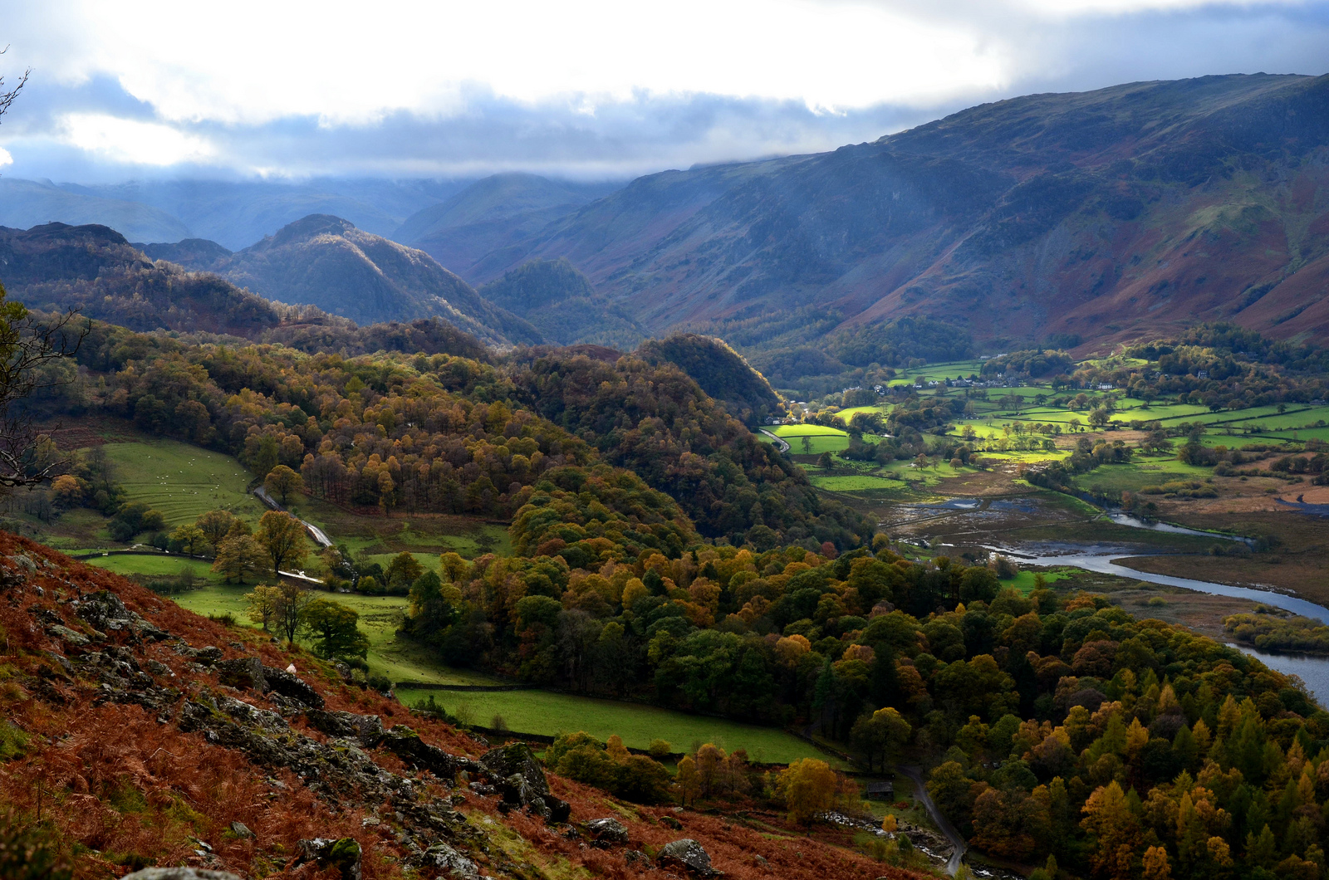
Figure 1 Ashness Woodlands Borrowdale.

Borrowdale’s Atlantic Oak woodlands.
The coincident decline of woodland plants, butterflies and birds indicates fundamental and important changes are happening in many UK woodlands. (Plantlife 2015)
Woodlands in Borrowdale will be enhanced through appropriate management; new glades, rides and clearings will lead to a more diverse ground flora and associated wildlife. All designated woodlands will be in-hand with no uncontrolled grazing. The area of woodlands in the valley will have increased and will offer greater resilience to the changing climate and the increasing threat of plant pests and diseases. The ash component of the woodlands will have declined but new species will have been introduced and natural regeneration will be present in all woodlands where appropriate. Levels of deadwood within SAC woodlands will have increased to a minimum of 30 tonnes per ha. Both species and age classes are diverse ranging from saplings to veteran trees. All PAWS restoration is completed. Biological records are up to date and inform current and future management prescriptions. Invasive plant and animal species will have been eradicated or reduced to acceptable levels. Deer are present throughout the valley but are managed as an asset not a threat. Areas of moribund wood pasture are back in management. New and re-established riverine woodlands will slow river flows protecting water quality and increase soil protection. Income streams from conifer thinning have declined but are matched by increased long term sustainable management of overstocked compartments of oak. All SAC woodlands will be in favourable condition their ancient soils remaining undisturbed. Well managed way marked woodland rides will present visitors with better access, providing vistas into the woodlands and enhanced views out to the wider landscape. Trees or plantations (conifer and broadleaves) in the landscape that have a recorded historical or cultural significance are maintained and management is tempered to enhance these sites. Interpretation and information is readily available for all woodlands via on site displays and other available technologies. Archaeological sites are recorded and all woodlands have been surveyed, forest operations are in place to enhance and protect these sites.

2.2 Management Objectives
State the objectives of management demonstrating how sustainable forest management is to be achieved. Objectives are a set of specific, quantifiable statements that represent what needs to happen to achieve the long term vision.

No. | Objectives (include environmental, economic and social considerations)
1. | Increase the current area of woodland by a minimum of 5% by the end of the plan period.
2. | When possible bring all woodland into direct management (in hand) and put in place appropriate grazing regimes.
3. | All woodlands managed in accordance with the UK Forestry Standard and the UK Woodland Assurance Scheme.
4. | Improve structure and increase canopy species composition. Increase woodland resilience to threats of disease; replace larch and ash with alternative native species and broaden the area of provenance to favour appropriate southern species.
5. | Maintain or improve existing conditions/habitats for BAP species present in the Borrowdale woodlands. Key species: Red squirrel, Otter & Netted carpet moth. Monitor and manage habitats according to specific needs.
6 | Maintain and where possible improve conditions for current historical and archaeological sites  using the Site and Monuments register. Record the condition of archaeological features across all compartments.  When carrying out woodland work ensure that the historic environment is protected in line with guidance from Historic England and consultation with NT Archaeologist.  .
7 | Improve visitor experience with both on site and off site interpretation. Improve access for management and enhance and encourage safe and sympathetic public access extending opportunities for education, recreation and participation where this does not conflict with the other objectives.
8 | Income from woodlands – Generate sustainable timber and wood fuel in ways that support other objectives and seek opportunities to encourage woodland based enterprises.
9 | Monitor and respond appropriately to threats posed by invasive species.
10 | Completion of all SSSI/SAC -PAWS restoration work by the end of the plan period.

- Plan Review - Achievements
Use this section to identify achievements made against previous plan objectives. This section should be completed at the 5 year review and could be informed through monitoring activities undertaken.

Objectives | Achievement
- Woodland Survey

4.1 Description
The National Trust manages approximately 10,000ha of land in Borrowdale of this 640ha is woodland, however this is not a true reflection of the valleys wooded character, for instance many of the fell sides beyond Great wood & Ashness woods are well covered with scrub, the Langstrath Valley continues to support a woody flora that dates back to the dissolution of the Monasteries. There are dozens of steep sided ghylls that have retained relict woodland and associated floras; Examples are, Barrow Beck on Bleaberry fell, Emblesteads gill & Bleatarn gill at Watendlath. Borrowdale is the most wooded of all the Lake District valleys, the dominant trees species by far is Oak Quercus petraea or hybrids of the species. The moist oceanic climate creates a humid environment ideal for tree growth along an annual rainfall gradient of 1500mm in Keswick rising to 3500mm at Seatoller in just 12km. The geology is from deep time, Ordovician volcanics dating back some 450 million years BP. Despite the hard acid nature of this rock there are numerous calcitic veins that give rise to numerous base rich flushes often supporting a wide range of tree and shrub species such as, ash, elm, bird cherry and aspen. In several of the woodlands the understorey and shrub layer is well developed while in others these two components are often absent due to grazing by sheep and deer. The ground flora is rich and diverse a reflection of the ancient soils and management regimes to which these woodlands have been subjected. The ecological importance of the Borrowdale woodlands was first detailed by Derek Ratcliffe and Francis Rose during the 1970’s an 80’s and led to the SSSI designations that cover much of the woodlands today. Their studies revealed a great wealth of lower plants, mosses, liverworts and lichens growing throughout the valley. Records of management mentioning timber sales from the Watendlath Valley date back to the 12th century and to the 15th century for woodlands cleared in the Langstrath valley. On the partially wooded fellsides at Seathwaite are the Borrowdale Yews, possibly the oldest living trees in Northern England thought to be in excess of 2000 years old.
In depth and detailed historical records are scarce, current compartment records mention numerous planting periods most dating back to the 1970’s, the earliest recorded planting dates mentioned are 1840 though there is no evidence to support these statements.

.

Brief Compartment Notes.
Cpt 2a Isthmus wood. 3.6ha Semi ancient amenity woodland of mature oak and beech probably P1900 ( P denotes approximate planting year) with many veteran trees. Understorey of hazel, beech and increasing cover of holly. The site is shared with Young Cumbria and the Keswick Launch Co both organisations have long term leases on areas of the woodland.
Cpt 2b – 2c 4.4ha Compartment 2b is lake edge willow carr that grades to alder and other broadleaves planted in the 1970’s but suffered major windthrow in 2005 exposing the old Keswick refuse tip. The woodland is enclosed with no public access. 2c is a willow carr that fringes the lakeshore and part of Crow park. Both cpts are often flooded throughout the year.

Cpt 3a Cockshot wood 5.26ha Extremely busy amenity woodland adjacent Keswick Theatre and Friars Crag. Continuous cover for the last 200 years. Pre 1800 thought to have been more open; the summit is mentioned by West (1750) as a fine ‘viewing station’ Earliest records are of group felling in 1880 and subsequent replanting with beech, oak, ash, scots pine and sycamore. Felling and restocking took place in 1900. Under NT ownership since 1925 has undergone considerable modification. In recent years a number of storms caused considerable damage to several mature oaks, however most trees have now recovered. Beeches that were planted and undermanaged have been heavily thinned. There is no grazing and regeneration of trees is prolific throughout the woodland. Public use of the woodland has increased and deer are no longer recorded from Cockshot. During the early 1990’s an oak census was carried out revealing 213 individual trees, there are many fine specimen oaks and a small number of specimen beech, along with sycamore, birch, cherry and hazel. There are PROW and permissive footpaths throughout the woodland.

Cpt 4a Castlehead wood SSSI 8.1ha Just south of Keswick Castle Head wood has been in NT ownership since 1925. The woodland is ringed with PROW and meets a high recreational demand for both local folk and visitors to Keswick. Castlehead has an oak dominated canopy with scattered sycamore, ash and one area (1ha) of mature beech, and an understorey of hazel. The earliest suggested planting dates are 1880. In 1975 Japanese larch, European larch beech, and a small number of red oak were planted in newly created clearings. Today most of the larch has been removed and the red oak has declined. There are many fine specimen oaks within the woodland the understorey is vibrant with plenty of regeneration while the field layer supports good communities of wood sage, wood sorrel, pignut and greater woodrush. The geology as with much of the valley is Borrowdale volcanics; Castlehead is thought to be formed from a basaltic plug being part of an ancient volcanic vent.

Cpt 5a Friars Crag 1.05ha Friars Crag is a small wooded promontory very close to Keswick and supports a number of notable oaks and scots pines. While actual visitor numbers are unknown this small area probably receives many hundreds of thousands of visitors annually. It was through the efforts of Canon Rawnsley, vicar of Crosthwaite and one of the founders of the National Trust, that much of Borrowdale was preserved from development. On his death in 1920 Friars Crag together with Lords Island and Calf Close Bay were given to the Trust as a memorial. A plaque to his memory is set into a wall beside the Friars Crag Path.
Cpt 6a Ings Wood SSSI 5.68 Total area 7.54ha Acquired in 1952 Ings wood is an interesting wet woodland that grades from well-developed broadleaved woodland of oak, birch, ash, sycamore scots pine to alder and willow car and finally fen and open water. There are extensive stands of Phragmites communis and Phalaris arundinacea, common reed and reed canary grass respectively, toward the margins of the lake; the ground flora is well established and diverse. In the past some areas have been planted with beech, spruce and larch and while these grew well for many years nearly all have been adversely affected by flooding resulting from changes in the course of Brockle Beck as it flows through the woodland. The word ‘Ings’ is possibly of Norse origin and refers to floodplain or water meadow indeed some authors suggest that this area was cut for hay during the early years of the last century. The woodland is favoured by roe deer, otters and water rail. No data is available for the invertebrate fauna. Breeding lamprey, Lampetra fluviatilis were recorded and filmed in the beck in 2016. Currently the greatest threat to this woodland is the presence of a large population of Himalayan balsam that has existed for at least 25 years and to date all efforts to eradicate this highly invasive plant have failed.
Cpt 6b Duck Egg Wood 0.7ha Small cpt of mixed of ash, beech oak and sycamore planted in the early 1970’s. The site is adjacent Ings wood and is often flooded in winter, windthrow is fairly common. Badgers are resident in this cpt.
Cpt 6c Roadside Wood 0.91ha A small linear woodland adjacent the Borrowdale road(B5289) with many specimen trees including sweet chestnut, oak, Lebanon cedar, horse chestnut, pine and yew planted in the mid-19th century by the Marshall family. There is abundant natural regeneration that tends to hide these wonderful specimen trees.
Cpt 6d Stable Hills Wood 0.39ha Planted in 1970 with larch, beech and ash among fine specimen oak P 1880. Most of the larch has been felled and few beeches remain while ash has come to dominate much of the compartment.
Cpt 6e Broomhill Point 0.35ha Prominent viewpoint over Derwentwater in a small grove of yew trees with several specimen oaks and scots pine. Several memorial trees have been planted in recent years. The lake shore path passes through the centre of this compartment; many thousands of people pass through the compartment each year.
Cpt 6f Calf Close Bay 0.44ha Small landscape woodland with an interesting mix of species including lime, silver fir, oak, horse chestnut, yew and cut leaved beech. The limes, the largest on the property were probably planted in the early 20th century.

Great Wood (in hand)
Cpt 7a Great Wood 4.87ha Compartment of P 50 European larch at Wall Corner with a few scattered broadleaves situated at the top of Great Wood with many windswept trees. Thinned in 1977 and 2002. The larch in this compartment will be clear felled during the plan period and replaced with native broadleaved species. This is the only clear fell area scheduled during the plan period.
Cpt 7b Great Wood 10.01ha (original clear fell) A well thinned compartment of mature oak with a good hazel understory and abundant natural regeneration of native broadleaves. The remaining P50 larch is also well thinned and after the next thinning remaining larch will be left as part of the mixed woodland landscape. The excellent condition of this compartment is a result of integrating woodland and deer management as part of an overall management strategy.
Cpt 7c 2.32 ha Great Wood Prior to 1994 the compartment supported P 1930 Douglas and larch which grew well on this site up until 1986 when the remains of Hurricane Charlie caused major windthrow through the centre of the compartment, the remaining trees were felled in 1993. In 1994 the compartment was replanted with larch and douglas fir and has been thinned regularly and will be thinned again during this plan period.
Cpt 7d 6.8ha Great Wood (2nd clear fell) Until 2004 this was a promising compartment of P1950 Japanese larch. Thinned by contractors in 2004 it was hit by a major storm in January 2005 leaving over a 1000 tonnes of timber on the forest floor. Natural regeneration was checked by deer for several years until 2009.At this time deer management was included in WGS (Woodland Grant Scheme) objectives. Today the species mix includes, ash, oak, birch, holly, Mt ash, hazel, sycamore, willow and alder.
Cpt 7e 10.7ha Great Wood Adjacent to 7d this compartment has some remaining P50 larch and alder. Originally known as Horse close wood the area was once more open in character than today. There are numerous veteran oak trees along with scattered yews and ashes. The presence of a Marshall Stone on the northern boundary suggests a planting period during the mid-19th century.
Cpt 7f 3.4ha Great Wood (SAC ) A compartment of fine mature oaks, planting dates are unknown but probably date from the 18th or early 19th century’s. The lichen flora is of international importance with many old forest species present including three species of large leafy Lobaria. The large beech on the edge of the car park supports Lobaria pulmonaria and is the only beech in the Lake District known to support this lichen species. The compartment has numerous base rich flushes which give rise to a rich ground flora of dog’s mercury and wild garlic. Just thirty years ago there were magnificent wych elms throughout the compartment, many cloaked in lichens and bryophytes, unfortunately all have succumbed to elm disease their rich epiflora is now lost. However there are still numerous young pole stage elms which have survived presumably from their parents root stocks. The other major canopy species are oak, sycamore and ash with scattered bird cherry, beech and birch.
Cpt 7g 8.7ha Great Wood P1950 larch well thinned on two occasions during the last twenty years and subsequently has developed a good understory of hazel that maybe suitable for a community coppicing project. The ground flora is well developed with many ferns and associated woodland herbs; bramble is fairly well developed close to the car park and provides excellent nesting cover for warblers and finches. The compartment will be thinned once again during the plan period.
Cpt 7h 10.6ha Great Wood P1950 larch and sycamore with very good understorey of ash and hazel in the lower reaches of this compartment. The larch is well thinned and much of the beech planted in 1970’s has been removed although beech regeneration does continue to dominate some areas, the canopy toward the upper reaches of the compartment supports ash sycamore, oak, cherry, scots pine, a number of specimen douglas fir and scattered spruce. Natural regeneration of native broadleaves, mainly ash, is present over much of the compartment. Thinning will continue during this plan period.
Cpt 7i 3.7ha Great Wood (SAC) An ancient woodland compartment with many ancient oaks and a rich hazel understorey, beech planted into the woodland has been controlled. The compartment encloses Cat Ghyll at the southern boundary and is particularly humid with a wonderful blanket of lichens and bryophytes on trees and rocks. The northern half once supported P50 larch until being clear felled in 1986. The clear fell was initially planted with oak however ash regeneration is now the dominant species across most of the site. This is probably some of the earliest PAWS restoration in Cumbria.

Cpt 7j 33.74ha Great Wood Walla Crag (SAC) The largest compartment in Great Wood with considerable variation in canopy species, understorey, ground cover, slope angle and geology. Numerous steep crags running with water skirt the upper reaches supporting ash, oak and birch, many of the oak are stunted by wind or have been coppiced perhaps more than a hundred years since. On more gentle slopes are areas of birch with scots pine. The larch that once covered the north eastern end of the compartment was cleared by Slovakian foresters in 1999. Natural regeneration in this area is mainly ash with some oak and sycamore. Due to the complex topography and lack of footpaths this compartment is still influenced by the presence of red deer.
Cpt 7k 6.03ha Great Wood Calf Close Bay (SAC) Important lakeshore woodland with specimen oaks, larch and scots pine many probably planted in the late 19th century or earlier. Water draining from Great Wood passes directly through this compartment and frequent high lake levels often result in flooding. The presence of another large population of epiphytic Lobarias and a large colony of touch me not balsam Impatiens noli-tangere the larval food plant for the nationally scarce netted carpet moth define the importance of this SAC woodland.

Ashness woodlands SAC. A large tract of woodland that runs south over the fells from Ashness through to Lodore and beyond. Much of the woodland grows over very thin soils atop steep boulder fields and steep unstable screes.
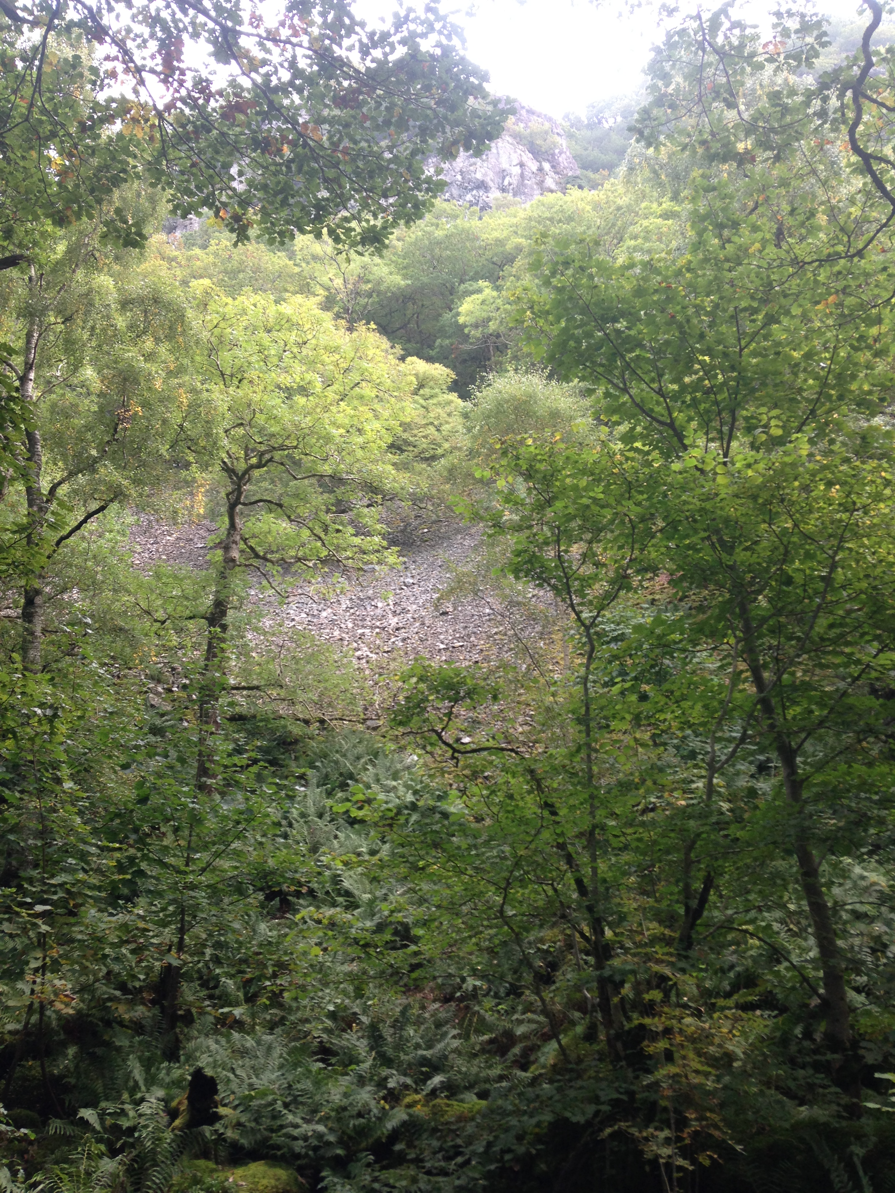
Cpt 8a 0.4ha Arboretum (SAC) A small unusual area of woodland adjacent Barrow House Hostel on the shores of Derwentwater. In the past this small area has been planted with a range of exotic tree species which include Sequoia giganteum, Ginkgo biloba and Liriodendron tulipifera, the presence of these exotics has probably arisen from the close proximity of Barrow House that dates back to 1760 and the desire and tradition to introduce new species. This unusual mix of species will be maintained. A large stone picnic table located in the woodland was donated by Peter Wilmers and his family in memory of their son, a regular visitor to these woodlands. The table was manufactured by Honister Slate Mine.

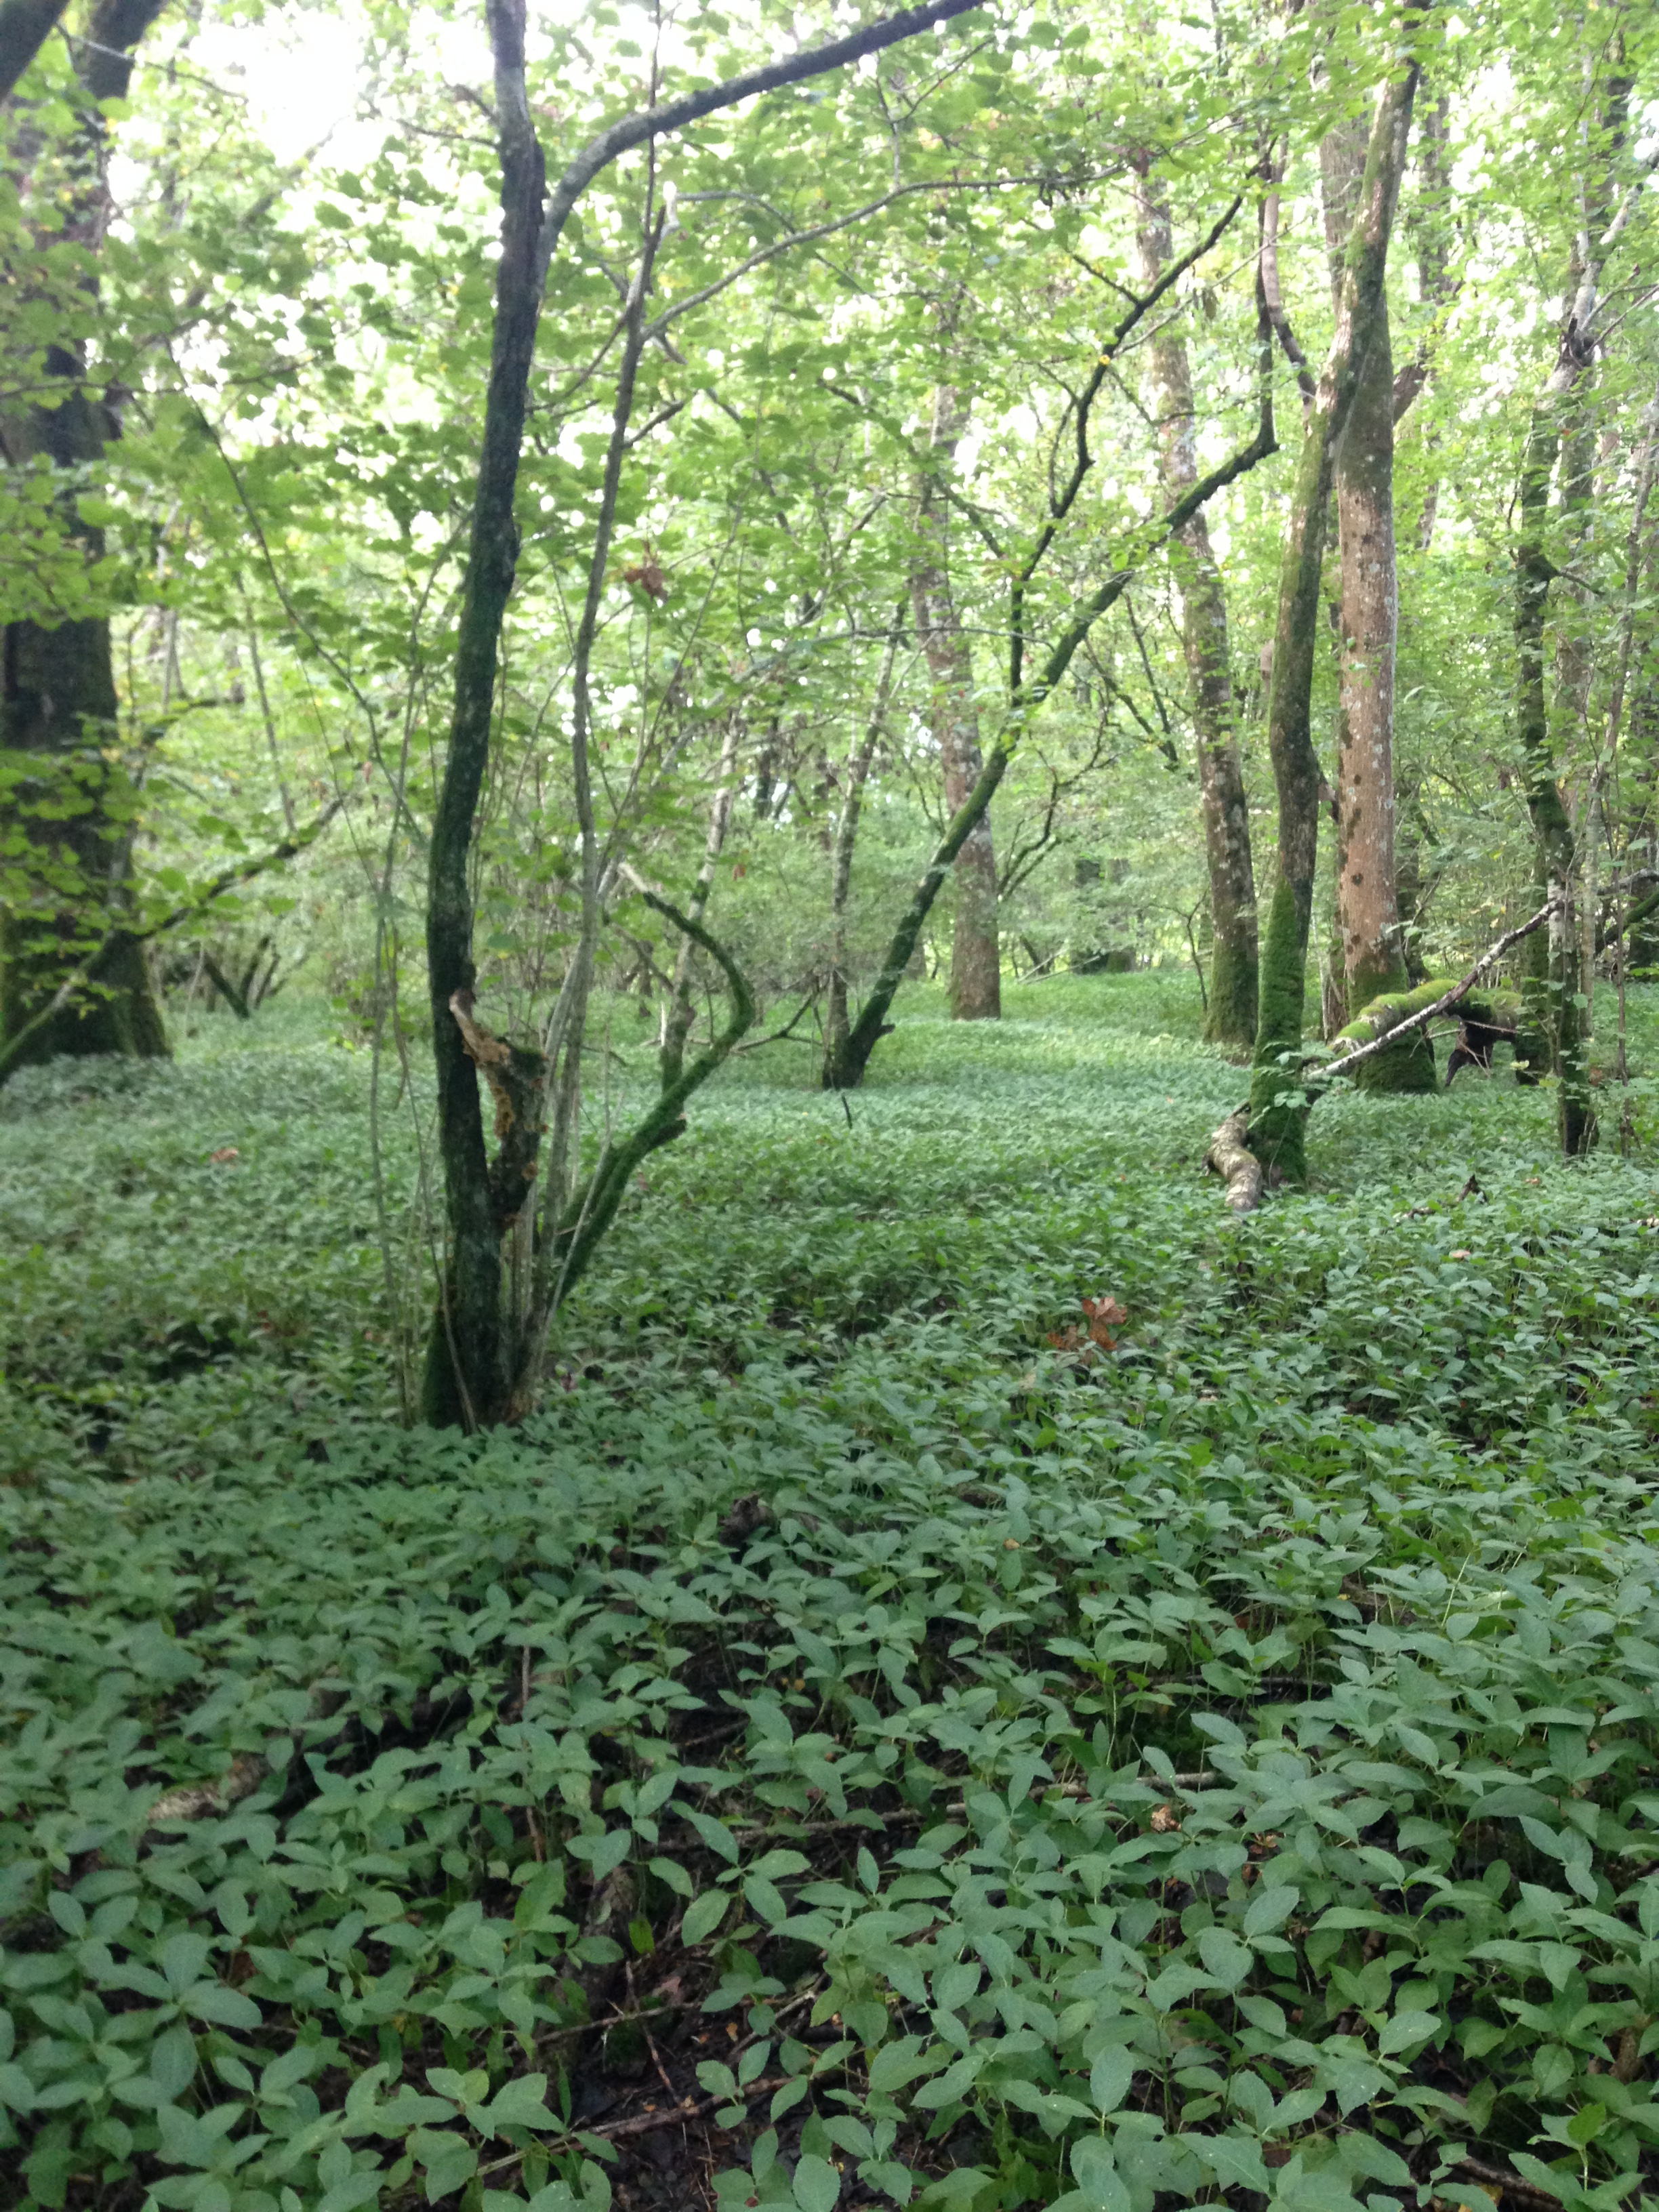

Cpt 8b 21.06ha Ashness wood (SAC)
Part of the large Troutdale – Lodore SAC enclosed by the Watendlath and Borrowdale roads the compartment includes screes coppice, Low crag wood and Strutta Wood all ancient oak woodlands. Much of the woodland sits across steep boulder fields and precipitous crags, access is almost impossible. The geology is complex, calcitic exposures are fairly common giving rise to base rich soils that in turn support a diverse mix of tree species and a rich and varied ground flora that often grades from dog’s mercury into stands of dense bilberry. The area close to Kettlewell has good stands of ash and hazel suitable for re coppicing. The highly fractured crags above are unstable and rock fall is common, the boulder and scree fields are cloaked in a profusion of mosses. Ashness woods are a key habitat for the northern hairy wood ant Formica legubris; red squirrels are present throughout the woodland. Historically Ashness woodlands were sheep grazed by Ashness Farm up until 2008 after which they were taken back in hand and are no longer grazed by sheep.
Cpt 8c 2.8ha Strutta Wood – Ashness (SAC ) A small area of woodland just below Ashness Bridge that has been in-planted with P60 European larch now very well thinned. The compartment once supported large wych elm but all are now lost to Dutch elm disease. The area supports good stands of bluebells and has a good hazel understorey. This area of Ashness is important for the northern hairy wood ant. Barrow beck flows along and down the eastern flank of the woodland, just below Ashness Bridge are the remains of an ancient sawmill, possibly late mediaeval. The remaining larch in this compartment adds considerable colour and texture to the landscape. (see page 5)
Cpt 8d 14.57ha Hogs Earth (SAC ) Important ancient oak woodland on undulating craggy terrain bounded to the east by the Watendlath road and in the north by Watendlath beck, the western flank falls away into steep inhospitable crags down to the shores of Derwentwater .The boulder strewn woodland floor is extremely rich in bryophytes. There are numerous charcoal pitsteads and ancient trackways throughout the compartment. Areas of larch and spruce planted in the mid to late 1990’s have been heavily thinned or completely removed. The woodland has been ungrazed by sheep since 2009 and natural regeneration is abundant throughout the compartment despite the presence of both red and roe deer. Active deer management is now an integral part of woodland management throughout the valley.
Cpt 8e 10.7ha Skelly Close (SAC ) Compartment records hint of periods of coppice management the last being in 1910.The compartment appears as new woodland in 1862 on the OS 1st edition map. During the 1960’s larch, spruce, beech and scots pine were introduced. During 2001 all of the conifers were removed by a Slovakian forestry team as part of PAWS restoration. Removal of sheep has allowed natural regeneration of oak, birch and ash among a bilberry rich ground flora. Excellent woodland for birds and red squirrels. Maintaining the upper boundary of this woodland in a sheep proof condition is challenging and sheep trespass is fairly common.
Cpt 8f 7.5ha Ashness wood (SAC ) Located under Skelly Crag and above the Watendlath road enclosed by drystone walls this compartment cloaks very steep boulder strewn ground and is rarely visited. North west facing crags are steep, wet and rich with bryophytes; many oceanic species are known from Ashness Woods. The canopy of oak and birch is closed and little natural regeneration is present. NT compartment records do not mention any form of management or intervention in this woodland. There are a few large Norway spruce on the upper boundary against the wall but these pose no threat and may be beneficial for red squirrels.
Cpt 8g 2.1 Hogs Earth (SAC ) Small linear compartment of oak, birch, Mt ash, holly and hazel, the oak dates from the late 19th century and as with other compartments the canopy has been modified with introductions of Japanese larch and scots pine in 1978.During recent years these have been thinned and will be thinned again during this plan period. Natural regeneration of native broadleaves in this compartment is excellent. Ground flora is abundant with large drifts of bilberry and boulder hugging bryophytes.
Watendlath Woodlands.
Cpts 9a & 9b 4.5ha Emblesteads wood (SSSI) Also known as Lawson’s coppice (Cpt 9a) this small woodland sits beside the Watendlath road on steep fell side. The canopy is of singled oak with abundant birch. Natural regeneration is good but is checked by sheep trespass and deer. There are many charcoal platforms in this area suggesting a greater woodland cover than today. (See Watendlath and Ashness Historic Landscape Survey Bowe Barn Office) At the lower reaches of the woodland (9b) there are several ash pollards and a more open canopy however natural regeneration is held in check by grazing sheep.
Cpt 9c 1.92ha Bracken platt. A small mainly broadleaved woodland planted in 1979 in partnership with the National Park Authority. Species planted included hybrid larch, scots pine, oak, ash and birch. Today most of the larches have been removed although some remain close to the gill at the southern end of the wood; there are also a number of ancient ash pollards that will benefit from halo thinning. The compartment was thinned in 2007 and will be thinned again during this plan period.
Cpts 9d & 9e 0.59ha Two small square compartments of conifers rather incongruous in the landscape planted in 1955 with European larch, Sitka spruce and Lodge pole pine none of which have grown very well and many are wind thrown. Neither compartment is sheep proof, there is zero natural regeneration. Previous compartment records suggest clear felling in 2020. Both compartments will be thinned during the plan period enclosed and replanted with native broadleaves. It may be possible to increase the area of woodland when replanting.
Cpt 9f 11.36 ha West Side Wood. Unusual woodland dominated by birch with very little oak, other canopy species includes Mtn ash, hazel and hawthorn. Planting periods of 1926 and 1979 are mentioned in compartment records; during 1986 sessile oak was planted but has not survived. The woodland is over sloping very wet ground with numerous boggy flushes. The closed canopy and waterlogged soils would appear to preclude any successful woodland regeneration The wet ground alongside the woodland supports good stands of bog myrtle Myrica gale.
Cpt 9g 11.37 Robin Bank This ancient wood pasture lies on the fell sides to the east of Watendlath Tarn and includes the areas known as Wood bank and Robin bank. The Watendlath landscape is outstanding , the assemblage of ancient ash pollards is probably one of the finest in Cumbria, many of these ancient ashes are believed to be more than 400 years old, there are also pollarded birch, oak, holly and mountain ash. The entire area is criss crossed with trackways and over 40 charcoal platforms have been recorded The first documentary evidence for the area dates back to 1195. This important wood pasture has suffered from constant grazing by sheep and red deer resulting in a total lack of natural tree regeneration and a slow decline in the number of stems per hectare. The current 2015/2016 HLS Agreement removes sheep grazing from this compartment for a period of at least ten years. Regular deer management is now in place for the Watendlath woodlands and tree regeneration monitoring will take place each year.

Stonethwaite woods (SAC)
Cpt 10a 35.6ha Huddlestons Shop (SAC) Situated on the north east side of Stonethwaite a large compartment of oak on steep craggy ground, many are multi stemmed with an area of birch toward the north east corner. There are scattered ash and sycamore in a number wet flushed areas and small leaved limes toward the southern end of the compartment. Along the lower slopes the canopy is open and there are several ancient ash pollards and 14 charcoal pitsteads along the edge of the wood. The canopy is closed with a distinct lack of natural regeneration. The woodland remains within the tenancy of Nook Farm and is currently within an HLS scheme that excludes sheep grazing. Red deer are present and stalking along the lower slopes takes place during the season, the upper areas of the woodland are precipitous and preclude any opportunities for deer management.

(Cpt 10b 24.4ha Stonethwaite West (SAC) 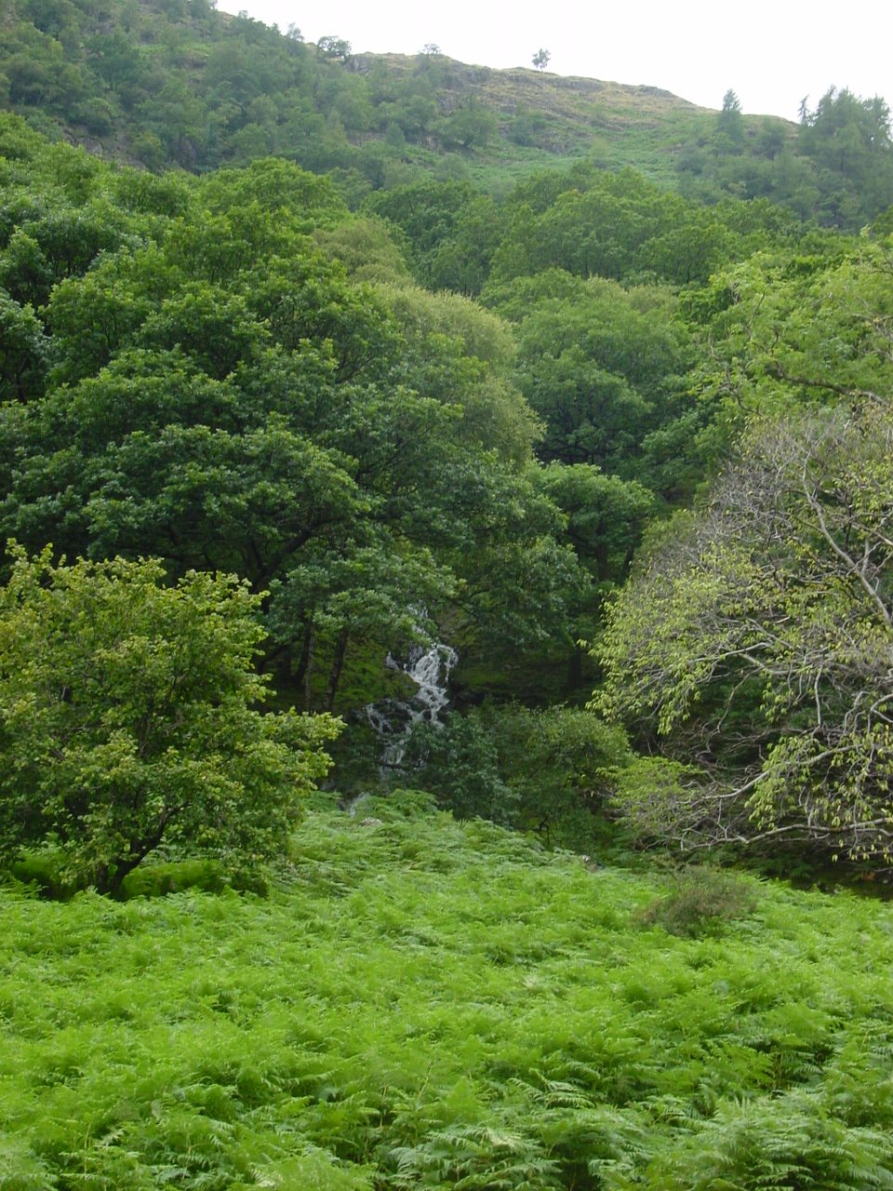
Located on the south west side of Stonethwaite valley this large impressive hanging woodland covers the flanks of Bull crag and Hanging Haystack and is divided by Stanger ghyll. The discontinuous canopy with many crags, streams and flushes provide considerable variation within the woodland. Unmodified by recent plantings the open nature of the canopy is thought to have existed for a long time, the unstable geology of the area may well be responsible for this open condition. The rich ground flora includes Festuca vivipara (viviparous fescue) Saxifraga stellaris (starry saxifrage) plus a number of rare species that include Melica nutans (mountain mellick) Melampyrum sylvaticum ( wood cow wheat) and Circaea alpina (alpine enchanters nighshade) High rainfall and high humidity provide ideal conditions for a rich and diverse fern and bryophyte flora. Although dominated by oak and birch stands there are also some oak and ash stands along the lines of Stanger ghyll, here there are also some fine ancient ash and a few remaining elms. The open areas support birch, rowan, hazel, ash, bird cherry, yew and holly.
Cpt 10b & 10c 1.1ha.Stonethwaite Campsite. Two small plantations planted in 1967 and 1973 respectively of 70% Japanese larch and native broadleaves. Both have been thinned over past years to favour the broadleaved species, oak, birch and alder. Both plantations were put in place to screen the campsite and act as windbreaks. Both will be thinned during this plan.
Cpt 10d 1.1ha Sandy Badrock memorial planting. Native broadleaved plantation, planted in 1984. Species planted oak, alder, holly, willow, hawthorn and hazel. Last thinned 202 and will be thinned during this plan period.

Seathwaite & Seatoller.
Cpt 11a 1.06ha High House Formerly referred to as K Shoes this small plantation surrounds the hostel and acts in part for shelter and screening. Planted in 1980 with 25% alder, 25% scots pine, 10% oak and 40% larch Sheep trespass was and to some extent still is a problem however most trees are now well established, will be thinned during this plan period.
Cpt 11b 21.24ha Low Bank (SAC) Both woodland and wood pasture this extremely diverse compartment ranks among some of the most important woodlands in the Trust’s care. The topography is steep and wet with many streams and flushes and the geology is in many areas is fractured and unstable. Areas of oak and birch blend to ash, hazel and bird cherry, in recent years there were many magnificent elms in among the ashes but sadly they are all gone. On the southern edge of the compartment are the Borrowdale Yews, three well studied ancient yews probably more than two thousand years old. Above the Yews are the ‘Wad Mines’ graphite from these mines was discovered during the 12th century and is reported to be the purest form of graphite ever mined on earth. The compartment has many pollards and although mainly ash many other pollarded species are recorded and include; wych elm, ash, hazel, birch, yew, rowan, hawthorn, holly and oak. In 1991 Oliver Rackham compared the importance of Low Bank with Hatfield Forest. Pollarding at Seathwaite probably dates back a thousand years the high number of ancient pollards are outstanding for their epiphytic lichen found on the ancient bollings. The shattered scree slopes and vast boulder fields are home to an equally rich assemblage of Atlantic bryophytes. Surveys by Day, Ratcliffe and Rose date back to the 1960’s and give testimony to the International importance of these woodlands. Today pollarding continues as a way of maintaining the ancient ashes of Low Bank, trees are pollarded over fairly short cycles, most are now hollow and will collapse if left more than 15- 20 years. The compartment is currently within HLS and is ungrazed by farm stock. A public right of way follows the lower edge of the compartment alongside Seathwaite beck.
Cpt 11c 18.15ha High & Low Stile woods (SAC) The canopy is dominated by large mature oaks at the northern end of the compartment with some open ground; the understorey is dominated by hazel with scattered birch, there are several areas of dense hazel, ash and bird cherry toward the southern end of the compartment. The topography is steep and wet with many streams and flushes and the geology is in many areas fractured and unstable. There is no boundary between 11b and 11c they can be regarded as a single unit, past compartment records mention planting in 1900 with MXB of oak, sycamore, ash, larch and scots pine. The bryophytes within this compartment are of International importance.
Cpt 11d Honister Ghyll 2.8ha Small linear compartment either side of the steep sided Honister ghyll. Canopy is dominated by oak with scattered birch, rowan, holly and ash. Open areas were planted with broadleaves in 1987 and again 1990. The ghyll is used as a venue for ghyll scrambling by several outdoor groups and other educational centres.

Cpt 11e 0.28 Honister plantation. According to compartment notes the land in this area supported more woodland than today and was clear felled during the 2nd world war. The NT planted the area in 1980 with oak, scots pine and ash.
Cpt 11f 0.1ha Crippen plantation A rather incongruous block of larch planted in 1910 and named after the notorious murderer H. Crippen. Last thinned 1999.

Cpts 12a, b & c 35.57 Johnny Wood (SAC)
A woodland of three compartments treated here as a single unit. Johnny wood is perhaps one the most studied woodlands in Borrowdale and has undoubtedly been continuous woodland for many centuries. Pollen research by Birks strongly suggests the current dominance of oak has been present for the last 700 years. Ancient trackways and over 30 charcoal pitsteads are also recorded from within the wood. The Atlantic bryophyte studies are equally impressive with a large number of nationally rare species recorded by Averis. Although dominated by oak there are base rich flushes with ash and some remaining small elms, hazel forms a thin scattered understorey along with mountain ash and willow, occasional yew trees are found toward the lower boundary of 12c. Over many years the main discussions regarding this woodland have been to graze or not to graze and to thin or not to thin. For many years the woodland was within a farm tenancy and heavily grazed, past efforts to regulate grazing were not successful and the woodland was taken back in hand in 2009. During 2009 some canopy gaps were created in order to assess rates of natural regeneration and to date this has not been very spectacular, sheep trespass remains an ongoing problem and is further exacerbated by the presence of deer. There are records for planting from 1900, 1982 and 1986/7 for small groups of oak, ash, birch and sycamore, little or no sycamore can be found in the wood today. Oak has been thinned and singled on several occasions during 1986 and 1987 and pollarding of ash in 1990. Past management has been restricted to the south western end of the woodland cpts 12b & 12c, the north western half of the wood being precipitous and therefore avoided in terms of active management is the richest in terms of lower plant diversity. In cpts 12b and 12 c the canopy is more open and trees much larger while in 12d growth forms are irregular and standing volumes lower probably due to the cold and very wet aspect of this compartment. Johnny Wood grows over a large blocky boulder field, soils are thin and tree mortality in some areas is high probably due to lack of nutrients and drought in the summer months. These poor conditions may well be the reason for past coppice management as landowners realised that this woodland will not grow oaks to full maturity. The main objective for Johnny Wood during this plan is to bring about a complete halt to sheep trespass and an assessment of the woodlands ability to regenerate either from coppice or from seed.
Cpt 12d 1.9ha Scale close coppice. Sitting astride Scale close Gill this very steep sided oak woodland is recorded as stored oak coppice. Last suggested coppice period during early 20th century. There are a small number of European larches thought to be in excess of 100 years old at the lower boundary of the compartment. In 1991 there were large healthy wych elms within the gulley. The very difficult access to this site has precluded any operations that require removal of timber; however the skyline now operating in the Lake District may allow management during this plan period.
Cpts 13a & 13b 11.6ha Frith Wood Closed canopy of stored oak coppice with birch on the lower slopes of Brund fell. Compartment records suggest two planting periods, oak in1880 and birch, ash and elm in1940. The entire woodland was thinned for firewood in 1952 by Willie Hind and his father at which time the woodland was owned by Lodore Estates. Thinned again in 1992/1993 removing 1680 trees. The canopy is now closed and despite half of the wood being ungrazed natural regeneration remains absent. There are a number of ash pollards along the lower boundary other tree species include rowan, bird cherry, hazel a few moribund elms, yew and a notable small leaved lime. Both compartments will be thinned during the plan period.

Cpt 13c 96.22 Troutdale –Kings How woodlands. (SAC) A large sprawling compartment that cloaks the central core of the Borrowdale fells including, Grange crags, Troutdale, Black crag and Long crag, Great end crag and Bowder crag, Kings How, Anderson band crag and finally Brund wood. Much of the woodland is favoured by rock climbers or red deer, details of any major management or intervention are unknown apart from some minor planting close to Troutdale Bungalow in 1978 after clear felling of larch (0.2ha) Records suggest planting dates of 1880 for oak, 1920, 1930 and 1940 for birch. The current canopy is varied and includes elm, sycamore, yew, juniper, willow, rowan, ash and Mtn ash with a scattered understorey of hazel and hawthorn and some blackthorn and bird cherry. Ash pollards are scarce but there are a number of fine ancient oak pollards close to Kings How possibly pollarded over 100 years ago. Flushes and streams criss cross the steep crags, in hollows there are several peaty bogs that support a diverse flora of sedges, rushes and orchids in the perfect habitat for aquatic invertebrates. As of 2015 most of this compartment has been incorporated into the current HLS for Stonethwaite Farm and Chapel House Farm (BLT) the prescriptions for this land need to be assessed and modified if necessary during this plan period. Other than ongoing biological monitoring it is unlikely that any other form of intervention will be required.
Cpt 13d 6.14ha Kidham Dubs (SAC) This small compartment includes Kidham, Gowder and Colywife Dubs. Mixed riverine woodland with P1880 oak, birch and alder and willow between the Borrowdale road and the River Derwent.
Cpt 14a 33.7 & 14c 2.9 Castle crag wood (SAC) Also known as High Hows Wood this large oak dominated woodland is a continuation of 13c separated by the River Derwent. From the river bank the woodland rises and falls over numerous rocky knolls and outcrops, soils are shallow in many places especially if smeared over moutonees’s. Planting dates of 1900 and 1920 are mentioned in the compartment records however this woodland is probably ancient and suggestions of a more open landscape probably date back to periods of coppice management. The woodland has numerous trackways and ancient walls, a prehistoric hill fort sits atop Castle Crag and there are a number of slate quarries within the woodland. Until recently the woodland has been sheep grazed but is now within an HLS agreement and since 2015 has been ungrazed. Natural regeneration is now appearing through much of the compartment and deer are at acceptable levels. There has been some conifer planting in the past mainly of larch and a few silver firs. The larch in the centre of the compartment will be felled or treated chemically during the plan period as part of PAWS restoration agreed with Natural England.
Cpt 14b 5.26 Low Hows wood. A compartment of mainly European larch over steep rocky slopes and boulder fields planted in 1964 with 50% larch, 40% scots pine, 10% beech and oak. Thinned in 1979 and again in 2008. Most of the beech has been removed and a further thin will take place during this plan period. The canopy will be more open after thinning a succession toward a mixed broadleaved canopy will be encouraged.
Cpts 14d 4.9ha Low Hows & 14e 1.1ha Dalt Wood Plantation woodlands of larch with some mature oak. Records suggest P1910 for much of the oak and also suggest that this is stored oak coppice, 1910 may well have been the last major coppice period in this area. Cpt 14d was thinned in 1995 and again 2008. Cpt 14e is also larch but much younger with a planting date around the mid 1990’s. Both compartments will be thinned during this plan period. Low Hows wood grows immediately adjacent the larger Castle Crag wood, a small drystone wall is the only boundary on the ground. The long term conversion to a more robust mixed woodland will continue during the plan period.
Cpt 14f 1.3ha, Dalt Wood. Small compartment adjacent Hollow’s Farm Campsite with a canopy of larch and oak with a few scots pine. The oak is probably P1900 with P60 larch. The compartment was thinned in 1995 and again in 2008 when the remaining larch were felled. Natural regeneration is abundant throughout this compartment and no further planting is anticipated.
Cpt 14g 1.9ha Lodge wood & 14h 2.9ha Scarbrow Wood. The two compartments are now being managed as a single unit. The canopy is mainly large mature oaks with an intermittent understorey. There are suggested planting periods of 1880 for oak and 1930 for larch. The larch was thinned in 1992 and again in 2008 when most were removed. This woodland has an interesting geological component, growing as it does on the intersection of two major geological formations the Silurian and the Ordovician. Located next to Hollows Farm Campsite Lodge wood experience’s high visitor numbers although these have little impact on the nature of the woodland.
Cpts 14i 2.1ha, 14j 3.8ha Holm crag Wood & 14k 0.95ha. Holm crag wood sits between Hollows farm campsite and the River Derwent; the smaller adjacent compartments are alder and willow carr on the banks of the River Derwent. 14j is used as a playground by campers during the summer season. In the past it has been sheep grazed and no regeneration has been recorded. Planting dates around 1900 are suggested and may well refer to oak coppice. Species planted include larch sycamore and birch. The main compartment was thinned in 1993 for the production of riven oak. During 2003 the woodland was fenced in order to stop grazing, however continued damage to the fence via the campsite allows sheep into the woodland and regeneration remains scarce. The woodland will be thinned during this plan period and the boundary maintained to ensure successful regeneration.Some limited planting will take to enhance the species diversity of the woodland.
Cpt 14l 0.62 Hollows Farm Although small this compartment is significant in the landscape and may well be a fragment of a once ancient coppice woodland. The oaks are thought to be P1850 and have well developed crowns. The compartment boundary will be secured and some planting will take place during the plan period.
Cpt 15a 0.18ha The Bield. Small P 1993 oak planting next to the Bield cottage. Due for thinning during the plan period
Cpt 16a 7.8ha Manesty Caravan site. This compartment is leased to The Caravan Club of Great Britain though the National Trust retains responsibility for management and tree safety on the site. Acquired in 1947 the woodland has seen many periods of change with numerous periods of conifer planting dating back into the last century. Compartment records suggest planting periods for MXB in 1900 and for MC in 1950. Tree species included; oak, birch, beech & rowan with Scots pine, Douglas fir, Sitka spruce and Japanese larch. Sheep grazing in the woodland ceased in 1990. During the plan period some limited thinning will take place.
Cpt 16b 9.7ha & 16c 10.59 ha Manesty Wood. This ancient woodland site on the shores of Derwentwater has been subjected to many periods of change and deliberate intervention, consequently the canopy shows considerable variation in height and species mix. Rhododendron has encroached from the adjacent Caravan site and surrounding properties and requires regular control. Compartment records refer to planting dates in 1890 for European larch and oak, 1900 for mixed broadleaves, with further planting in 1960, 1962, 1980 and 1984. Mixtures of larch and beech were introduced in several discreet units. A key feature of Manesty wood are the ‘Manesty Larches’ that stand toward the northern end of the wood, most are well over 100 years and well thinned. These magnificent larches highly significant in the wider landscape are said to be some of the finest European larch in the Lake District. In other areas of the woodland larch has been extensively thinned in order to encourage broadleaved regeneration. A small manmade pond on the western side of the wood has an interesting aquatic flora and supports a good range of invertebrates including many species of dragon fly. The pond supplied water to the nearby lead mines on the shores of Derwentwater. Despite being an in hand woodland sheep trespass remains a major problem for this woodland. There are numerous track and pathways and gates in and out of the wood are often left open allowing fell sheep into the wood. A major objective for this compartment is to ensure that sheep trespass no longer impacts on this woodland. During the plan period further thinning of larch and broadleaves will take place in both compartments.
Cpt 16d 4.9ha Scalethorns. Young woodland P 1962 with a mixture of oak, larch scots pine, Norway spruce, sycamore and some beech. Thinned in 1978 1985, 1999 and 2017.The woodland has won a number of RFS (Royal Forestry Society) medals. Thinning will continue and will favour a mixed woodland of broadleaves with scattered scots pine. Rhododendron has been problematic in this woodland in the past but now under managed control. Despite being an in hand woodland sheep trespass remains a problem and major improvements to the boundary are needed and will be put in place during the plan period.
Brandlehow wood - The entire woodland came back in hand in 2015 from Seathwaite Farm after being heavily sheep grazed since the 1960’s. The wood is an important feature of the Borrowdale landscape rising from the western shores of Derwentwater. The canopy is dominated by oak but there are many fine specimen conifers scattered throughout the woodland, these include larch and douglas fir
Cpt 17a 7.4ha Brandlehow Wood. Located at the southern end of the wood between the main path through the wood and the road. Approximately 2 ha of this compartment have been planted with larch, compartment records suggest dates of 1965, 1978 and 1990. The larch in this cpt is probably P1978. There are several fine specimen Douglas fir close to the lakeshore. The larch component will be thinned during the plan period.

Cpt 17b 4.3ha Brandlehow wood. Compartment dominated by oak possibly P 1900 or earlier. In common with many other oak woodlands this compartment has been under thinned resulting in poor crown development. The compartment will be thinned during the plan period.
Cpt 17c 17.85ha Brandlehow wood This forms the main core of Brandlehow wood and is extremely popular with visitors especially the lakeshore path that stretches the length of the woodland. The canopy of oak is often interrupted by conifers; larch, hemlock and scots pine along with superb Douglas firs are found throughout the compartment, large beech are found at the northern end of the compartment. Small areas of Norway spruce planted in 1978 have recently been removed. Toward the northern end of the woodland a number of Southern beech (Nothofagus) are growing within a small hemlock plantation. A small number of enclosures were erected in the 1980’s to assess the woodlands ability to regenerate in the event of stock exclusion. Management during the plan period will see further thinning and monitoring of natural regeneration. The objective for this compartment is to continue with the current mix of species.
Cpt 17d 0.54ha Brandlehow wood Small linear group of mature oaks along the lakeshore, extremely important as a landscape feature.
Cpts 17e 1.34ha Brandlehow wood. Lakeshore woodland that is regularly flooded. Past management involved regular drainage work, this no longer takes place and many trees have succumbed to increased periods of flooding. The compartment will transition to a more natural species mix of alder and will in future years.
Cpt 17f 0.22 ha Brandlehow wood. Small stand of silver birch, scots pine and willow on lakeshore. P 1950 currently managed as landscape feature.
Cpt 17g 1.63ha Brandlehow wood Probably part of some historic garden or parkland. Compartment records mention planting dates of 1880. Tree species include larch, scots pine, silver fir, birch, beech, cherry, oak, bird cherry and willow. The compartment is also important for Touch-me-not balsam and the Netted Carpet Moth. Some small scale thinning will take place during the plan period in the area just below the Hawse End Centre.

Cpt 17h 1.3ha Brandlehow wood. This small compartment sits at the foot of Catbells, through the summer months a continual stream of people move from the Lakeshore through the woodland and onto the open fells. The canopy is varied with many majestic beeches, specimen ash trees and ash pollards, close to the road a number of hornbeams form part of the canopy. The compartment often suffers from sheep trespass. Rhododendron is present on the site and will be controlled during the plan period followed by some tree planting.
Cpt 17i 3.6ha Brandlehow wood. Within this compartment is the only beech hanger on the property. Records suggest P 1900 for the beech and oaks that grow on the slopes at the northern end of the compartment. A number of trees have been lost over the last twenty years including the only hornbeam and a large sweet chestnut. The compartment is grazed by Seathwaite farm and new planting will need to be suitably protected. A number of new parkland trees will be planted during the plan period.
Cpts 18a 1.7ha, 18b 0.29ha, 18c 2.4ha Derwentwater Islands. These well wooded Islands support a range of tree species including; oak, cherry, yew, beech, birch, ash, larch, alder, willow, silver fir and sitka spruce. A single sitka spruce growing on Lords Island (18c) is perhaps the largest specimen in the North Lakes. The islands provide important cover and habitat for many bird species including geese, common sandpiper, oyster catcher, heron, cormorants and gulls. Otter are recorded from Lord’s Island. All of the Islands are subject to high visitor pressure especially 18a and 18b.

Cpt 19a 11.4ha Keskadale Oakwood SAC. (Common)
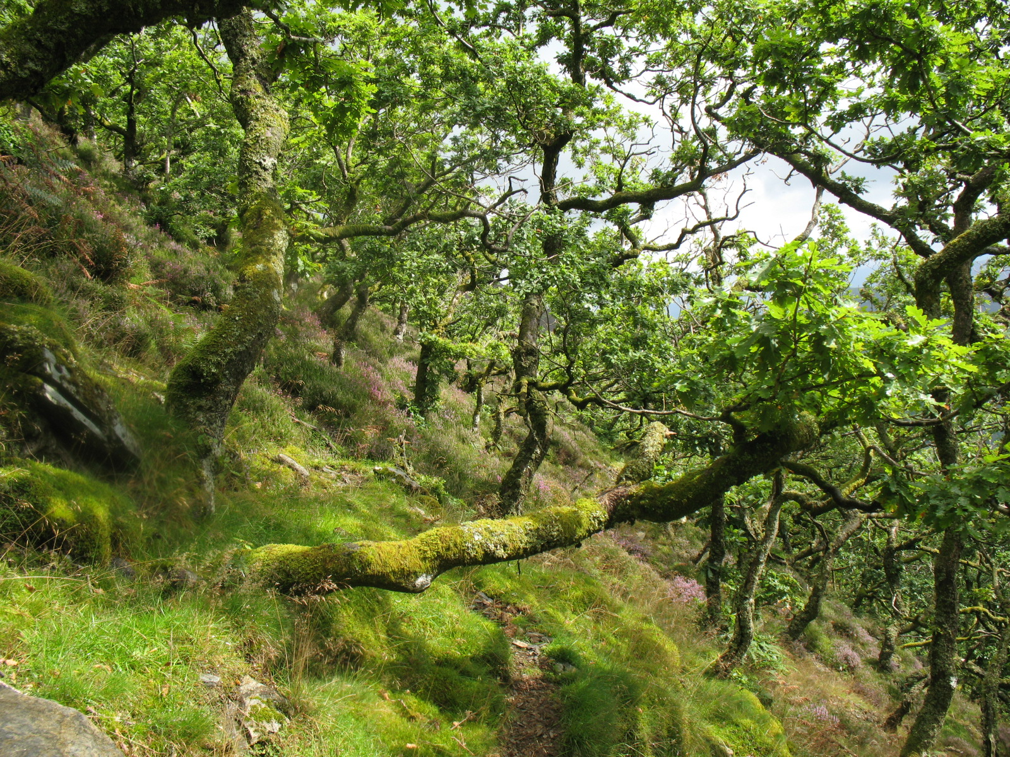
Keskadale Oak wood SAC
Situated in the Newlands valley below Ard Crags this south facing ancient oak wood reaches an altitude of almost 500 metres and may well be the highest recorded oak wood in Britain. The form of the woodland is contorted with most trees stunted and pruned by powerful south westerly winds. Soils are shallow soils and over lay free draining Skiddaw slates that hold little or no water in dry summer months. For many centuries Keskadale was grazed by sheep and although a working woodland, last coppice period during the late 19th century, continued to decline in area and stems per ha until 2006 when enclosure halted grazing by farm stock. The woodland has been stock fenced and the area of exclusion increased to 50ha.

Cpt 19b 7.4 ha Birkrigg Oaks. Small unenclosed woodland identical in every way to Cpt 19a with the exception that it is not enclosed and is grazed by sheep. Located below Scar Crags this compartment is monitored by Natural England and the National Trust to assess any changes in vegetation cover as sheep numbers allowed on the common are reduced.

Cpt 20a 1.1ha Vicarage Hill Wood. Small urban woodland close to Keswick school that has developed since its acquisition in 1948. Tree species include large mature oaks and beeches that follow the boundary with sycamore ash and other native broadleaves forming the core of the woodland. There are often problems with general rubbish being dumped within the woodland as well as issues with boundary trees and their proximity to neighbouring houses on Vicarage Hill and Glebe Close. The woodland will be thinned during the plan period.

4.2 Information
Use this section to identify features that are both present in your woodland(s) and where required, on land adjacent to your woodland. It may be useful to identify known features on an accompanying map. Woodland information for your property can be found on the Magic website or the Forestry Commission Land Information Search.
Feature | Within Woodland(s) | Cpts | Adjacent to Woodland(s) | Map No
Biodiversity- Designations
Site of Special Scientific Interest | Yes | 4a.6a.7f,  7i,7j,7k,  8a,8b,8c  8d,8e,8f  8g,8h,9a  9f,9g,  10a, 10b  11b,11c  12a,12b  12c,13c  13d,14a  14b,14h  19a, 19b | Yes Derwentwater. | Designation Maps
Special Area of Conservation | Yes - As above |  | Yes
Tree Preservation Order | No |  | No
Conservation Area | No |  | No
Special Protection Area | No |  | No
Ramsar Site | No |  | No
National Nature Reserve | No |  | No
Local Nature Reserve | No |  | No
Other (please Specify): | No |  | No
Notes

Feature |  |  | Within Woodland(s) |  |  | Cpts |  | Map No |  | Notes
Biodiversity - European Protected Species
Bats | Species (if known) |  | Yes |  | All |  |  | See Cpt  Maps |  | Recorded species include: Soprano pipistrelle, Common pipistrelle and Daubenton. There are 7 species recorded from Cumbria and it is likely that all seven species occur in Borrowdale.
Dormouse |  |  | No |  |  |  |  |  |  | No recorded data
Great Crested Newt |  |  | No |  |  |  |  |  |  | No recorded data
Otter |  |  | Yes |  | 6a, 7k, 8b,13d,  14c,14f, 14j,14k,  13c, 13a,13b,  11c,11b |  |  |  |  | Over recent years otters have made a steady recovery in much of the North Lakes. There numbers still appear to fluctuate from one year to the next. Records of sightings in Derwentwater are not uncommon and there have been reliable sightings in Rosthwaite and Stonethwaite, it is likely that the riverine woodlands in Borrowdale play an important role in the ecology of the species.
Sand Lizard |  |  | No |  |  |  |  |  |  | No recorded data
Smooth Snake |  |  | No |  |  |  |  |  |  | No recorded data
Natter jack Toad |  |  | No |  |  |  |  |  |  | No recorded data
Biodiversity – Priority Species
Schedule 1 Birds |  | Species: | Yes |  |  |  |  |  |  | Nesting in the valley: Peregrine falcon, Barn owl, bullfinch, Kingfisher, Common sandpiper, Redstart, Dipper, Ring ouzel, reed bunting, skylark? Woodcock, yellowhammer and pied flycatcher.  Visitors.  Osprey, Golden eye, Redwing & fieldfare.
Mammals Red Squirrel, |  |  | Yes |  | All |  |  |  |  | Present throughout the valley and recorded from all woodlands. Numbers have declined since 2001 after the arrival of grey squirrels. Measures in place to control grey squirrels since 2001 have been responsible for the survival of red squirrels albeit at reduced densities.
Reptiles. |  |  | Yes |  |  |  |  | See Bio Species Map |  | Grass snake, adder, common lizard and slow worms are recorded from within the valley, grass snakes have been observed in Ings wood with regular sightings of common lizard and slow worms form woodland in Troutdale and scrub adjacent Great wood.
Plants |  |  | Yes |  | All |  |  | See Bio Species Map |  | Borrowdale’s Atlantic Oak woodlands are celebrated for their rich oceanic flora of mosses and liverworts with over 130 species recorded. The fern flora is also fairly rich especially within the deep wet gulleys found throughout much of the valley. The filmy fern Hymenophyllum wilsonii is relatively abundant in Seatoller, Johnny wood and Stonethwaite woods. Adders tongue fern Ophioglossum vulgatum, is recorded from Falcon Crag adjacent to Great Wood. In open flushed areas there are often numerous orchid colonies. The notable Impatiens noli-tangere is found on the lower slopes of Great Wood and on the fringes of Brandlehow wood.
Fungi/Lichens |  |  | Yes |  |  |  |  | See Bio Species Map |  | Lichens. This highly specialised group, like the bryophytes, has been well studied by several eminent botanists and records for the most important areas are detailed on the Bio species Maps.  Fungi. There are records for Great Wood, Keskadale, Watendlath & Manesty woods. These will be added in 2018.
Invertebrates (butterflies, moths, beetles etc) |  |  | Yes |  |  |  |  | See Bio Species Map |  | Invertebrate data for the woodlands will be added in 2018.
Amphibians (pool frog, common toad) |  |  | Yes |  |  |  |  | See Bio Species Map |  | Common frog and common toad are recorded from throughout the valley.
Other (please Specify): |  |  | Yes/No
Historic Environment
Scheduled Monuments |  |  | Yes |  | N/A |  |  |  | There are 6 scheduled mine sites including the Wad Mine at Seathwaite and Force Crag Mine in Coledale & Castlerigg Stone Circle. None of the sites are within woodland.
Unscheduled Monuments |  |  | Yes |  |  |  |  |  | Unscheduled monuments are extensive and include, Charcoal platforms, potash kilns, old trackways, ancient walls enclosures and huts.
Registered Parks and Gardens |  |  | No
Boundaries and Veteran Trees |  |  | Yes
Listed Buildings |  |  | Yes |  |  |  |  |  | Detail to be added in 2018
Other (please Specify): |  |  | Yes/No
Landscape
National Character Area): Cumbria High Fells
National Park |  |  |  | Yes | All Cpts
Area of Outstanding Natural Beauty |  |  |  | No
People
CROW Access |  |  |  | Yes | All Cpts
Public Rights of Way (any) |  |  |  | Yes |  |  | See Access Maps |  | The majority of woodlands detailed in this plan have PROW.
Other Access Provision |  |  |  | Yes |  |  | See access maps |  | The National Trust has an open access policy for the majority of woodlands in this plan. There are numerous permissive rights of way through most of the woodlands.
Public Involvement |  |  |  | Yes |  |  |  |  | The National Trust operates an extensive volunteer programme over most areas of the Valley and includes regular woodland volunteers and numerous high fell volunteers that regularly work on woodland tasks.
Visitor Information |  |  |  | Yes |  |  |  |  | Visitor information is widely available through a range of media and information outlets. The NT has a shop at the northern end of the valley which is a major source of information and visitor support. There are numerous on line websites constantly updated and regular outputs via social media outlets.
Public Recreation Facilities |  |  |  | Yes |  |  |  |  | The extensive network of woodland paths and tracks connects too many paths leading to the high fells; bridleways are used regularly by countless numbers of mountain bikers. A children’s play trail and den building area are located in Cockshot Wood Cpt 3a.
Provision of Learning Opportunities |  |  |  | Yes |  |  |  |  | The National Trust collaborates with numerous colleges and Universities and deals with many educational visits to the valley. Oxford University have been regular visitors to the valley for 20 years.
Anti-social Behaviour |  |  |  | Yes |  |  |  |  | There are often issues with uncontrolled camping in some woodlands although this has declined in recent years. Fly tipping occurs on occasions and is normally restricted to woodland car parks.
Water
Watercourses |  |  | Yes |  | All Cpts |  |  |  |  | A relatively steep sided valley Borrowdale has abundant small streams, rivers and countless wet flushes upwellings. The River Derwent runs through the length of the valley into Derwentwater.
Lakes |  |  | Yes |  |  |  |  |  |  | Derwentwater, Watendlath Tarn.
Ponds
Yes.
The only area of open water recorded as a pond is in Manesty wood compartment 16c.
There are also numerous dams and ancient water supplies scattered throughout the valley.

4.3 Habitat Types
This section is to consider the habitat types within your woodland(s) that might impact/inform your management decisions. Larger non-wooded areas within your woodland should be classified according to broad habitat type where relevant this information should also help inform your management decisions. Woodlands should be designed to achieve a diverse structure of habitat, species and ages of trees, appropriate to the scale and context of the woodland.
Feature | Within Woodland(s) | Cpts | Map No | Notes
Woodland Habitat Types
Ancient Semi-Natural Woodland | Yes |  |  | See Below
Planted Ancient Woodland Site (PAWS) | Yes |  |  | See Below
Semi-natural features in PAWS | Yes |  |  | See Below
Upland mixed ash woods | No
Upland Oakwood | Yes |  |  | See Below
Wet woodland | Yes |  |  | See Below
Wood-pasture and parkland | Yes |  |  | See Below
Other (please Specify): | Yes/No |  |  | Trees outside woodlands
Notes.
With the exception of a few small compartments the majority of woodlands in Borrowdale are considered to be ASNW, this is reflected in the large area that have been designated (See Designation maps) Coniferization has taken place in some woodlands or on land adjacent to ASNW. Most of these plantings were carried out in the middle of the last century. During the last twenty years conifers have been removed or heavily thinned in all designated woodlands. By the end of the plan period these compartments will either be free of conifers or will have conifers that pose no threat to the ecological integrity of the site, examples are the mature douglas firs in Great wood and Brandlehow wood and the notable larches in Manesty wood. A number of conifer plantations that can be considered as PAWS sites will continue to undergo normal thinning cycles however natural regeneration of native broadleaves will be encouraged. There are no plans to perpetuate conifer plantings in these areas. This conversion to mainly broadleaved cover will probably take a further twenty to thirty years if these compartments remain free of disease.
Upland Oakwood. The complex of woodland that cloaks the fellsides of Borrowdale is an important example of the Upland Oak woods that once covered the Western Seaboard of the UK. The Natural England Citation reads as follows: “Borrowdale has the most extensive block of western old sessile oak woods in northern England, and has a diverse range of stand types, which contributes to conservation of habitat structure and function. Amongst the oak stands there are small patches of 91D0 Bog woodland (birch Betula sp. on peat), ash Fraxinus excelsior woodland and alder Alnus glutinosa stands. The woods are especially rich in bryophytes and lichens, and northern species occur, such as the moss Ptilium crista-castrensis. Rare plants, such as touch-me-not balsam Impatiens noli-tangere and alpine enchanter’s-nightshade Circaea alpina, also have important British occurrences here.”
Wet Woodland.
The woodland of the Ings is predominantly alder dominated and represents a particularly good example of this type. Occasional ash and silver birch trees are found amongst the alder, with rarer elm and sessile oak to the fringes. In the absence of any significant grazing, the ground flora is diverse and well developed. Wet, fen species such as meadowsweet Filipendula ulmaria, yellow iris, Iris pseudacorus and marsh marigold Caltha palustris tend to characterise the flora but there is also a thriving colony of the rare elongated sedge Carex elongata. A major threat to this woodland is the presence of a significant colony of Himalayan balsam.
Wood Pasture.
The woodlands at Watendlath (Cpt 9g) and at Seathwaite (Cpt 11b SAC) are fine examples of ancient ash wood pasture. They support large numbers of ancient pollards, primarily ash, although many other pollarded species are recorded especially at Seathwaite. Wood pasture tends to be notable for a rich diversity of plant and invertebrate species, both these compartments support a wealth of epiphytic lichens and bryophytes especially Seathwaite.
Each compartment is within a current HLS agreement and neither is grazed by farm stock. Both will be monitored during the plan period in order to assess presence or absence of natural regeneration.

Trees outside Woodlands.
Borrowdale has a large number of trees located within the landscape but not actually within woodlands. Many species were planted during the late 19th century and others are found along the boundaries of tracks and field margins. There are over 1000 pollarded trees in the valley and most are described in a paper ‘The Notable Trees of Borrowdale’ to be produced in 2018.

Non Woodland Habitat Types
Blanket bog | Yes |  |  | There are extensive areas of blanket bog on the high fells beyond Great wood (Bleaberry fell) and woodlands at Watendlath (Armboth fell)
Fenland | NO |  |  | Only small fragments of fen remain within the valley, these are located on the shores of Derwentwater one forming the boundary of compartment 6a (Ings wood) another in Kitchen Bay close to compartment 17g.
Rush pasture | NO
Reed bed | Yes |  |  | Very small areas around the shores of Derwentwater (cpt 6a)
Wood pasture | Yes |  |  | Woodland pasture at Thorneythwaite GR250130  Acquired by the NT in 2015 will added to this plan in 2018.
Upland hay meadows | No
Upland heath land | yes |  |  | Add in 2018
Unimproved grassland | Yes |  |  | Add in 2018
Peat lands | Yes |  |  | Add in 2018
Wetland habitats | Yes |  |  | Add in 2018

4.4 Structure
This section should provide a snapshot of the current structure of your woodland as a whole. A full inventory for your woodland(s) can be included in the separate Plan of Operations spreadsheet. Ensuring woodland has a varied structure in terms of age, species, origin and open space will provide a range of benefits for the biodiversity of the woodland and its resilience. The diagrams below show an example of both uneven and even aged woodland.
Woodland Type (Broadleaf, Conifer, Coppice, Intimate Mix) | Percentage of Mgt Plan Area | Age Structure (even/uneven) | Notes (i.e. understory or natural regeneration present)
Native Broadleaves | 45 | Even Aged | There is a north / south vegetation gradient within the valley. Northern woodlands as in Great Wood SAC are greatly improved in both understorey and natural regeneration, while the woodlands to the south at Stonethwaite and Seatoller often suffer from sheep trespass leading to loss of natural regeneration and a uniform structure.
Native Broadleaves | 35 | Uneven Aged | The SAC woodlands have a good range of middle aged trees and fallen dead trees often with a good understorey of shrubs and small trees.
Intimate Mix | 10 | Uneven Aged | The best examples are in Cpts 7d, 7e & 7h in the north of the valley and in Cpts 11c and 11b in the south of the valley.
Coniferous | 10 | Even Aged | The only even aged conifer plantings are Cpts 14b, 14d, 14e at Grange and 7g in Great wood. All are due to be thinned during this plan.
Coppice | <1 | Uneven Aged | There is no active coppice detailed in this plan but there are small areas where coppicing will be introduced.

- Woodland Protection
Woodlands in England face a range of threats; this section allows you to consider the potential threats that could be facing your woodland(s). Using the simple Risk Assessment process below woodland owners and managers can consider any potential threats to their woodland(s) and whether there is a need to take action to protect their woodlands.

5.1 Risk Matrix
The matrix below provides a system for scoring risk. The matrix also indicates the advised level of action to take to help manage the threat.

Impact | High | Plan for Action | Action | Action
 | Medium | Monitor | Plan for Action | Action
 | Low | Monitor | Monitor | Plan for Action
 |  | Low | Medium | High
 |  | Likelihood of Presence

5.2 Plant Health
Threat.
Phytophthora ramorum
Despite continued outbreaks across the Lake District P. ramorum has not been recorded within the Borrowdale valley. See attached link below for details.
Likelihood of presence (medium)
Most larch in Borrowdale is well thinned and host species e.g. rhododendron are at very low rates of cover.
Impact (medium)
In terms of woodland structure/biodiversity impact would be medium to low, however in terms of woodlands in the wider landscape the impact would be high and also impact on the historical context of NT Woodland. Ex The Manesty Larches.
Response
National trust forestry teams and contractors carry out forest bio security measures as recommended by the Forestry Commission. Annual monitoring of larch plantations.
https://www.forestry.gov.uk/phytophthora

Threat Ash Dieback.
Hymenoscyphus fraxineus
Reported throughout the region but currently affecting young trees <20 years. Suspected cases observed in Borrowdale in 2017.
Likelihood of presence (high)
Presumably as spore production increases infection rates will increase. Widespread Infection likely within 10- 20 years or less.
Impact (high)
Present in most woodlands ash forms many characteristic stripes and is the major species within all wood pastures in Borrowdale. As individual farm trees the species is probably of international significance. There are many hundreds of ancient and veteran ashes scattered throughout the valley many supporting an epiflora rich in bryophytes and lichens. Invertebrate communities are also of national importance. Loss of ash will diminish the overall biodiversity and landscape character of the valley.
Response
Annual monitoring for first signs of infection paying attention to the ancient and notable ashes in the valley. Develop a planting programme to replace significant groups of trees before they are lost from the landscape. National trust forestry teams and contractors carry out forest bio security measures as recommended by the Forestry Commission. Annual monitoring of Ash within the valley.
https://www.forestry.gov.uk/ashdieback

Threat.
Phytophthora austrocedraea
Now reported widely through Cumbria therefore the threat level is high.
Likelihood of presence Medium
There are a few stands of Juniper scattered through the valley, Falcon Crag, Watendlath and Low Scawdel. Their isolation may well help aid their survival.
The species J. Communis is the UK’s rarest native conifer complete with its own HAP.
Impact High
Response
Monitoring by staff - carried out year round. Photo data base to be developed. https://www.forestry.gov.uk/paustrocedrae

5.3 Deer
Likelihood of presence. High
Red and Roe deer are the only two species resident in the North Lakes.
Impact. Medium/High
In the past the impact of deer has been considerable and has subsequently led to an improved management strategy across much of the North Lakes Estate.
Response
In recent years management of both species has been increased, annual deer counts take place across the area including the United Utilities estate in Thirlmere. Twice yearly vegetation monitoring takes place in key woodlands in
Borrowdale. The number of stalkers has increased. The property now has a deer larder and supplies venison to a local game dealer.
This strategy has brought about many positive changes to the structure of many woodlands especially those where farm stock are excluded.

5.4 Grey Squirrels
Likelihood of presence. High | Both red and grey squirrels are present in Borrowdale. The grey squirrel was first recorded in Borrowdale during 2001
Impact. Low | Currently the grey population has no impact on tree growth; no bark stripping has been recorded in Borrowdale.
Response. | Organised grey trapping and shooting in place for the past 17 years. Greys are maintained at low densities, trees remain undamaged and red squirrels are present albeit at a reduced densities. Future plans will involve better publicity for this work and increased public participation through a volunteer monitoring programme.

5.5 Livestock and Other Mammals
Threat. Sheep | The lack of natural regeneration in woodlands can be caused by many factors, for example, lack of light or closed canopy, poor mast years, overgrazing by deer and trespass by farm stock. Within the Borrowdale woodlands it is grazing animals that have the greatest impact on woodland regeneration and of these it is sheep that cause the biggest loss of young trees. In the past there has been a tradition of sheep grazing in woodlands for specific periods of time in any given year. Once established in woodlands sheep will always attempt to regain this ground after removal.
Likelihood of presence high | Remains high in a few woodlands especially where visitor pressure/access is constant and gates maybe left open. The logistics of boundary maintenance are a major problem in the valley, many are on steep unstable ground and formed by a combination of wire fences and drystone walls and are subject to regular collapse.
Impact high | Can be extreme, just a few sheep can eradicate an entire cohort of regeneration from woodland in a short period of time.
Response | Main objective is to have all woodlands in-hand by the end of the WMP. Direct control is the only mechanism that can halt loss of regeneration. Ensure that boundary maintenance is part of the annual work programme and that capital costs are included in annual budgeting plans. There is a need for greater contact and cooperation with our tenant farmers. Compliance with HLS agreements needs to be monitored regularly.

5.6 Water & Soil
Threat.  Erosion of soils  Pollution.  Acidification of Water. | Forestry operations poorly timed may cause loss of soils especially during high rainfall on steep terrain.  There is only one clear fell proposed in this plan. (See Cpt7a Great Wood) Extraction of timber will be restricted to dry conditions and appropriate measures put in place to protect water supplies and water courses as detailed in UK Forests and Water Forestry Standard Guidelines.  The majority of compartments where timber production is planned have reasonable access and the risk of any operational erosion remains relatively low.  Possible sources include; Pesticides, fuels, oils and lubricants and residues arising from forest operations.
Likelihood of presence high | high
Impact (low) | Low
Response | Areas/cpts known to be readily waterlogged are avoided during the wetter months of the year. If working in zones where erosion is possible then site visits are carried out and a plan of operations is agreed and measure put in place to minimise any impact. Comply with COSHH regulations.  Pesticides. No longer used within the woodlands.  Fuels oils and lubricants.  Fuel storage – refer to Forestry and Water Guidelines.  Pollution control. Contingency plans for accidental spillages.

5.7 Environmental
Threat Invasive species: Current invasive species are; Himalayan Balsam, Japanese knotweed, Rhododendron ponticum, skunk cabbage.
Skunk cabbage.
Currently only known from Cpt 2b.
Rhododendron ponticum
Present in only the following cpts; 6b, 7g, 16a, b, c, d. Although present in these compartments the plant remains under control and is cut back on a regular basis. The cover of R ponticum has not increased in the last twenty years.
Japanese Knotweed
Two very small colonies persist in Cpts 2b and 2c with a third located on the boundary of cpt 7e (Great Wood)
Himalayan balsam
Once widespread throughout the valley especially in riverine habitats/woodlands. After a twenty year programme of control by pulling and spraying with glyphosate a few small pockets remain. The seeds are highly mobile and plants are likely to appear in new areas for the foreseeable future.

Response. | By the end of the plan period Skunk cabbage and Japanese knotweed will have been eradicated. Any remaining Rhododendron will be restricted and under control, the overall area will have decreased by 50%. A review of Himalayan balsam sites will take place in 2018, locations and colony sizes will be mapped. Following this work a programme will be drawn up to eradicate the plant from the banks of the River Derwent. The major strongholds for this plant are compartment 6a (Ings Wood) and compartment 2b (Town Cass) at the northern end of the Derwentwater. Seeds arising from these infestations are more or less trapped within the woodland but may well escape into the lake and mover through the system to Bassenthwaite Lake. Both sites are continually waterlogged, the use of glyphosate is not an option and physical removal is impossible especially in the Ings.

5.7 Environmental
Threat Fire, Flood, Wind, | Fire. Relatively uncommon with no major woodland fires recorded in the valley for over 100 years. Most fires occur on the open fell in early spring when bracken is still brown and dry.  Likelihood Very low.  Wind & Flood  Very high rainfall zone with highest recorded figures in England. A huge catchment area and steep sided valley prone to flash flooding and landslips. Open to SW air flow often hit by major storm fronts.  Likelihood: Very high  Impact: Med/Low  Despite high rainfall and major storms the areas most affected tend to be those that are devoid of a tree canopy. High winds last caused major structural damage in the valley during 2008 when over 1000 trees were lost. (most were conifers) There is only one recorded landslip within woodlands in the last fifty years, in compartment 10b (Stonethwaite woods)  Response.  Maintain well thinned woodlands where possible, continue to increase the area of woodland cover where appropriate especially in existing partially wooded ghylls and land prone to flooding adjacent the River Derwent.

5.8 Climate Change Resilience
Threat Uniform Structure, Provenance, | Uniform structure.  Atlantic oak wood can appear extremely uniform and lacking in structure yet almost all is designated. Past management favoured oak over other species and over time oak has come to dominate the canopy. Grazing in woodlands by sheep and deer with numbers unchecked has in some woodland caused loss of the understorey and shrub layers, the overall structure of the woodland being reduced to a single stand of trees.  Likelihood.  Remains high in those compartments where sheep and deer grazing are uncontrolled.  Impact.  Detrimental to the overall health of the woodlands leading to species loss and a slow decline in the number of stems per ha. The lack of structure and reduced number of species pose a major problem in the event of disease outbreaks, overall resilience is greatly reduced.  Response.  In all woodlands a full survey to assess the current grazing issues. Carry out the necessary changes in management to remove any negative issues regarding woodland regeneration.  Develop a strategy that considers the long term aims for woodland structure and species diversity.  .

- Management Strategy
This section requires a statement of intent, setting out how you intend to achieve your management objectives and manage important features identified within the previous sections of the plan. A detailed work programme by sub-compartment can be added to the Plan of Operations.

Management Objective/Feature | Management Intention
1. Increase area of woodland cover by 5%. To be achieved by the end of the plan period. | a. Identify areas where woodland expansion is feasible. Reconnecting or expanding from existing woodlands will be a priority.  b. Investigate methods of funding/compensation and engage with tenant farmers and local community.  c. Primary expansion of woodland via natural regeneration but this may be enhanced with tree planting.
2. All woodlands managed in accordance with the UK Forestry Standard and the UK Woodland Assurance Scheme. | a. Ensure management records and monitoring records are up to date.  b. Adhere to appropriate guidance in all forestry operations.  c. Refer to The UK Forestry Standard (2011)  d. Refer to UK Woodland Assurance Scheme (2012)
3. Protect and enhance the biodiversity of the woodlands | a. Ensure long term retention of woodland cover with no clear felling.  b. PAWS restoration in designated woods will be completed by the end of the plan period.  c. Aim to increase the dead wood amounts in SSSI woodlands –to between 20 -30 tonnes per hectare both standing and fallen.  d. Remove or control invasive species to acceptable levels: includes: Himalayan balsam and Rhododendron and Grey squirrels.  e. Continue with biological monitoring for priority species and keep records up to date.  f. Identify and protect current and future veteran trees.  e. Deer management. Continue to manage both red and roe deer throughout the valley and investigate new avenues for the sale of venison from Bowe Barn.
4. Improve woodland structure and increase diversity of main canopy species. | Post thinning of single species stands of oak, ash or larch. Increase stand diversity via planting a range of native broadleaves and conifers. (Scots pine)
5. Protection of historic environment. | a. Refer to Historic Survey’s for archaeological features within the woodlands.  b. When carrying out work ensure that the Historic environment is protected in line with guidance from Historic England.  c. Collaborate with the NT archaeologist regarding site specific problems and the need for any further research.  d. Maintain and protect designed woodland landscape elements in the valley i.e. Stable Hills, Friars crag, Barrow House.
6. Protection of water. | a. Undertake best practice during forestry operations to protect soils and sedimentation losses. Apply UK Forestry standard Guidelines.  b. Maintain structural diversity and ground roughness to retain water within woodland for as long as possible.  c. Increase area of riverine/floodplain woodland when opportunities arise.
7. Access and public engagement. | a. Assess the current access situation and seek agreement on areas of improvement.  b. Continue to work with local schools to enable them to get outdoors and closer to nature.  c. Ensure that the woodland management programme is used as a tool to engage visitors and educate them about the importance of conservation and what our woodlands can offer.
8. Contribute to the local economy. | a. Maintain regular thinning programmes and maximise optimal economic value where appropriate.  b. Where appropriate seek out regional contractors with experience of forestry on difficult sites.  c. Investigate/develop local coppicing volunteer group.

- Stakeholder Engagement
There can be a requirement on both the FC and the owner to undertake consultation/engagement. Please refer to Operations Note 35 for further information. Use this section to identify people or organisations with an interest in your woodland and also to record any engagement that you have undertaken, relative to activities identified within the plan.

Work Proposal | Individual/ Organisation | Date Contacted | Date feedback received | Response | Action
 | Woodland Trust | 11/12/2017
 | Environment Agency | 11/12/2017
 | LDNPA | 11/12/2017
 | Parish Council | 11/12/2017
 | Parish Council(s)
 | Ancient Tree Forum | 11/12/2017
 | English Heritage
 | Cumbria Wildlife Trust | 11/12/2017
 | National Trust managers/Advisers | 11/12/2017
 | Natural England | 11/12/2017

- Monitoring
Indicators of progress/success should be defined for each management objective and then checked at regular intervals. Other management activities could also be considered within this monitoring section. The data collected will help to evaluate progress.
Management Objective/Activities | Indicator of Progress/Success | Method of Assessment | Frequency of Assessment | Responsibility | Assessment Results
Increase area of woodland |  | MAP | 5 years | North Lakes Property
Control Invasive species | Area/species reduction | Visual/ camera survey/vegetation surveys/maps | Annual/ twice annual | Woodland Ranger  Senior Forester
Improve woodland structure | Species counts per ha, success of regeneration | Visual/photo records | 5 years | Woodland Ranger/  Regional advisor
PAWS Restoration | Progress via work programme | Area removed or reduced/ | 5 year | Woodland Ranger  Head Forester
Visitor experience | On-site/on line interpretation | Visitor surveys | 3 years | Woodland Ranger/ Visitor services
Rare & BAP Species.  Red Squirrel, Otter, Touch –me-not balsam/netted carpet moth | Presence/area/numbers | Visual/counts/ presence/camera surveys | Bi annual surveys | Regional advisers  Woodland ranger  Countryside Manager
Woodland archaeology | Update records via surveys | Completion of surveys and mapping | 5 years | Woodland Ranger  Regional advisers

FC Approval – FC Office Use Only
UKFS Management Plan Criteria |  | Approval Criteria |  | Achieved | Notes
Plan Objectives  Forest management plans should state the objectives of management and set out how the appropriate balance between economic, environmental and social objectives will be achieved. |  | Management plan objectives stated.  Consideration given to environmental, economic and social objectives relevant to the vision for the woodland. |  | Yes/No
Forest context and important features in management strategy  Forest management plans should address the forest context and the forest potential and demonstrate how the relevant interests and issues have been considered and addressed. |  | Management intentions communicated in Section 6 of the management plan are in line with stated objective(s) section 2.  Management Intentions should take account of:  - Relevant features and issues identified within the woodland survey (section 4)  - Any potential threats to and opportunities for the woodland identified under woodland protection (section 5)  - Relevant comments received through stakeholder engagement documented in section 7. |  | Yes/No
Identification of designations within and surrounding the site  In designated areas, for example national parks, particular account should be taken of landscape and other sensitivities in the design of forests and forest infrastructure. |  | Survey information (section 4) identifies any designations impacting on woodland management  Management Intentions (section 6) have taken account of any designations. |  | Yes/No
Identification of designations within and surrounding the site  In designated areas, for example national parks, particular account should be taken of landscape and other sensitivities in the design of forests and forest infrastructure. |  | Survey information (section 4) identifies any designations impacting on woodland management  Management Intentions (section 6) have taken account of any designations. |  | Yes/No
Felling and restocking to improve forest structure and diversity  At the time of felling and restocking, the design of existing forests should be re-assessed and any necessary changes made so that they meet UKFS Requirements.  Forests should be designed to achieve a diverse structure of habitat, species and ages of trees, appropriate to the scale and context.  Forests characterised by a lack of diversity due to extensive areas of even-aged trees should be progressively restructured to achieve age class range. |  | Felling and restocking is consistent with UKFS design principles (for example scale and adjacency).  Current diversity (structure, species, age structure) of the woodland has been identified through the survey (section 4).  Management intentions aim to improve/maintain current diversity (structure, species, and ages of trees). |  | Yes/No
Consultation  Consultation on forest management plans and proposals should be carried out according to forestry authority procedures and, where required, the Environmental Impact Assessment Regulations. |  | Where appropriate - Consultation is in line with current FC guidance and recorded in section 7. The minimum requirement is for statutory consultation to take place and this will be carried out by the Forestry Commission.  Plan authors are encouraged to undertake stakeholder engagement (FC Operations Note 35) relevant to the context and setting of the woodland. |  | Yes/No
Approving Officer Name |  |  | Plan approved |  | Yes/no

