National Trust
The Cloud and Maggoty Wood
Woodland Management Plan
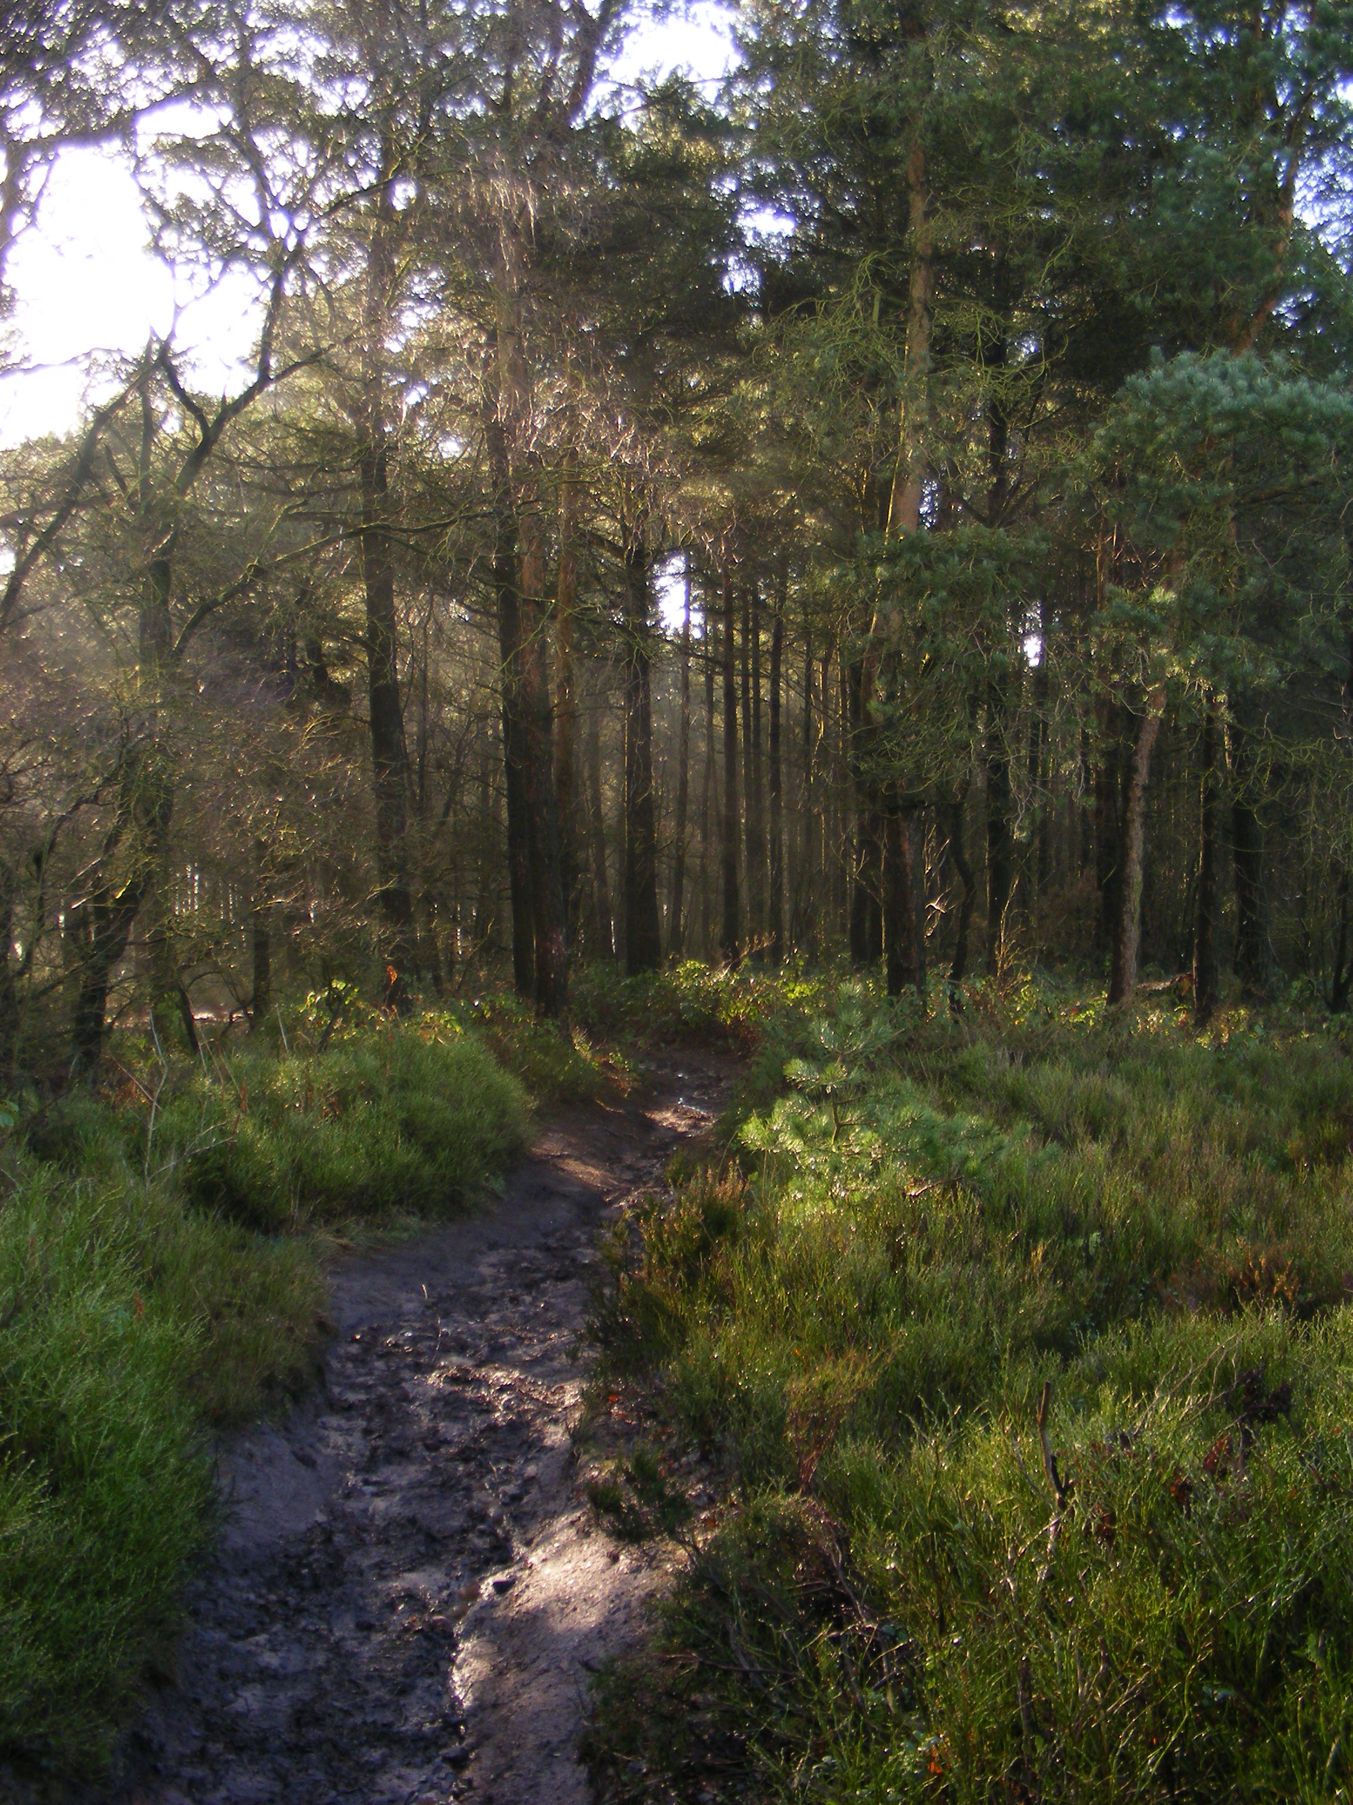
Plan Period 2018 to 2028
5 year Review 2023

No. | UKFS Management Plan Criteria | Approval Criteria | Applicant Check
1 | Forest management plans should state the objectives of management and set out how the appropriate balance between economic, environmental and social objectives will be achieved. | Have objectives of management been stated? Consideration given to economic, environmental and social factors (Section 2.2) | 
2 | Forest management plans should address the forest context and the forest potential and demonstrate how the relevant interests and issues have been considered and addressed. | Does the management strategy (section 6) take into account the forest context and any special features identified within the woodland survey (section 4) | 
3 | In designated areas, for example national parks, particular account should be taken of landscape and other sensitivities in the design of forests and forest infrastructure. | Have appropriate designations been identified (section 4.2) if so are these reflected through the work proposals in the management strategy (Section 6) | 
4 | At the time of felling and restocking, the design of existing forests should be re-assessed and any necessary changes made so that they meet UKFS Requirements. | Felling and restocking are consistent with UKFS forest design principles (Section 5 of the UKFS) | 
5 | Consultation on forest management plans and proposals should be carried out according to forestry authority procedures and, where required, the Environmental Impact Assessment Regulations. | Has consultation happened in line with current FC guidance and recorded as appropriate in section 7 | 
6 | Forests should be designed to achieve a diverse structure of habitat, species and ages of trees, appropriate to the scale and context. | Do the felling and restocking proposals create or improve structural diversity (refer to the plan of operations) | 
7 | Forests characterised by a lack of diversity due to extensive areas of even-aged trees should be progressively restructured to achieve a range of age classes. | Do the felling and restocking proposals create or improve age class diversity (refer to the plan of operations) | 
8 | Management of the forest should conform to the plan, and the plan should be updated to ensure it is current and relevant. | Has a 5 year review period been stated (1st page) and where relevant achievements recorded in section 3 | 
9 | New forests and woodlands should be located and designed to maintain or enhance the visual, cultural and ecological value and character of the landscape. | When new planting is being proposed under this plan is it consistent with UKFS and FC guidance on woodland creation

Contents
1 Background information 5
1.1 Location 5
1.2 Description of the woodlands in the landscape 6
1.3 History of Management 6
2 Woodland Information 7
2.1 Areas and features 7
2.2 Woodland resource characteristics 11
2.3 Site description 11
2.4 Significant hazards, constraints and threats 14
3 Long term vision, management objectives and strategy 17
3.1 Long term vision 17
3.2 Management Objectives 18
3.3 Strategy 18
4 Management prescriptions/operations 20
4.1 Silvicultural systems 20
4.2 New planting 21
4.3 Other operations 21
4.4 Protection and maintenance 21
4.5 Game management 23
4.6 Protecting and enhancing landscape, biodiversity and special features 23

4.7 Management of social and cultural values 23

5 Detailed Management Prescriptions 24
6 Work programme 26
7 Monitoring 27

Bibliography/ references

Appendices  Appendix 1 Compartment Schedule  Appendix 2 Plan of operations | Maps  Map 1 Cloud Compartments  Map 2 Maggoty Compartment and features  Map 3 Cloud Biodiversity  Map 4 Cloud Access  Map 5 Cloud Archaeology  Map 6 Cloud Stand Types  Map 8 Cloud Management

Summary

This woodland management plan covers two National Trust woodland properties; The Cloud near Congleton and Maggoty Wood in Gawsworth. It follows the Forestry Commission template for woodland management plans to ensure it is compliant with the UK Forest Standard and the UK Woodland Assurance Scheme.

The Cloud is a gritstone hill rising to 343m with a steep curving north face and a gentler slope to the south. The summit plateau and parts of the scarp slope are open heathland and grassland whilst the lower slopes are wooded. The National Trust owns 54ha of which 25ha is woodland. This plan covers just the woodland area. Woodland was established shortly after enclosure of former common land in 1831. From 1840 to at least 1912 the whole summit plateau is shown as Cloud Fir Plantation. This was largely felled in the First World War and the current plantation mostly dates from 1960. The southern and western parts of the woodland are mainly broadleaf with oak and birch the dominant species. Several BAP priority bird species breed in the woodland including spotted flycatcher and bullfinch. A number of archaeological features are present.

Maggoty Wood covers just 0.94ha and is a mature broadleaved woodland dominated by beech and oak.
Bluebells are present. The main feature is the Grade 2 listed grave of Maggoty Johnson.

At the Cloud, succession is leading to woodland expansion, loss of heathland species under a developing canopy and the development of a woodland ground flora. Rhododendron is present. Visitor pressure is high and many of the paths are in poor condition. Areas of planted beech have been damaged by grey squirrels.
At Maggoty Wood the main concern is tree safety, although trampling is damaging the ground flora.

Whereas previous proposals have suggested harvesting the Scots pine and returning the Cloud Plantation to heathland with scattered trees, this plan recommends retaining the Scots pine for the long term, allowing the development of old growth characteristics and a more diverse woodland structure. It is also proposed that broadleaf woodland on the steep western and northern slopes be allowed to spread where it will replace habitats of low value. Rhododendron will be eradicated from the whole site. Any future grazing management of the open heathland will avoid damage to the woodland. Archaeological sites will be conserved and protected. Footpaths and countryside furniture will be maintained to a high standard.

At Maggoty Wood, tree safety management will continue. Dead wood will be increased and future veteran trees identified and protected. Measures to prevent trampling of ground flora will be extended and the archaeological feature will be protected.

Background information

Location
 | The Cloud | Maggoty Wood
Nearest town, village or feature | Congleton | Gawsworth
Grid reference | SJ 902 634 | SJ 888 701
Total area (ha) | 24.76 (whole property 54ha) | 0.94

Compartment No | Compartment Name | Area (ha)
C1 | Cat Stones | 4.52
C2 | Cloud Side South | 1.89
C3 | Cloud Plantation | 12.50
C4 | Cloud Side North | 6.01
M1 | Maggoty Wood | 0.94

See Maps 1 and 2 for compartments

©Crown copyright and database rights 2015. Ordnance Survey Licence No AL100023974

Description of the woodlands in the landscape
The Cloud is a gritstone hill lying approximately two miles east of Congleton. It has a steep curving scarp face to the north west and north east, and a more gentle dip slope to the south. The land rises from 200m above sea level on the western boundary to 343m at the summit. The upper part of the hill is covered in dry dwarf shrub heath of heather and bilberry. The lower part is predominantly wooded. Oak-birch woodland has developed on the scarp slope and is spreading into formerly open areas. The lower part of the dip slope is occupied by a Scots pine plantation. The Trust's landholding extends to 54 hectares of which the woodland covers 25ha.The Cloud is partly in Cheshire and partly in Staffordshire but all of the woodland for this plan is on the Cheshire side.

Maggoty Wood is a small strip of mature woodland in the village of Gawsworth two miles south west of Macclesfield. It is dominated by large beech and oak. It lies on the northern side of the Ben Brook valley. Adjacent woodland south Maggoty Lane has recently been acquired by the Parish Council.

Both The Cloud and Maggoty Wood lie within National Character Area 61 The Shropshire, Cheshire and Staffordshire Plain

History of Management
The Cloud
Until 1831, The Cloud was part of Black Heath Common and was presumably kept open by grazing and removal of small wood. The common was enclosed in July 1831. By 1841, a plantation (Cloud Fir Plantation) covered most of the plateau and this is shown on the Ordnance Survey maps up until 1912. The plantation was largely felled in the First World War leaving only the southern area under trees. Replanting took place in the late 1950's to early 1960's.The National Trust acquired the site in 1962

Management carried out since acquisition- thinning of plantation in 1964 and 1981(2004 Biological Survey).
More recent management at the cloud includes: - removal of birch and pine from the heath, some rhododendron removal, bracken control, cutting a fire break on the heath, footpath drainage and repair work.

Maggoty Wood
The wood was acquired in 1935 when the village of Gawsworth was rapidly expanding.
Recent management- mostly tree safety work, thinning of sycamore and Hedgelaying. Protection of areas of bluebells using fenced exclosures has also been carried out.
Woodland Grant Scheme Details
EWGS Ref | Dates | Area | Comps | Details
28873 | 2012-17 | 18.55ha | C1,2,3 | For tree safety work, litter clearance, maintenance of access furniture, path drainage and repair, identification of potential veteran trees and halo thinning, increasing dead wood, controlling rhododendron
28663 | 2012-17 | 0.95ha | M1 | For providing safe, well marked permissive public access, litter clearance, carrying out tree safety inspections and remedial work, identification of potential veteran trees and halo thinning, increasing amounts of dead wood

Woodland Information

Areas and features
Designated Areas | The Cloud | Maggoty Wood
Special Areas for Conservation
Special Protection Area
Ramsar Sites
National Nature Reserves
Site of Special Scientific Interest
National Park
Areas of Outstanding Natural Beauty
Local Nature Reserves
TPO / Conservation Area
Details

County Wildlife Site. Details in Property Office.
The Cloud lies approximately 1 mile west of the Peak District National Park boundary.

Rare and important species | The Cloud | Maggoty Wood
Schedule 1 Birds
BAP Birds | Bullfinch, Cuckoo¹, Curlew,  Dunnock, Lesser redpoll,  Lesser spotted woodpecker²,  Linnet, Song thrush, Spotted flycatcher Woodcock³,  Wood Warbler⁴
BAP Mammals
Bats | Unknown
BAP Reptiles/Amphibians
BAP Invertebrates | See below
BAP Plants | Bluebell (Local BAP) | Bluebell (Local BAP)
BAP Fungi/Lichens
Details
Birds
Notes 1=2013 only, 2=2004 only, 3=probably winter only, 4=2002-3 only. Italics-species recorded on adjacent heathland/farmland

In addition to the BAP species listed for The Cloud, the following Red List/Amber list species have been recorded;
Red List; mistle thrush, ring ouzel, peregrine and merlin (the latter three are one off records- non breeders)
Amber List; Kestrel, Willow warbler, meadow pipit, tawny owl. Nightjar was recorded until about 1984 (2004 Biological Survey)

Records from The Cheshire and Wirral Ornithological Society (CAWOS), except where stated. Data is held at NT Property Office.

Invertebrates
The Cloud supports a number of Nationally Scarce invertebrates;
Hallomenus binotatus False darkling beetle- a wood decay species
Coleophora vitisella -a micro-moth which feeds on cowberry
Lita virgella ( Prolita sexpunctella?) -a micro-moth which feeds on heather
The false darkling beetle is the only NS species found in the woodland, the micro-moths are associated with the heathland.

Bluebell, a Cheshire BAP species occurs in Maggoty Wood and in the semi-natural woodland of Cloud Side (C2, C4). Cowberry, which occurs in the heathland vegetation of the Cloud, is local in Cheshire as it is an upland species. A rare hybrid between cowberry and bilberry Vaccinium x intermedia has been recorded in comp C1. It is only known from one other site in Cheshire (2004 Biological Survey)

See Map 2 Maggoty and Map 3 Cloud biodiversity (from 2004 Biological Survey)

Habitats | The Cloud | Maggoty Wood
Ancient semi-natural woodland (ASNW) |  | ?
Other semi-natural woodland | Yes | Yes
Plantations on ancient woodland sites (PAWS)
Veteran and other notable trees | Yes
BAP Priority Habitats | Upland heathland  Upland oak woodland | Lowland mixed woodland
Details

There is no ASNW on the Inventory however Maggoty Wood may be a small remnant (woodlands of less than 2ha were not included in the inventory)

One veteran pine was noted in Cloud Plantation (2010 NT Survey) with a girth of 310cm. This is at SJ90250 63500 on the edge of the open heathland. (Two other veterans were noted from the property but these are both hedge trees in fields to the north). There are no veteran trees at Maggoty Wood but several trees which will be veterans in the near future.

See Map 3 Cloud biodiversity (from 2004 Biological Survey)

Water | The Cloud | Maggoty Wood
Watercourses
Lakes
Ponds
Wetland habitats
Details
There are no watercourses, ponds or wetlands at either site

Landscape  ©Crown copyright and database rights 2015. Ordnance Survey Licence No AL100023974 | The Cloud | Maggoty Wood
Landscape designated areas
Landscape features
Rock exposures | Yes
Historic landscapes
Details
The Cloud has extensive exposures of Chatsworth grit which form low cliffs along the top of the scarp slope. Within the woodland compartments, the rock is exposed in a number of old quarries.

Cultural features | The Cloud | Maggoty Wood
Public rights of way | Yes
Prominent viewing points | Yes
Existing permissive footpaths | Yes | Yes
CROW Access land | Yes
Public recreational facilities
Visitor information |  | Yes
Details
The Cloud - two public footpaths cross the site. One follows the ridge from Gooseberryholme Lane to Cloud Side and forms part of the Gritstone Trail and Staffordshire Way. The other follows the southern boundary and forms a circular walk with the other footpath. All other paths on the Cloud are permissive. The open heathland and part of the woodland (19.62ha) is designated CROW Access land. See Map 4 Visitors park on the roadside or in the Cheshire County Council car park in Timbersbrook.

A permissive footpath runs the length of Maggoty Wood. It appears to be well used by local people. There is a visitor information board at the entrance to the wood and transcripts of the grave inscriptions.

Archaeological Features | The Cloud | Maggoty Wood
Scheduled monument
Unscheduled monuments | Yes
Registered parks and gardens
Listed buildings |  | Yes
Other
Details

The Cloud
There are 24 archaeological features on the NTSMR ranging from Bronze age barrows to a WW2 crash site. A number of these are within the woodland compartments. See Map 5 and individual compartment descriptions for details.

Maggoty- The tomb of Samuel 'Maggoty' Johnson's is a Grade 2 listed structure. See Map 2

Woodland resource characteristics
Stand Type | Cloud |  | Maggoty
 | Area (ha) | % | Area (ha) | %
Broadleaf | 9.13 | 37 | 0.94 | 100
Mixed conifer/broadleaf | 3.10 | 12
Conifer | 11.63 | 47
Open ground | 1.06 | 4
Total | 24.92
See Map 6 for stand types (Cloud only) and Appendix 1 for Compartment Schedule.

Site description
The Cloud
C1 Cat Stones 4.52ha
©Crown copyright and database rights 2015. Ordnance Survey Licence No AL100023974

This is the southernmost part of the National Trust's landholding and is bounded to the south by Gooseberryholme Lane. It is predominantly broadleaved woodland of semi-mature birch and oak with occasional sycamore with an understorey of rowan and holly. The ground flora is mainly bracken, bramble, broad buckler fern and ivy with occasional bilberry. The southern end of the compartment is dominated by a series of old quarries which are now wooded and provide habitat for bullfinch and spotted flycatcher (2004 Biological Survey). A small area at the entrance off Gooseberryholme Lane was planted with beech, pedunculate oak, rowan, hybrid larch and red oak in the 1970's. The beech (approximately 30 trees) are now 30cm DBH, 16m tall , have a closed canopy with little growing beneath. They have been damaged by grey squirrels. Open areas have bushy heather and bilberry and oak is regenerating here. A rare hybrid between bilberry and cowberry Vacciniuim x intermedium was recorded in this compartment in 1972 and again in 1985.Rhododendron is frequent. Archaeological features include the old quarries (NTSMR 51900, 52901), old boundary walls (NTSMR 51911, 51912, 51916) and a building platform and gate stoops (NTSMR51914), Vantage point (NTSMR 51913) and mound (NTSMR51915).
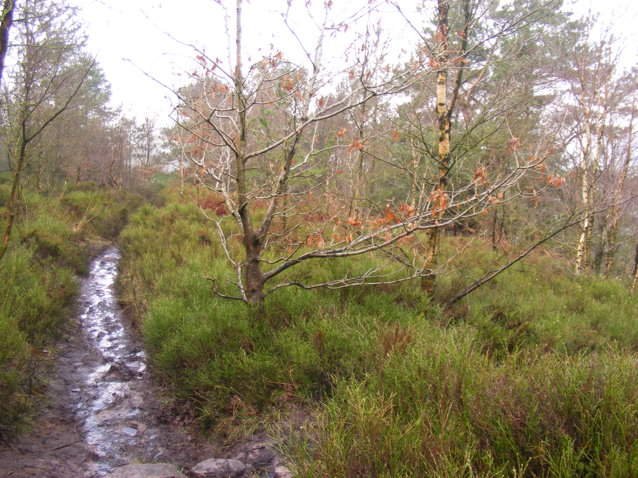

Photo 1 Open area compartment C2
C2 Cloud Side South 1.89ha
This compartment occupies the steep west facing scarp slope with the public footpath forming its eastern boundary. The woodland is a mix of Scots pine, and birch with occasional oak over bracken and bramble with some bilberry. Bluebell is occasional (2004 Biological Survey).There are no very old trees but the wood has a good mix of age classes present. Open glades have dense bilberry and bracken and frequent naturally regenerating birch, oak and Scots pine. Rhododendron is present. No archaeological features have been found.

C3 Cloud Plantation 12.50ha
This is a Scots pine plantation with two age classes present. The bulk of the plantation is P1960 with an average tree diameter of 31cm and height of 18m. The plantation appears to have been thinned and has a basal area typically around 40. In the north eastern corner is an area probably planted at the same time but unthinned. The average diameter here is 21cm (height 17m) with a basal area of 52-62m²/ha and a Yield Class 8. An area near the southern boundary appears to be an older age class (see photo 2). The trees are larger, with average diameter of 40cm, height of 19m and a basal area of 42. There are occasional mature broadleaves scattered through the plantation including oak (40cm dbh) rowan and birch with one or two red oak. There is a line of mature oaks along the southern boundary. Gaps in the canopy are colonised by birch. Throughout the wood, the ground flora is dominated by bracken, bramble and broad buckler fern, however bilberry survives in places, and cowberry is also occasional. Along the northern edge, the woodland has a long sinuous boundary with the open heathland although the transition between the two habitats is abrupt. Rhododendron is present. Archaeological features include a series of banks, ditches and mounds previously interpreted as a hill fort but now thought to be an old field system(NTSMR 51904,51906 ,51907,51917,51918) ,and a boundary stone (NTSMR 51902).
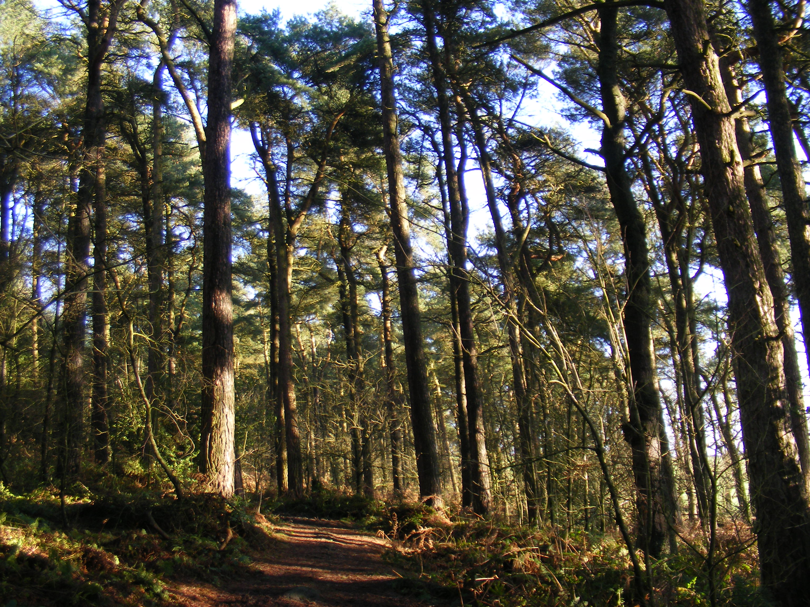

Photo 2 Larger pines, compartment C3

C4 Cloud Side North 6.01ha
This new compartment is recent secondary woodland on a steep west facing slope. The closed canopy is dominated by birch (P1970-present) with an understorey of holly and Rowan. The woodland has a diverse structure and good mix of age classes. The top of the slope is dominated by mature (P1930) Scots Pine. The ground flora is predominantly bracken, bilberry, cowberry, broad buckler fern and mosses. There is frequent rhododendron. The woodland is gradually colonising open ground and expanding northward. An area inside a dilapidated fence within the compartment may or may not be grazed. North of this compartment the birch is becoming established on the open ground of the lower slopes (P1990-present), but this is not included in the current plan. Bullfinch and song thrush noted in 2004 Biological Survey.

M1 Maggoty Wood 0.94ha
The wood is dominated by P1900 oak and beech with occasional European larch, sycamore and common lime. There is an understorey of holly with beech seedlings and saplings. The ground flora is sparse due to dense shading and trampling but patches of bramble and bluebells occur. Two areas have been fenced to protect the bluebells and ground flora. There are no veteran trees (NT 2010 survey) but there are several potential veterans including an oak with girth of 305cm (tag no 00635). The largest beech has a girth of 400cm. A holly hedge runs along the southern roadside boundary. The only archaeological feature is the grave of Samuel
'Maggoty' Johnson which is Grade 2 listed. Recent work has included major tree surgery to trees along the northern boundary where limbs were threatening to damage property. There is some dumping of garden waste in the wood and some den building.
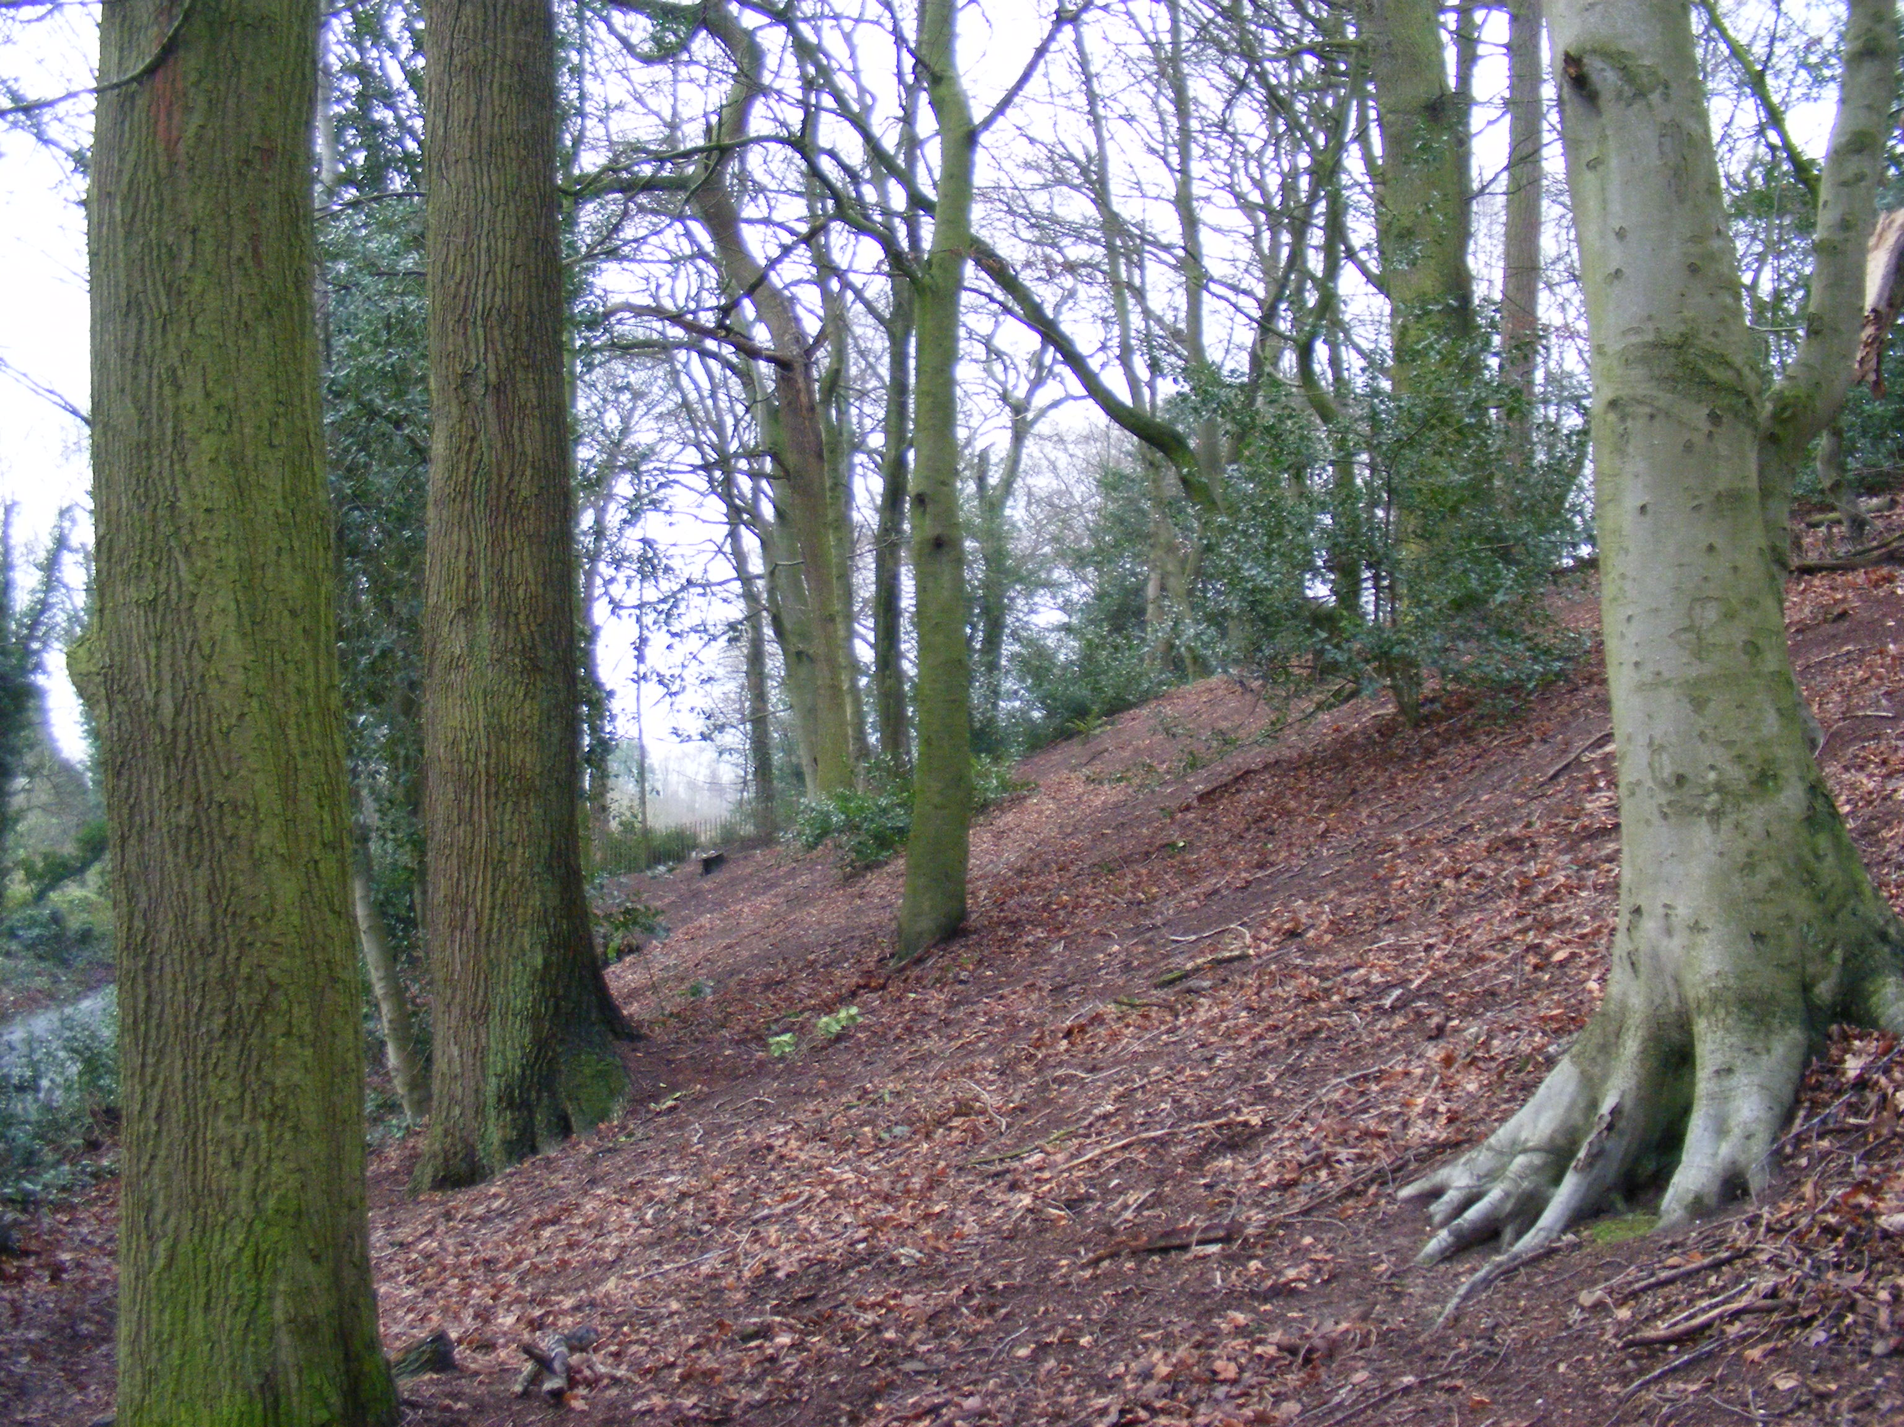

Photo 3 Maggoty Wood

Constraints, threats and opportunities

Succession
Woodland cover on the Cloud is expanding, particularly on the western flanks. This can be seen as is both an opportunity and a threat. On the one hand it is an opportunity to extend the semi-natural woodland into areas which currently have low value for wildlife such as species poor grassland or dense bracken stands. On the other hand it may threaten areas of high value open heathland and its associated wildlife.

Within the woodland area, canopy closure and accumulating needle/leaf litter eventually leads to the loss of heathland species such as heather and bilberry, the development woodland soils and a more typical woodland flora of bramble and buckler fern. In parts of the site which have been wooded for many years this process is well advanced and soils have been altered to such an extent that it is unclear whether heathland species would be capable of recovery. In some areas, clearance of trees may lead to bracken becoming dominant with little wildlife gain.

As the woodland matures it will have an increasing value for wildlife, particularly wood decay invertebrates, breeding birds, bats etc.

Management of Adjacent Areas
Any proposal to introduce grazing management to the open areas of The Cloud may have a detrimental impact on the woodland. Regular access by farm vehicles, poaching by livestock especially where concentrated around watering or feeding points will damage soils and footpaths, and browsing may retard natural regeneration. Grazing within the woodland areas is not desirable, thus any grazing of the heathland would require fences to be erected.

Visitors
The Cloud is well known and loved by local people. The open views from the plateau across Cheshire and to the Pennines are the reason many visitors come, and these could ultimately be lost if tree cover was greatly expanded. However, the woodland is also an important element of the visitor experience, and any attempt at large scale tree removal is likely to be highly unpopular. Public interest in Trust activities is high and the reaction to any management may be negative unless the work is clearly explained and justified.

1.2 million people live within 20km of the Cloud (Office for National Statistics). Trampling is confined to paths, some of which are very wide and muddy. Disturbance caused by dogs off leads may result in reduced numbers of ground nesting birds.

Additional threats include fires, anti-social behaviour and mountain bikes.

Public Safety
The proximity of roads and properties mean that tree safety is a major concern at Maggoty Wood. Annual assessments, tree surgery and felling have a large resource implication for the Trust, both in terms of staff time and cost of contractors. As trees reach maturity, this is likely to increase. Soil compaction, the presence of grey squirrels and tree diseases are all likely to contribute to this.

Access for Management
Gooseberryholme Lane is not within the Trust's ownership at The Cloud (although presumably there is a right of access with vehicles) and there is no roadside stacking area for timber. On site, vehicular access is difficult. Compartments C2 and C4 Cloud Side are very steep and rocky, making management here difficult and dangerous.

Maggoty Wood is so small that vehicular access is not an issue.

Environmental conditions
Cloud Side and Cloud Plantation are exposed to the prevailing winds, and the upper part of the plantation is approximately 300m (1000ft) above sea level. The soils are thin and acidic (pH 4.5). Both of these factors will affect the type of vegetation and tree growth. The Scots pine is yield class 8 which is relatively low. Exposure may make the woodland prone to wind throw following thinning or group felling.

Resources
Both the Cloud and Maggoty Wood are managed from the National Trust’s Alderley Edge office. The Trust has two full time staff to cover Alderley Edge and both of these sites, plus 8-10 conservation volunteers and a volunteer safety patrol.
At The Cloud, any income from timber harvesting is likely to be small due to poor access and low quality of the timber (only really suitable for chip). The costs of repairing damage caused by harvesting and extraction are likely to mean any such project will not be cost effective.

Plant diseases
Dothistroma septosporum Red Band Needle Blight is now established throughout the British Isles (see http://www.forestry.gov.uk/PDF/fcrn002.pdf/$FILE/fcrn002.pdf). It has been found on a range of conifer species, especially Corsican and lodgepole pine and, to a lesser extent, Scots pine. Whilst Scots pine has generally been considered to be of low susceptibility, an increase in the distribution and severity of the disease on this species is now being seen. It weakens the tree, reduces productivity and vigour and eventually leads to mortality. Dispersal is thought to occur through moist winds and mist along with the movement of infected material. Scots pine is a major constituent of the woodlands and landscape at The Cloud and an outbreak of Dothistroma could have a serious consequences.

Invasive non native plants
Rhododendron is present at The Cloud in all woodland compartments and on the adjacent heathland. It has not been mapped and its extent is unknown.

There is no rhododendron at Maggoty Wood, however introduction of invasive non native species is a potential threat here due to the proximity of gardens and the dumping of garden waste.

Grey squirrels
The presence of grey squirrels will affect the choice of future tree species at both sites. Beech is unlikely to produce trees of good form and stature in the future unless grey squirrels are constantly controlled. Bark damage is likely to increase risk of failure and have implications for public safety.

Climate change
Natural England has identified possible threats to semi-natural woodland posed by climate change. Warmer winters may allow the expansion in distribution of many tree pests and diseases, as well as increasing the over-winter survival of mammals such as grey squirrel and deer. An increase in the frequency of storm events is likely to lead to more regular disturbance of the woodland canopy which may change the species composition. Increased occurrence of summer drought will lead not only to tree stress, but also to loss of humid conditions for bryophytes and increased fire risk. See Natural England and RSPB 2014. Historic England has also produced a document outlining the possible consequences of climate change for the historic landscape. See Historic England (2008).

Lack of knowledge
The Trust does not appear to have any detailed up to date information about biodiversity on the sites and this may mean that woodland operations inadvertently damage important features.

Bats, badgers and birds
All bats are European Protected Species. Damaging or destroying a breeding or resting place is an offence regardless of whether the act was deliberate or reckless. Any work which may disturb bat roosts requires a licence from Natural England. Badger are also protected by law and work near a badger sett may require a licence. Woodland work should avoid the bird breeding season (April-Aug).

Long term vision, management objectives and strategy

Long term vision (2066)

The mature mixed woodlands at The Cloud are valued for their wildlife as well as being a popular area for quiet recreation. The Cloud Plantation is starting to develop the characteristics of an old growth Scots pine forest, with birch and oak increasing through regeneration in natural gaps in the canopy, abundant standing and fallen dead wood, and glades with bilberry, cowberry and heather. The steep western slopes are clothed in broadleaved woodland with oak and birch the main canopy species. A wide range of age classes are present here and the woods support a good assemblage of breeding birds including redstart, willow warbler and spotted flycatcher. Rhododendron and other non-native invasive species are absent. Visitors use well maintained paths through the woods to access the open heathland at the top of the escarpment with its extensive views of Cheshire, Staffordshire and the Peak District.

Maggoty wood is a mixed native broadleaf woodland with multiple age classes and a diverse understorey. There is abundant standing and fallen dead wood. Paths are well maintained, erosion and trampling is minimal and there is a rich ground flora with an impressive display of bluebells in the spring.

Management Objectives

- Protect and enhance biodiversity of woodlands and open habitats
- Ensure the woodlands are resilient to climate change and plant diseases
- At the Cloud ensure the balance between woodland and heathland is managed sustainably
- Encourage safe and sympathetic public access
- Protect cultural and historical features
- Seek appropriate opportunities to offset the costs of management
- Manage the woodlands in accordance with UKWAS and the UK Forest Standard

Strategy
- Protect and enhance biodiversity of woodlands and open habitats
a) At The Cloud retain the mature Scots pine for the long term
b) Identify and conserve current and future veteran trees
c) Actively increase amounts of dead wood
d) Eradicate non native invasive plant species
e) Use opportunities provided by natural processes (such as storms) in management
f) Time forestry operations to avoid the bird breeding season
g) Maintain areas of low disturbance
h) Carry out surveys for plants, birds, bats, invertebrates etc and ensure results inform management

- Ensure the woodlands are resilient to climate change and plant diseases
a) Reduce the impact of other pressures on woodland and other habitats e.g. trampling, grey squirrel damage, effects of adjacent land use.
b) Increase structural heterogeneity in the woodland
c) Maintain a diverse range of native and near native tree species
d) Favour natural regeneration over planting where possible, but where planting is required, use locally grown native tree species
e) Identify and conserve refuge areas

- At the Cloud ensure a balance between woodland and heathland is managed sustainably
a) Identify and maintain areas of important heathland (outside the woodland)
b) Allow no further encroachment of The Cloud Plantation (compartment 3C) onto the heathland area
c) Allow the continued natural expansion of woodland around the lower western and northern flank of the escarpment
d) Identify key views and ensure they are maintained by the selective removal of individual trees and scrub.
e) Within the woods identify and maintain remnant areas of heathland
f) Ensure that the management of the open heathland does not impact on the extent and integrity of the woodland

- Encourage safe and sympathetic public access
a) Manage woodland primarily for quiet enjoyment and limit other activities to designated areas
b) Maintain quiet areas with low disturbance
c) Implement path improvements to reduce erosion and trampling
d) Restrict the use of mountain bikes.
e) Carry out regular patrols
f) Undertake regular tree safety inspections and carry out work appropriate to the risk zone
g) Recruit, involve and support volunteers

- Protect cultural and historical features
a) Remove trees from archaeological sites as directed by the Regional Archaeologist
b) Consult Regional Archaeologist before undertaking works which may impact on historic features and ensure protective measures are in place during operations.

- Seek appropriate opportunities to offset the costs of management
a) Maximise income from grants
b) Seek to utilise timber grown on the properties for infrastructure where feasible

- Manage the woodlands in accordance with UKWAS and the UK Forest Standard
a) Comply with statutory requirements
b) Keep up to date records of management, monitoring etc
c) Follow guidance in all operations (e.g. protection of watercourses, use of pesticides, felling and restocking etc)

Management prescriptions/operations

Silvicultural systems
Prior to any major works or activities taking place a separate more detailed “Operations Site Assessment” will be drawn up. This assessment will demonstrate that the activities will not have any detrimental impact and will follow habitat regulations. The Operations Site Assessment will follow Forestry Commission guidelines and format (see appendix).

4.1.1. Harvesting
The 2004 Biological Survey recommended that the Cloud Plantation (compartment 3c) should be removed when mature or economically viable to allow dwarf shrub heath to return with scattered trees/light woodland. Most of the pine is 55 years old (but some older stands are present) and in a commercial plantation harvesting would be expected to take place within the next 10-30 years. It is estimated that there is currently about 3000 m³ of standing timber in this compartment. At yield class 8 this could be expected to increase to 4000 m³ by 2026, or 7000 m³ by 2046

Difficult access, the high risk of soil erosion, damage to archaeology and public rights of way, and public perception all suggest that harvesting Cloud Plantation would be inappropriate. It is also unclear whether the objective (light woodland cover with dwarf shrub heath) could actually be achieved by felling the Scots pine.

No harvesting is therefore proposed. Instead the plantation will be allowed to progress towards an old growth type rich in older trees and dead wood habitats. Interventions may be required to maintain existing heathland vegetation (See 4.1.2) and to prevent unwanted species becoming established (see 4.4.1).

At Maggoty Wood tree felling will only be carried out for safety reasons.

4.1.2 Phased felling and restructuring of plantations
Within Cloud Plantation, the unthinned stand of P1960 Scots pine (3.74ha) will be thinned and respaced to maintain areas of remnant heath, allow the remaining trees to reach their full potential and create small gaps to encourage natural regeneration of native broadleaves. This will produce approximately 300m³ of timber and will be phased over the 10 years of the plan (extraction is not recommended). Timber and brash will be stacked to reduce shading and encourage regeneration of dwarf shrubs. Care will be taken to ensure that this thinning operation is centered on areas of remnant heath. The Intensity of thinning and the management of light levels in the stand should ensure that bracken is continually suppressed.

In Compartment C1(The Cloud) beech will be thinned from the P1970 mixed broadleaf plantation(0.25Ha) to convert it to a more native stand type.

4.1.3 Establishment, restocking and regeneration
Natural regeneration will be favoured wherever possible.

New planting
No new planting is proposed in this plan

Other operations
All boundaries including walls and fences of all woodlands should be maintained in good condition. Regular inspection and repair of boundaries will be carried out.

Protection and maintenance

4.4.1 Pest and disease management

Red Band Needle Blight. Dothistroma
The conditions that allow this disease to establish can be avoided by the thinning of dense closed canopies, and diversifying the species present. Both of these actions are being proposed for the Cloud.
see http://www.forestry.gov.uk/dothistromaneedleblight and http://www.forestry.gov.uk/pdf/DNBStrategy11-04-2012.pdf/$FILE/DNBStrategy11-04-2012.pdf
If the Scots pine at the Cloud becomes infected, the objectives of the management plan will need to be reviewed.

Invasive non-native species
At the Cloud the extent of rhododendron will be properly mapped to enable the Trust to take a strategic approach to its removal. This should include an assessment of the slope and the height of the bushes to assist in the application for FC stewardship grant. Up to £4,400/ha is available. The priority will be removal from areas of open heathland and native woodland (C1, 2 and 4). Within C3 Cloud Plantation, the priority will be the upper edge of the wood where rhododendron is likely to seed onto the open heathland, and open areas of heathland within the plantation. Within the timescale of this plan (10 years) it will be eradicated from the site.
See also 4.4.4 Pesticide Use

Staff will remain alert to potential new introductions (e.g. from garden waste) and will take appropriate action where needed.
.
4.4.2 Fire plan
The National Trust has a basic fire plan.

4.4.3 Waste disposal and pollution
- Comply with COSHH regulations. See also 4.4.4 Pesticide Use
- Storage of fuel – See FC Forestry and water guidelines.
- Burning of lop and top should only occur if no alternative available. On peaty and fragile soils this will be burned on steel sheets supported off the ground. Fires will not be started on bare rock surfaces. Ash will be disposed of away from sensitive habitats
- Emergency Pollution control. A contingency plan will be drawn up to deal with accidental spillages.- (See FC Forestry and Water Guidelines)
- Old fencing wire, posts and plastic tree shelters these will be collected removed from site and disposed of appropriately
- All wastes will be disposed of to reputable and licensed waste disposal contractors.
- Biodegradable chain oil will be specified for all users on National Trust Property
- Contractors with machinery will be required to have anti-spill oil clean-up kits on site at all times with their machines.
- Suitable refuelling and overnight parking points will be discussed and marked on a map with the site risk assessment, to avoid sensitive areas such as proximity to water bodies or particularly sensitive ground vegetation.

4.4.4 Pesticide Use

- Pesticide use will be minimised. Users of pesticides will take all precautions to protect the health of humans and safeguard the environment and avoid the pollution of water.
- It will be ensured that pesticides are stored, used and disposed of responsibly and sustainably
- The responsible and sustainable use of herbicides will only be one element in the effective control on non-native invasive plants
- One method of herbicide reduction will be the direct targeting of key areas for control for non-native invasive plants.
- Where chemical control is the only option use will be minimised either by the application of herbicide on freshly cut stumps or direct injection into the rootstock. The regrowth is considerably easier to treat than full grown bushes, requires less herbicide and is much more responsive to chemical treatment. This will also reduce the risk of spray drift affecting the environment and the operator. The removal of foliage also has the added benefit of removing the seed source.
- Young seedlings will be eradicated as soon as they establish preferably by hand, before they have a chance to spread. It is easier to control small seedlings by hand than large bushes.
- Pesticide application will take careful consideration of buffer areas, weather and ground conditions and the risk to water supplies.
- Care and precautions will be taken to avoid herbicide drift and accidental spraying of any other vegetation.
- Contractors and staff shall clearly understand and implement precautions, environmental protection plans, protocols and emergency procedures.
See Reducing Pesticide Use in Forestry. FC Practice Guide 2004

4.4.5 Protection of other identified services and values
Soils
- Soils will be protected and enhanced in terms of physical, chemical and biological properties
- Property and woodland activities will be planned and managed in order to avoid damage to the soil structure and function. If damage does occur, reinstatement work will be undertaken.
- Timing of operations will be flexible to take into account the season and weather. Dry soils have a greater bearing capacity than wet soils. Operations will be monitored and modified, postponed or stopped if degradation starts to occur.
- Features of historic, cultural or biological value will be identified and protected. The visual impact of tracks will be minimised by blending with landforms and respecting the local character of the landscape. Track surfaces and drainage will be designed to avoid erosion and soil compaction and minimises the risk of water pollution. Materials used will be neutral or inert and in keeping with the property and the ecology of the woodland and other habitats. Base rich ballasts will be avoided. .

Game management
There is no game management on these properties

Protecting and enhancing landscape, biodiversity and special features

4.6.1 Management of designated areas
There are no designated areas

4.6.2 Measures to enhance biodiversity and other special features [UKWAS 2.1.1/6.1.1]
See 3.3 Strategy and 5 Compartment Prescriptions.

Surveys monitoring and records
Biological information is currently rather sparse for both The Cloud and Maggoty Wood. Surveys and monitoring for breeding birds, bat roosts in trees, invertebrates of dead wood and open ground should be carried out. Cheshire Wildlife Trust has been commissioned to carry out zoological surveys in 2016. Opportunities to increase knowledge of other groups e.g. lichens, fungi, lepidoptera will also be encouraged. Existing records will be collated and updated regularly and be readily available to help inform and guide management decisions.

4.6.3 Special measures for ancient semi-natural woodland (ASNW) and semi-natural woodland (SNW)
No ASNW present at either site. Special measures for semi-natural woodland -see 5 Compartment Prescriptions

4.6.4 Special measures for plantation on ancient woodland site (PAWS)
No PAWS present at either site

4.6.5 Measures to mitigate impacts on landscape and neighbouring land [UKWAS 3.1.2]
Contact and dialogue will be maintained with neighbours as necessary to ensure that any management and tree felling take in to account their plans for neighbouring land uses.

Management of social and cultural values

4.7.1 Archaeology and sites of cultural interest
Archaeological features will be protected during all forestry and arboricultural operations. Staff, volunteers and contractors will be made aware of the location of archaeological sites and these will be marked on the ground prior to any works. In addition, many of the features will require ongoing conservation work such as tree removal. This work will be directed by the Regional Archaeologist.

4.7.2 Public access and impacts on local people

Restoration of the central path through the woodland to the Cloud summit will be carried out including proper drainage and surfacing. Measures will be taken to restrict the use of mountain bikes through partnership with Congleton mountain bike club and a network of licensed routes.

Parish Councils and relevant organisations will be fully consulted at the planning stage of any major operation. Timing of operations will take account of visitor levels. The public will be kept informed of major management works and forestry operations through temporary on-site signage prior to operations. It is unlikely that public footpaths will be damaged by the proposed forest operations

An annual ongoing programme of roadside and property tree safety surveys will aim to ensure the safety of people and property on or passing near to the National Trust Property. Woodland furniture such as signs, waymarkers and path surfaces will require regular maintenance. All woods will be managed to a high standard demonstrating the National Trust’s care for the countryside. Where possible the Trust will seek to support local employment. Volunteers will be actively encouraged to participate in the monitoring, management and maintenance of the Cloud and Maggoty Wood.
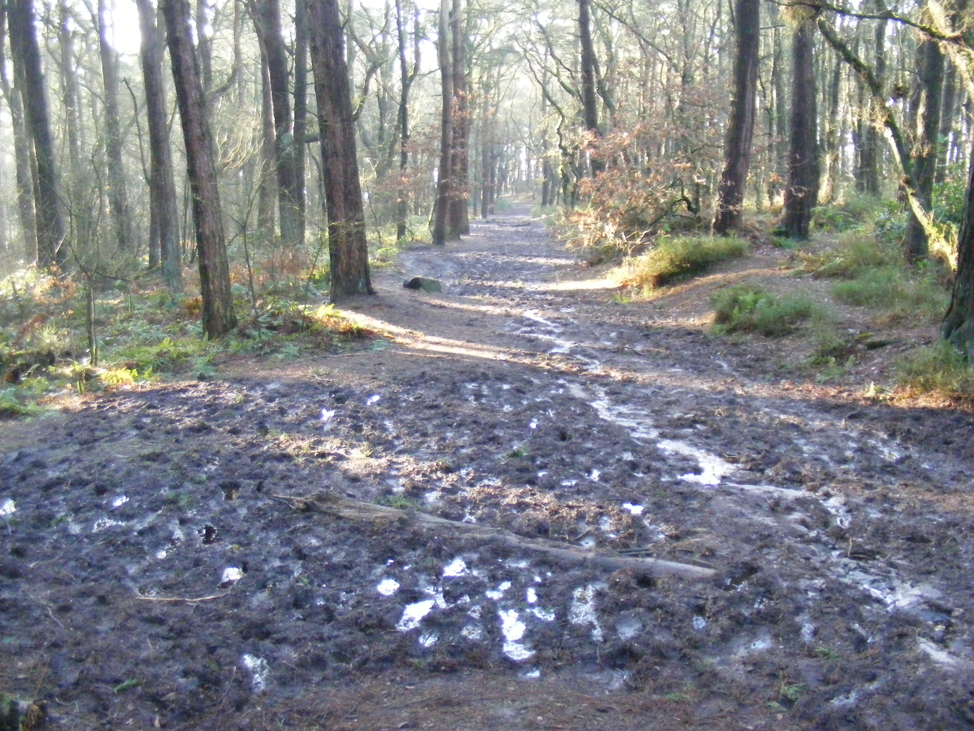

Photo 4 Main path to summit, Jan 2016

5. Compartment Prescriptions
See Maps 7 and 8
C1 Cat Stones.
The woodland in this compartment will be allowed to progress naturally to native stand types appropriate to the soils and location but areas of open heath will be retained. Rhododendron will be eradicated The shade bearing beech in the P1970 mixed broadleaf stand (0.25ha 30 trees) and occasional hybrid larch will be thinned out from the stand in order to release the oak, encourage the recovery of the ground flora and allow the establishment of natural regeneration of native species and the next generation of trees. The re-establishment of beech will be discouraged. Large stems and branch wood will be left in situ to increase the dead wood volumes. Track surfaces will be maintained and the entrance gate replaced.

C2 Cloud Side South and C4 Cloud Side North
These areas will progress naturally to native stand types appropriate to the soils and location but areas of open heath will be retained. Rhododendron will be eradicated. The woodland will continue to be allowed to establish the lower slopes where this does not conflict with other conservation objectives for the property.

C3 Cloud Plantation
The dense stand of P1960 Scots pine at the eastern end of the compartment (3.74ha-see map) will be thinned. This work will not be carried out in a single operation but phased over several years. Within this stand the priority for thinning will be areas which retain dwarf shrubs in the ground flora to prevent them being shaded out. The next priority will be the halo thinning of native broadleaves especially oak. The objective is to reduce the basal area of the stand to approximately 25m²/ha by the end of the 10 year period of this plan. Timber will be used on site or left in situ to increase the dead wood volumes. Care will be needed to ensure that timber stacks and brash does not smother the dwarf shrubs.
Elsewhere in this compartment, little intervention is required. Natural processes such as gap creation and the establishment of native broadleaf natural regeneration will be encouraged. Fallen and standing dead wood will be retained.

The current boundary of woodland will be identified on ground using markers/GPS waypoints. These markers will assist in the management of the heathland ensuring that there is no further encroachment of the woodland onto the open plateau. The sinuous boundary of the woodland and heathland will be maintained.

Rhododendron will be eradicated from the whole compartment.

M1 Maggoty Wood
Tree safety inspections and subsequent remedial works especially along the roadside and adjacent to housing is a high priority for this woodland. The National Trust will follow best practice by retaining hulks and large fallen dead wood for example.

Measures to prevent soil erosion, compaction, trampling and to encourage natural regeneration and the re-establishment of the ground flora will be extended and maintained.
Beech natural regeneration will be monitored and controlled where necessary to favour native species including oak, birch, hawthorn and rowan.
The site will be patrolled for litter and fly tipping, especially garden waste.

6 Work programme
Cpt no | Activity | Year
Cpt no | Activity | 1 | 2 | 3 | 4 | 5 | 6-10
C1-4 | Map extent of rhododendron (including on heathland) | 
 | Commission and carry out surveys and monitoring for birds, mammals, invertebrates, vegetation etc |  |  |  |  |  | 
 | Implement measures to restrict mountain bike use to licensed routes |  |  |  |  |  | 
C1 | Monitor and control beech saplings |  |  | 
 | Thin out beech/larch/red oak from P1970 mixed broadleaf stand and encourage natural regeneration. |  |  | 
 | Replace gate entrance and maintain footpath surfaces and drainage | 
 | Eradicate Rhododendron |  |  |  |  | 
 | Maintain areas of open heathland |  |  |  |  |  | 
C2,C4 | Eradicate Rhododendron |  |  |  |  | 
 | Maintain areas of open heathland |  |  |  |  |  | 
C3 | Thin dense P1960 Scots pine stand |  |  |  |  |  | 
 | Eradicate Rhododendron |  |  |  |  | 
 | Track repair, surfacing and maintenance |  |  |  |  | 
 | Install marker posts and map edge of heathland | 
M1 | Extend fenced areas to protect soils and ground flora |  |  |  | 
 | Tree safety inspections and remedial works | As per TSM schedule
 | Patrols for litter and fly tipping |  |  |  |  |  | 

7 Monitoring

Management Objective/Activities | Indicator of Progress/ Success | Method of Assessment | Frequency of Assessment | Compartment | Assessment Results
Thinning of Scots pine | Health/ extent of dwarf shrub heath. Basal area. | Visual inspection. Mensuration | Ongoing | C3 | Determines level of thinning regime.
Control non native invasive species. ALL | Absence of  Rhododendron and other species | Visual inspection | Annual | C1-C4, M1 | Pull up/treat regrowth with herbicide
Beech seedling/sapling removal. | Absence | Visual inspection/mapping | Ongoing | C1 | Establish phased programme of removal by sub compartment
Natural regeneration | Seedlings and saplings stocking density assessment | visit | all | C1 | To measure success of silviculture and determine to restock by planting or if natural regeneration not adequate
Maintenance of adjacent heathland and viewpoints | Absence of trees and scrub | Visual inspection | Ongoing | C1-C4 | Control of scrub and trees on heath

8 Stakeholder Engagement
Individual/ Organisation | Date Contacted | Date feedback received | Response | Action
National Trust Archaeologist | 09/02/16 | 02/03/16 | Recommended changes to draft | Included recommendations
National Trust Ecologist | 09/02/16 | 09/03/16 | Recommended changes to draft | Included recommendations
National Trust Forestry Advisor | 09/02/16 | 09/03/16 | Recommended changes to draft | Included recommendations
National Trust Cheshire Properties Staff | 09/02/16 | 09/03/16 | Recommended changes to draft | Included recommendations

Bibliography/References

Eaton M et al. 2015. Birds of Conservation Concern 4. Available from
http://www.bto.org/science/monitoring/psob

Forestry Commission. 2011. UK Forest Standard. Available from
http://www.forestry.gov.uk/pdf/FCFC001.pdf/$FILE/FCFC001.pdf

Forestry Commission. 2005. Woodland Management for Bats. Available from
http://www.forestry.gov.uk/pdf/woodland-management-for-bats.pdf/$FILE/woodland-management-for-bats.pdf

Forestry Commission. 2011.Forestry and Water Guidelines. Available from
http://www.forestry.gov.uk/pdf/FCGL007.pdf/$FILE/FCGL007.pdf

Heritage England. 2008. Climate Change and the Historic Environment. Available from http://www.historicengland.org.uk/images-books/publications/climate-change-and-the-historic-environment/

Jenkins T, Gilbert J, Mackie E and Matthews R. 2012. Tree Species-A document listing the tree species included in the 2011 Production Forecast. Forestry Commission.

Marzano M and Dandy N. 2012. Recreational use of Forests and disturbance to wildlife- A literature review. Forestry Commission FCRP 020. Available from
http://www.forestry.gov.uk/pdf/FCRP020.pdf/$FILE/FCRP020.pdf

Matthews R W and Mackie E D. 2006. Forest Mensuration-A handbook for practitioners. Forestry Commission. Edinburgh

Mayle B, Ferryman M and Pepper H.2007. Controlling Grey Squirrel Damage to Woodlands. FC Practice note 4. Available from http://www.forestry.gov.uk/pdf/fcpn004.pdf/$FILE/fcpn004.pdf

Natural England. 2014. Climate Change Adaptation Manual. Available from http://publications.naturalengland.org.uk/publication/5629923804839936

National Trust 2004 Conservation Evaluation Congleton The Cloud . Internal report

Symes, N and Currie, F. 2007. Woodland Management for Birds; a guide to managing declining woodland birds in England. RSPB/Forestry Commission

UK Woodland Assurance Standard 2013 United Kingdom Woodland Assurance Standard 3.1. Available from
http://ukwas.org.uk/wp-content/uploads/2012/05/UKWAS-Third-Edition-version-3.1-20122.pdf

