Woodland Management Plan

To be completed by the plan author:
Woodland or Property name | North Lakes – Buttermere Valley Woodlands

Woodland Management Plan case reference
The landowner agrees this plan as a statement of intent for the woodland |  | Yes
Plan author name | Maurice Pankhurst

For FC Use only:
Plan Period  (dd/mm/yyyy - Ten years) | Approval Date: |  | Approved until:

Five Year Review Date

Revision No. | Date | Status (draft/final) | Reason for Revision
Template user support:
The functionality in this version of the management plan template has been downgraded to ensure compatibility with Word 2003. This document is not protected and as such rows can be added & deleted or copied and pasted from tables where needed.

UK Forestry Standard management planning criteria
Approval of this plan will be considered against the following UKFS criteria.
Prior to submission review your plan against the criteria using the check list below.
UKFS management plan criteria |  | Minimum approval requirements | Author check
1 | Plan Objectives:  Forest management plans should state the objectives of management and set out how an appropriate balance between social, economic, and environmental objectives will be achieved. | - Management plan objectives are stated.  - Consideration is given to environmental, economic and social objectives relevant to the vision for the woodland. | Yes
2 | Forest context and important features in management strategy:  Forest management plans should address the forest context and the forest potential and demonstrate how the relevant interests and issues have been considered and addressed. | Management intentions communicated in Sect. 6 of the management plan are in line with stated objective(s) Sect. 2.  Management intentions should take account of:  - Relevant features and issues identified within the woodland survey (Sect. 4)  - Any potential threats to and opportunities for the woodland, as identified under woodland protection (Sect. 5).  - Relevant comments received from stakeholder engagement and documented in Sect. 7. | Yes
3 | Identification of designations within and surrounding the site:  For designated areas, e.g. National Parks or SSSI, particular account should be taken of landscape and other sensitivities in the design of forests and forest infrastructure. | - Survey information (Sect. 4) identifies any designations that impact on woodland management.  - Management intentions (Sect. 6) have taken account of any designations. | Yes
4 | Felling and restocking to improve forest structure and diversity:  When planning felling and restocking, the design of existing forests should be re-assessed and any necessary changes made so that they meet UKFS requirements.  Forests should be designed to achieve a diverse structure of habitat, species and ages of trees, appropriate to the scale and context.  Forests characterised by a lack of diversity, due to extensive areas of even-aged trees, should be progressively restructured to achieve age class range. | - Felling and restocking proposals are consistent with UKFS design principles (for example scale and adjacency).  - Current diversity (structure, species, age structure) of the woodland has been identified through the survey (Sect. 4).  - Management intentions aim to improve / maintain current diversity (structure, species, and ages of trees). | Yes
5 | Consultation:  Consultation on forest management plans and proposals should be carried out according to forestry authority procedures and, where required, the Environmental Impact Assessment Regulations. | - Stakeholder engagement is in line with current FC guidance and recorded in Sect. 7. The minimum requirement is for statutory consultation to take place, and this will be carried out by the Forestry Commission.  - Plan authors undertake stakeholder engagement (ref FC Ops Note 35) relevant to the context and setting of the woodland. | Yes
6 | Plan Update and Review:  Management of the forest should conform to the plan, and the plan should be updated to ensure it is current and relevant. | - A 5 year review period is stated on the 1st page of the plan.  - Sect. 8 is completed with 1 indicator of success per management objective. | Yes

Section 1: Property Details
Woodland Property Name
Name | National Trust. Buttermere Valley Woodlands. |  | Owner  National Trust
Email | maurice.pankhurst@nationaltrust.org.uk |  | Contact Number | 017687 81924
Agent Name (if applicable)
Email |  |  | Contact Number
County |  |  | Local Authority | Allerdale
Grid Reference |  |  | Single Business Identifier | 106327021
What is the total area of this woodland management plan? (In hectares) |  |  | 157.96ha
You have included an Inventory and Plan of Operations with this woodland management plan? |  |  | Yes
You have listed the maps associated with this woodland management plan? |  |  | Yes
Do you intend to use the information within this woodland management plan and associated Inventory and Plan of Operations to apply for the following? |  |  | Felling Licence |  | Yes
 |  |  | Thinning Licence |  | Yes
 |  |  | Woodland Regeneration Grant |  | No
You declare that there is management control of the woodland detailed within the woodland management plan? |  |  | Yes
You agree to make the woodland management plan publicly available? |  |  | Yes

Section 2: Vision and Objectives
To develop your long term vision, you need to express as clearly as possible the overall direction of management for the woodland(s) and how you envisage it will be in the future. This covers the duration of the plan and beyond.

2.1 Vision
Describe your long-term vision for the woodland(s). (Suggest 300 words max)
Woodlands detailed in this plan will be enhanced through appropriate management; Woodland cover will have increased and will offer greater resilience to the changing climate and the increasing threat of plant pests and diseases. The ash component of the woodlands will have declined but new native species will have been introduced and natural regeneration will be present in all woodlands where appropriate. Most woodlands in this plan have at some time in the past, been felled and replanted and maybe regarded as Ancient semi natural woodlands (ASNW) Levels of deadwood within selected woodlands will have increased to a minimum of 30 tonnes per ha. In appropriate compartments species and age classes will be diverse ranging from saplings to veteran trees. Compartment records are up to date and will inform current and future management prescriptions. Invasive plant and animal species will have been reduced to acceptable levels. Roe deer are present throughout the woodlands but are managed as an asset not a threat. New and re-established riverine woodlands will slow river flows protecting water quality and increase soil protection. Income streams from conifer thinning will remain constant. All SSSI woodlands will be in favourable condition their ancient soils remaining undisturbed. Well managed way marked woodland rides will present visitors with better access, providing vistas into the woodlands and enhanced views out to the wider landscape. Trees or plantations (conifer and broadleaves) in the landscape that have a recorded historical or cultural significance are maintained and management is tempered to enhance these sites. Interpretation and information are readily available for all woodlands via on site displays or other available technologies. Archaeological sites are recorded, and all woodlands have been surveyed, forest operations are in place to enhance and protect these sites. There are numerous trees outside of woods that are not included in this plan but have been recorded and are detailed in the Buttermere & Ennerdale Veteran Tree Survey.

2.2 Management Objectives
State the objectives of management demonstrating how sustainable forest management is to be achieved. Objectives are a set of specific, quantifiable statements that represent what needs to happen to achieve the long-term vision.

No. | Objectives (include environmental, economic and social considerations)
1 | Increase the current area of woodland by a minimum of 5% by the end of the plan period.
2 | To manage all woodlands in accordance with the UK Forestry Standard and the UK Woodland Assurance Scheme.
3 | Improve structure and increase canopy species composition. Increase woodland resilience to threats of disease; replace larch and ash with alternative native species and broaden the area of provenance to favour appropriate southern species.
4 | Maintain or improve existing conditions/habitats for BAP species present in the Buttermere valley woodlands. Key species: Red squirrel, Otter Monitor and manage habitats according to specific needs.
5 | Maintain and where possible improve conditions for current historical and archaeological sites  Using the Site and Monuments register. Record the condition of archaeological features across all compartments.  When carrying out woodland work ensure that the historic environment is protected in line with guidance from Historic England and consultation with NT Archaeologist.  .
6 | Improve visitor experience with both on site and off-site interpretation. Improve access for management and enhance and encourage safe and sympathetic public access extending opportunities for education, recreation and participation where this does not conflict with the other objectives.
7 | Income from woodlands – Generate sustainable timber and wood fuel in ways that support other objectives and seek opportunities to encourage woodland based enterprises.
8 | Ensure biological records are maintained and updated

Section 3: Plan Review – Achievements
Use this section to identify achievements made against previous plan objectives. This section should be completed at the 5-year review and could be informed through monitoring activities undertaken.

Objectives | Achievement at Year 5
Increase the current area of woodland by a minimum of 5% by the end of the plan period.
To manage all woodlands in accordance with the UK Forestry Standard and the UK Woodland Assurance Scheme.
Improve structure and increase canopy species composition. Increase woodland resilience to threats of disease; replace larch and ash with alternative native species and broaden the area of provenance to favour appropriate southern species.
Maintain or improve existing conditions/habitats for BAP species present in the Buttermere valley woodlands. Key species: Red squirrel, Otter Monitor and manage habitats according to specific needs.
Improve visitor experience with both on-site and off-site interpretation. Improve access for management and enhance and encourage safe and sympathetic public access extending opportunities for education, recreation and participation where this does not conflict with the other objectives.
Income from woodlands – Generate sustainable timber and wood fuel in ways that support other objectives and seek opportunities to encourage woodland based enterprises.

Section 4: Woodland Survey
This section is about collecting information relating to your woodland and its location, including any statutory constraints i.e. designations.

4.1 Description
Brief description of the woodland property:
The National Trust cares for several woodlands located throughout the Buttermere Valley; woodlands are in the south along the shores of Buttermere and along the northern shores of Crummock Water and Loweswater (See map 1. Compartments) There are several small satellite woodlands associated with these individual units. Also included in this plan are the National Trust Woodlands at Dunthwaite.
Loweswater. The main area of woodland is Holmewood covering some 48ha located along the western shoreline of Loweswater. (see Fig 1) A complex mixed species woodland covering the slopes of Burbank Fell, the upper compartments remain dominated by conifers, mainly larch and sitka spruce with some small stands of douglas fir while the lower reaches of the woodland support fine open grown oaks, beaches, specimen silver firs and veteran scots pines. Records suggest initial enclosure in the mid-17th century and conifer planting in 1800, there are records of 2000 larch poles being sold in 1830 for the sum of £92.00 to Fletchers of Maryport. Re-planted after the 2nd World War to resemble the outline of a pheasant by Johnstone Edwards President of the Royal Forestry Society. Holme wood was acquired by the National Trust in 1937 from William Marshall of Patterdale.
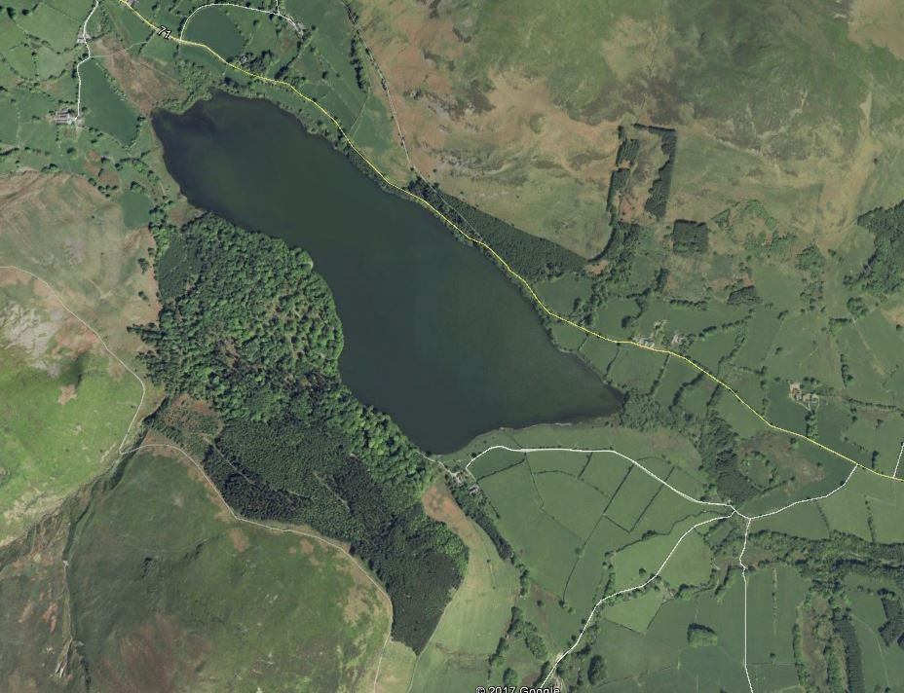
Figure 1 Holme Wood.
As with many Lakeland woodlands sheep trespass does occur however at a frequency with little impact on overall woodland structure. Holmewood supports a healthy population of red squirrels, badgers are present close to Watergate, bird species include buzzard, sparrow hawk with peregrine falcon nesting in the area, furthermore the woodland is notable for its population of pied flycatchers that have been monitored for over three decades by BTO. (This maybe the longest single species monitoring programme in the Lake District) Roe deer are present in the area and are included in the deer management plan for Buttermere. Red deer are not recorded within Holmewood.
The broadleaved areas support a rich ground flora, with levels of both standing and fallen dead wood at appropriate volumes/ha. There are numerous streams and ghylls, Holme force is the main feature in the woodland, the area around the waterfall is home to an interesting diversity of bryophytes.
The woodland is an important carbon sink in an area heavily grazed by sheep and plays a major role in reducing nutrient & sediment transfer into Loweswater. In recent years much research has been undertaken into the ecological status of the lake. (https://westcumbriariverstrust.org/projects/the-loweswater-care-programme
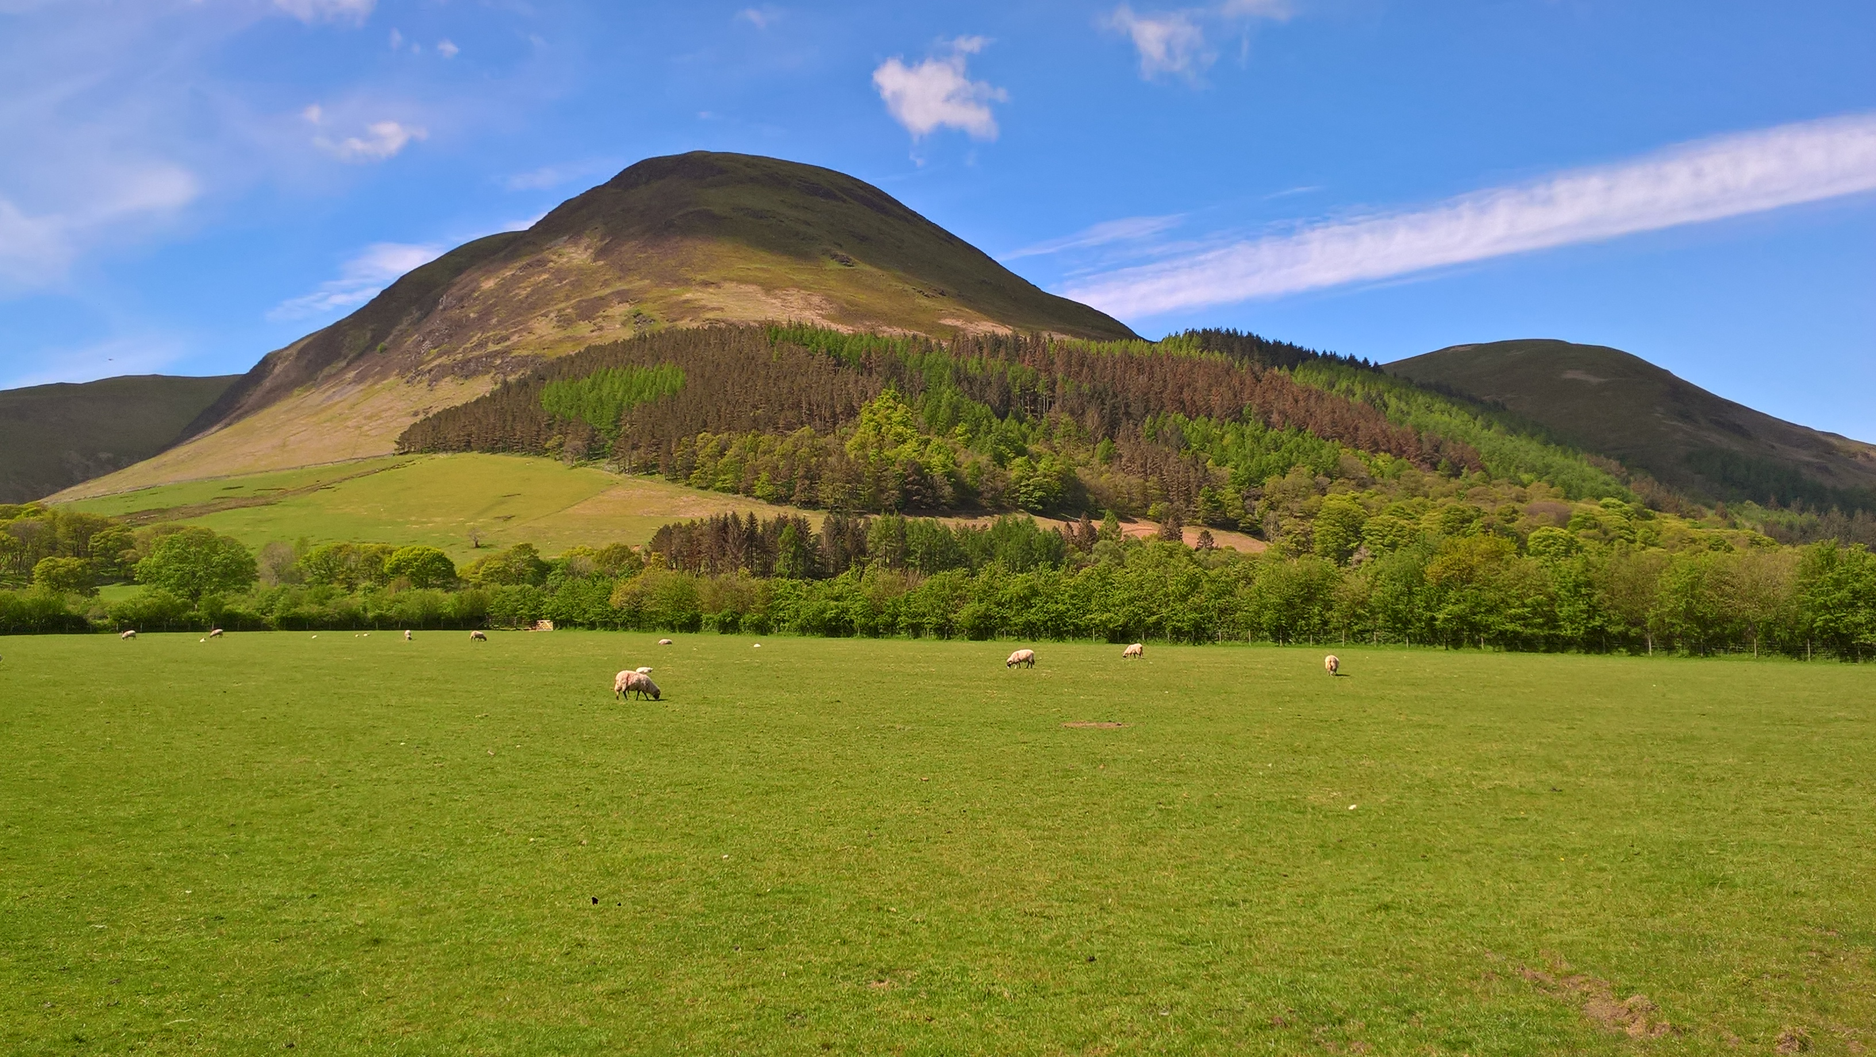
Figure 2 Holme wood

Cpt 1a 3.5ha Holme Wood The compartment is very wet with many flushes and streams. Last thinned in 2005 to favour broadleaves and a further thin to waste 2009. The sitka will be completely removed during the plan period allowing willow and alder to develop over the wetter areas of the compartment.
Cpt 1b 4.5ha Holme Wood. Adjacent Holme beck this compartment contains many fine oaks, silver firs and several very large ancient scots pines, the understorey is well developed with hazel, holly and Mt ash. Small groups of larch and beech were planted in 1961. Thinning will concentrate on exposing these fine pines and oaks and the removal of poorly formed beech. The upper reaches of the compartment once supported many fine elms however most have now succumbed to Dutch elm disease. Silver fir is regenerating freely in some areas of this compartment and needs to be controlled. The bryophytes are of particular interest close to Holm Force. (Felling licence expires 25th June 2024. Ref 010/44764/2018)
Cpt 1c 2.6ha Holme Wood. Small lakeshore compartment with Silver fir, scots pine, and oak. There are areas of birch and larch scattered throughout the compartment in need of thinning. The under story is robust with birch, oak, ash and willow. Thinning during the plan period will concentrate on removing larch and controlling the spread of silver fir regeneration. (Felling licence expires 25th June 2024. Ref 010/44764/2018)
Cpt 1d 5.6ha Holme Wood. In the past this has been a much larger compartment however thinning operations carried out in 2007 and 2008 created an open canopy of mature oak with a rich understorey of mixed broadleaves and silver fir, furthermore thinning has greatly enhanced the conservation value over a substantial area. The revised compartment boundaries now reflect these changes and the character of the woodland. Public pressure is considerable through this area via people staying at the bothy situated on the lakeshore; many of the oak trees in the vicinity of the bothy have suffered bark damage which may have contributed to branch losses that frequently occur close to the Bothy. The specimen silver firs in this compartment give rise to considerable amounts of regeneration that needs to be kept in check.

Cpt 1e 4.6 ha Holme Wood. A complex compartment with many species including, larch, douglas fir, sitka spruce, Norway spruce, oak, beech, sycamore and ash. Close to Holm beck the compartment is open and well thinned and supports good assemblages of bryophytes however most of the compartment is a mosaic of either well thinned trees or under thinned larch with poorly formed beech. Sitka spruce has been well thinned with abundant regeneration. Thinning will continue during the plan period and it may be necessary to completely remove some of the poorer larch and beech and replant with native species. (Felling licence expires 25th June 2024. Ref 010/44764/2018)
Cpt 1f 4.3 ha Holme Wood.
This compartment sits adjacent Holme Beck and at the lower reaches supports several mature oak trees; the higher humidity here gives rise to a fairly rich bryophyte flora not found in other areas of the wood. The oak gives way to larch which becomes dominant throughout the upper areas of the compartment as the terrain steepens. The top corner of this compartment has thicket stage larch and sitka spruce and should be respaced as soon as possible, 2021 at the latest. Timber extraction from this steep sided cpt is likely to require a Skyline. (Felling licence expires 25th June 2024. Ref 010/44764/2018)
Cpt 1g 3.4 ha Holme Wood
This compartment sits well above the lakeshore and above the broadleaves that fringe the lower slopes; dominated by conifers, species include sitka spruce, norway spruce douglas fir, European larch and scots pine. There is a small area of mature Norway spruce close to the bothy. Thinning of these various stands will continue throughout the plan period.

Cpt 1h 2.6ha Holme Wood The compartment is dominated by large mature veteran beeches and oaks, as the gradient increases the woodland takes on the character of a rather fine beech hanger. In recent years the population of large elms has declined and is likely to disappear completely in the next few years. Levels of fallen deadwood in this area are excellent and support a rich population of forest fungi. This compartment has high conservation value and is likely to be important for woodpeckers, pied flycatchers and a host of saproxylic invertebrates. No operations are planned for this compartment.

Cpt 1i 10.2 ha Holme Wood A complex compartment dominated by conifers that form part of the pheasant’s eye a major feature in the wider landscape. Some thinning was carried out in 2014 however much of the cpt has not been thinned for many years. The periphery is dominated by larch and scots pine planted in discreet units while internally there are areas of douglas fir and Norway spruce, the upper reaches of the cpt closer to Cpt 1f support a good stand of sitka spruce that was thinned in 2018, thinning will continue throughout the plan period. A large compartment that should perhaps be further divided. (In the event that the larch forming the eye of the pheasant is lost the area could be replanted with aspen which may well produce the same effect in the landscape in autumn.) Infected larch (P ramorum )was felled (500m³ ) in September 2020. This work did not change the overall shape in the wider landscape. The area felled will be replanted in 2021/2022 season with MC/MB.
Cpt 1j 3.1 ha Holme Wood Dominated by conifers with almost no broadleaves, however there are some good stands of douglas fir, many perhaps at their maximum size for the timber market, the largest could be left as seed trees and will undoubtedly become important landscape trees in future years. Thinning will continue during the plan period (Felling licence expires 25th June 2024. Ref 010/44764/2018)
Cpt 1k 3.3 ha Holme Wood This cpt supports a wide range of tree species including, oak, sycamore, birch, ash, hazel, larch scots pine. A major part of its defining character are the numerous veteran beeches and oaks on the lower flanks toward Loweswater. A number of small areas planted with oak and beech appear stunted probably due to lack of thinning, these are located adjacent the tracksides above Watergate Farm. The large numbers of ancient beech trees have produced large quantities of dead wood both fallen and standing, the compartment is likely to be highly significant for woodland fungi, birds and invertebrates. Thinning of conifers and stunted beech will continue during the plan period.
Cpt 2a 0.9ha Sparky’s wood. A small linear plantation adjacent Watergate Farm. The plantation grows on deep soils at the foot of sloping ground. Vigorous tree growth includes, oak, birch, ash, sycamore grading into larch, scots pine, norway spruce, sitka spruce and silver fir. As a thin linear strip, it is not wind firm and windthrow is a common event. One major issue concerns the power supply to the farm; windblown trees regularly fall across the mains cutting the supply. As the trees grow larger this scenario of trees causing power failures is likely to increase. During the plan period the trees behind the farm will be thinned and the conifers beyond the farm will be clear felled. Once completed the area will be planted with native broadleaved species. (An exemption allowing felling without a felling licence has been granted for part of the cpt, however NWE have not acted on this opportunity to solve the problem. Oct 2020)
Maggies Bridge. Cpt 3a 0.68 ha larch thinned in 2017, final thin toward the end of the plan (2027) & 3b 1.1 ha norway spruce removed in 2017. Manage and establish natural regeneration during plan period. (Felling licence expires 25th June 2024. Ref 010/44764/2018)
Cpt 3c 1.2 ha Loweswater Roadside. Linear woodlands with larch, scots pine, alder, oak, sycamore unthinned for at least 25 years. The lakeshore woodland also has willow and alder which could be laid into the lake and left as refuges for fish. Given the linear nature of these woodlands thinning will need to be carried slowly over a number of years.
Cpt 4a 1.9ha Palace How and 4b 2.8ha Back Hows Wood. (see figure 4)
Compartment records suggest this is ancient woodland previously felled and replanted with a mix of oak, larch and scots pine, no dates are mentioned. The current woodland has a somewhat juvenile open appearance possibly planted in the early seventies; management by the NT in recent years has favoured the oak with considerable reduction in the cover of larch throughout the woodland, very few scots pine appear to have survived. The process of favouring the broadleaved character of the woodland will be maintained and the few remaining scots pine will be haloed allowing them to develop larger crowns. Many of the oak trees exhibit stunted canopy growth probably due to shallow soils that are smeared over a rocky knoll known as Tindle Crag, there is an abundant understory of oak and birch albeit rather etiolated. The bryophyte community appears vibrant in among numerous fern species especially along the remains of an old wall that originally divided the two compartments. Although isolated with no parking this small woodland is popular with local residents, a circular ride is mown annually. The NT had planned to make some alterations to the entrance to Palace Howe to allow for timber stacking and collection by timber wagons. The current Covid crisis has delayed this process which will hopefully be resolved in 2021.
Figure 4 Entrance to Palace Howe Cpt 4a & 4b
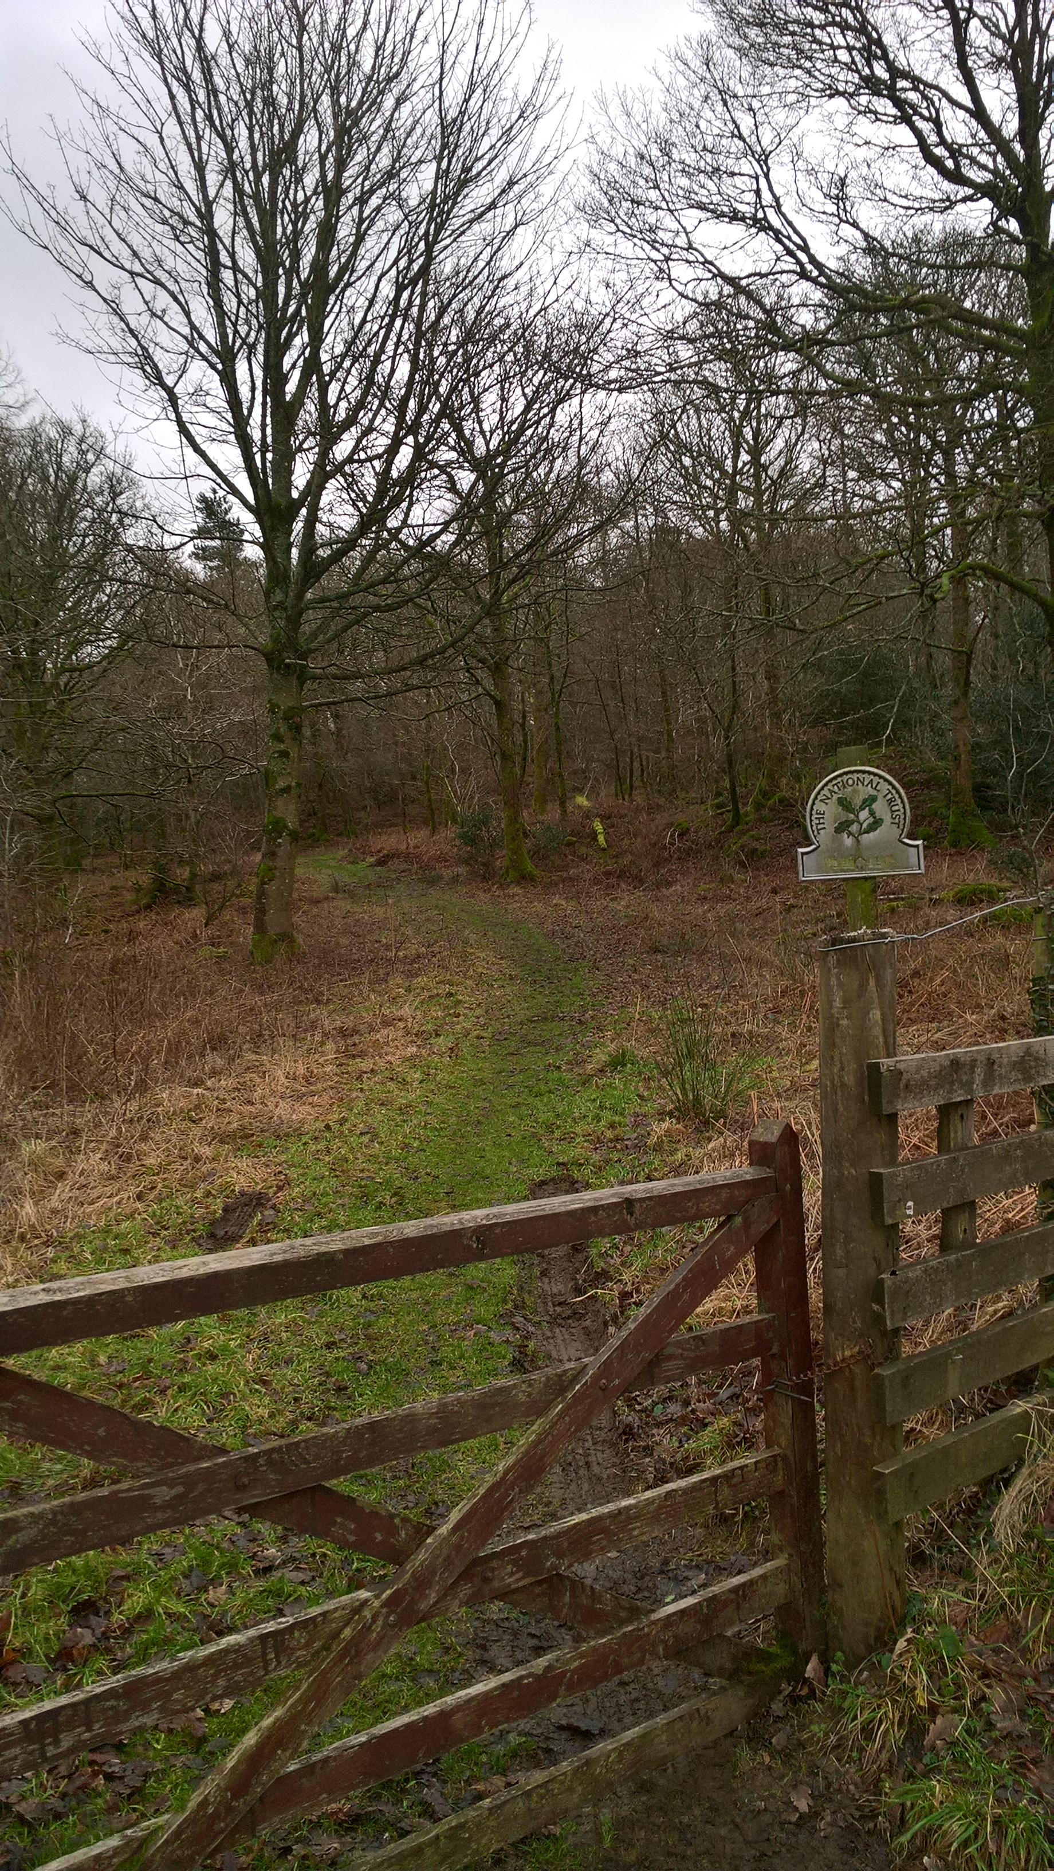

Lanthwaite Wood
A very popular woodland for walkers/dog walkers and local folk. There are numerous tracks and permissive pathways throughout the woodland Sheep trespass into this woodland is extremely rare. In terms of natural regeneration and structure the majority of Lanthwaite wood is in ‘favourable condition’ as the woodland is thinned, and its conifer component declines decisions will be needed to ensure its long-term structure and appropriate species mix. There are numerous semi ancient trees scattered throughout the woodland and these will be haloed during the plan period. Lanthwaite wood will continue to be managed along the lines of continuous cover with no areas of the woodland subjected to clear felling.
Cpt 5a 6.4ha Lanthwaite Wood. A large compartment often over steep craggy ground. Located along the top of the woodland it runs from Scale Hill Hotel to the top of a rocky knoll at the highest point in the wood. Its location and steep ground are perhaps the main reason for it being under thinned. The Scale Hill end is dominated by hemlock (Tsuga heterophylla) which appears to grow very well on this site and has shaded out the broadleaves (beech & oak) which brings problems for future thinning operations. The hemlock gives way at the path junction to an area of P95 oak which is fairly well thinned, the beech here is of very poor provenance. The upper edge of the compartment is dominated by scrubby oak which will remain unmanaged. Toward the upper end of the compartment the woodland grades into larch. The entire compartment was thinned in 2019/20 (Felling licence expires 25th June 2024. Ref 010/44764/2018)
Cpt 5b 3.4ha Lanthwaite Wood This riverside compartment supports a mosaic of trees species planted over numerous periods probably dating back to the early 20th century. The largest trees in the compartment are beech, silver fir, oak and scots pine. There are areas that are well thinned while others remain overstocked with an etiolated understorey. The silver firs in the middle of the compartment are fine specimens and would be even more impressive if given a light thin. The river bank has continuous broadleaved cover of oak, birch and willow and will be managed sensitively in order to maintain optimum ecological conditions for the River Cocker SSSI/SAC.
Cpt 5c 1.2 ha Lanthwaite Wood Contiguous with 5b the compartment is mainly close grown young oak with some scots pine and scattered beech. The compartment is bounded on two sides by the River Cocker and Crummock water here the ground flora is dominated by woodrush an indication of fairly constant waterlogging. Part of the compartment has been recently coppiced in order to expose interesting archaeology believed to be a mediaeval bloomery and an associated leat. This compartment will require further thinning during the plan period.
Cpt 5d 3.8 ha Lanthwaite Wood. This compartment has a mix of larch, silver fir, beech, scots pine, sycamore, and scattered douglas fir, the mix of trees is blended throughout much of the compartment and is in need of thinning. There are a number of mature oaks and beeches along the ride side in the middle of the compartment. Natural regeneration of beech and silver fir is fairly abundant over much of the area. Thinning will take place during the plan period and regular respacing of natural regeneration carried out on a three-yearly cycle. Areas where silver fir has formed thickets will be cleared to favour native broadleaves.
Cpt 5e 4.7ha Lanthwaite Wood In terms of access this compartment presents the biggest challenge and subsequently certain areas are under thinned Toward the southern end there are a series of rocky knolls with larch, beech, oak, a few douglas fir and a number of notable scots pine, toward the end of the rocky outcrops there are areas with young pine and oak in need of thinning, where 5e and 5f meet the canopy is dominated by scots pine and oak. Toward the end of the compartment the canopy changes and is dominated by scrubby oak and beech, many of the oaks are in poor health with considerable dieback, this is almost certainly due to thin soils over outcropping geology in this area of the compartment The compartment is marked and will be thinned during March 2020.
Cpt 5f 5.2ha Lanthwaite Wood
This compartment is dominated by oak, albeit rather stunted most trees being multi –stemmed, possibly coppiced in the past, there are scattered pine and a few sitka spruce, the ground flora is dominated by heather and gorse. The sitka spruce will be removed from the compartment during the plan period. On the shoreline at the end of the compartment near the boathouse the woodland structure changes with large mature oaks and pines replacing the low growing scrubby oaks, alder is abundant along the shoreline. The upper reaches of the compartment support larch and scots pine planted in the 1970’s. This area will be thinned during the plan period favouring the scots pine especially those with well-developed crowns, the oak and scots pine close to the boathouse will also be thinned.
Cpt 5g 1.6ha Lanthwaite wood. A small but rather complex compartment with mature scots pine, silver fir, douglas fir, and a large Corsican pine, many are of specimen quality and will be retained. There are areas of poor-quality beech and areas of larch in need of thinning. A small area of sitka spruce will be removed. Thinning will take place during the plan period.
Cpt 6a 0.7ha Fletcher Fields. Small linear woodland adjacent Crummock water shoreline. The canopy is mainly mature semi mature oaks, close grown unthinned and regularly grazed by sheep, toward the southern end there is a small enclosure of 0.1 ha planted with birch, ash a few larch and beech. The cpt will be thinned during the plan period.
Buttermere. There are several discrete woodlands clustered around the hamlet of Buttermere, the largest is Burtness a mixed woodland of conifers and broadleaves located on the south western shore of Buttermere below Chapel crags, the woodland is a prominent feature of the Buttemere Landscape. Given its proximity to Scales Wood (SSSI) an upland oak wood it is likely that Burtness was also an Oakwood prior to its conversion to conifers in the 19th century. During the 1980’s the mature larch (P1890) at the north western end of the woodland were felled leaving just a few scattered specimens along the lakeshore. Current and future management will see a slow transition to a woodland landscape where broadleaves become the dominant canopy species although the mature larch will be retained. The transition to a mixed woodland canopy is likely to take another 30/40 years.
Other woodlands close to Buttermere include Long How SSSI, Nether How SSSI and Ghyll Wood SSSI. Their notification is related to the Buttermere fells geological SSSI. Although small woodlands they bare a strong resemblance to many of the Atlantic Oakwoods found throughout the North Lakes Property.
Cpt 7a 1.49 ha Wilderness Wood A small roadside compartment that has been unthinned since planting in the early 20th century and is now in need of clear felling. Tree species include larch, sitka spruce, Norway spruce, birch, alder, oak and beech. Thinning the woodland is no longer an option as the trees are close grown and will almost certainly suffer wind throw after thinning. The compartment will be clear felled during the plan period, the boundary will be secured, and the area replanted with native broadleaves. There are a few mature oaks and birches scattered throughout the compartment, these will not be removed.
Cpt 7b 0.66ha Woodhouse (roadside) This small roadside compartment has remained unthinned since being planted in mid 1900’s. Tree species include beech, sycamore with some larch and an area of oak in the middle of the compartment. During the plan period the larch will be removed, and the broadleaves will be thinned. The compartment currently has no fixed boundary and is constantly grazed by sheep. A new boundary fence will be erected to exclude sheep. Some enrichment planting will be needed.
Cpt 7c 0.3ha Woodhouse. Small compartment dominated by beech and sycamore possibly P50. At the entrance to Woodhouse are two extremely large silver firs possibly P1890. The roadside beech and sycamore will be thinned during the plan period.
Cpt 7d 1.08ha Woodhouse lakeshore. Small compartment of sessile oak possibly P1900 with a few scots pine and larch. The woodland grows in very thin soils over a rocky knoll and has not been thinned. Access to the woodland is almost impossible thus no operations are planned during the plan period. This is a key woodland within the wider landscape.
Cpt 7e 1.6ha Nether How SSSI. Similar condition as 7d sessile oak in thin soils on a rocky outcrop and unthinned, access is not possible, and no works are planned. Like 7d Nether How is an important feature of the Buttermere landscape.

Cpt 7f 6. 7ha Long How SSSI This woodland has much in common with the Atlantic Oakwoods found throughout the Lake District. Compartment records are very brief and refer to planting dates of 1900 for oak, possibly the last coppice cycle, and 1975 for Japanese larch. The woodland has a moist mossy appearance with some very wet areas with sphagnum, however the majority of the woodland grows over rocky outcrops on very thin soils (see below) Deadwood is considerable both fallen and standing the latter being more abundant. Despite being in- hand sheep trespass is a regular occurrence and needs to be addressed. The oak canopy is closed and would perhaps benefit from thinning however the soils are so shallow that current mortality rates will eventually create a better woodland structure. The remaining larch will be removed during the plan period. The key objective during the plan period should be to overcome the issues of sheep trespass prior to any interventions.
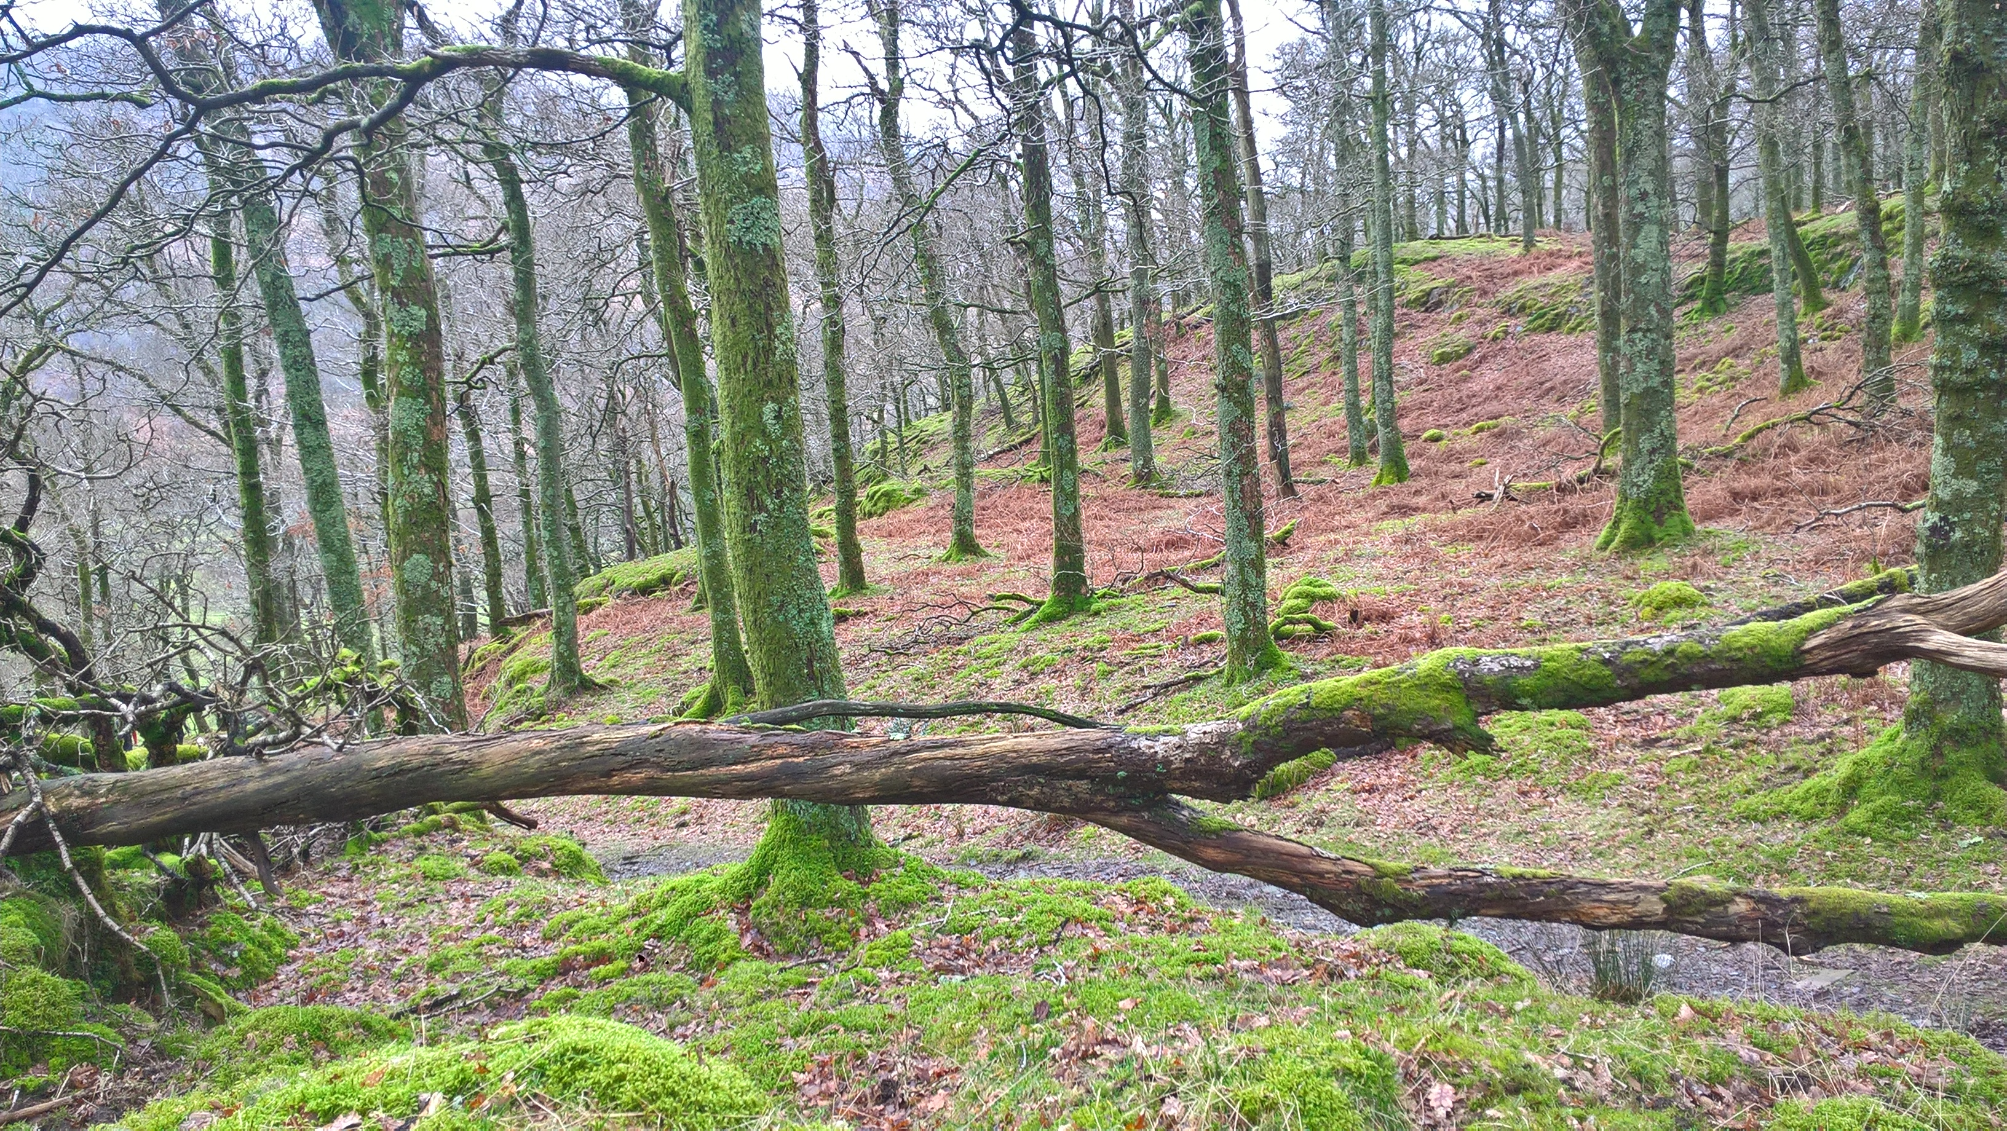
Cpt 8a 1.4ha Ghyll Wood. SSSI. Located in the centre of the village of Buttermere this small linear woodland is very popular with visitors and stray sheep. Natural regeneration of trees is limited to the steep ghyll sides. No operations are planned for this compartment during the plan period.
Cpt 9a – 9c Pike Rigg. Mixture of mature oaks with scattered birch open to grazing farm stock. No operations are planned for these woodlands.

Cpt 10a Folders wood – 10b Kirk Close. Both compartments were thinned in 2014, Kirk close was partially clear felled and replanted in 2015 with broadleaved species. Both compartments will require thinning again toward the end of the plan period. Rhododendron in 10a will be eradicated by end 2021.
Burtness Wood. Future management of Burtness wood raises several problems that need to be addressed during the plan period. Currently deer are not a threat in Burtness, but trespassing sheep are.
- Burtness Wood 32.65 ha, the canopy is dominated by conifers with larch being the dominant species in most compartments. A managed transition toward a mixed woodland with a canopy dominated by broadleaves is an achievable objective not but within the times scale of this plan; One major issue remains to be resolved before this transition can begin. Sheep trespass has been solely responsible for holding this woodland in check for the last 40 years and today natural regeneration remains extremely scarce. Large mature broadleaved trees are mainly absent from the woodland apart from Cpt 11a & 11c and a few mature sweet chestnuts in 11b. The species mix is poor, and some enrichment planting would be beneficial. The clear-felled area (Cpt 11g) has been restocked with broadleaved species. Several compartments remain under thinned while others support young pole stage beech of very poor provenance that need to be replaced. (cpt 11f) The threat of windthrow remains high in many compartments. There are also considerable access issues regarding this woodland.

Cpt 11a 3.2ha Burtness wood.
Located at the north western end of Burtness wood this compartment is dominated by larch with an understorey of birch, oak and hazel and Mt ash, a few adolescent scots pines can be found scattered throughout the compartment; much of the understorey remains suppressed by the larch while other areas are at thicket stage and in need of thinning. As with most of the upper compartments the terrain is steep and rocky. During the plan period young larch will be thinned and respaced to favour developing oaks.
Cpt 11b 7.1ha. Burtness wood. One of the key features of this compartment is that it is greatly overstocked. There are areas of thinned larch and areas of thicket stage larch, the broadleaved component, mainly birch and oak is similar to 11a, unthinned or supressed. Toward the southern end of the compartment the character of the woodland changes; it is more open with large well thinned larch, scots pine, a few mature sycamores, close to the track there are several mature sweet chestnuts. The open bouldery nature of this area is further enhanced by a reasonable assemblage of bryophytes that cloak an old drystone wall that marks the compartment boundary. Thinning during the plan period will favour the broadleaved element of the compartment.

Cpt 11c 1.6ha Burtness wood. Relatively well thinned with a reasonable mixture of tree species including oak and a few elms with larch remaining the dominant species. Although fairly well thinned this lakeside compartment remains overstocked and trees with well-developed crowns are rare. Plan objective for this compartment is to reduce larch and halo oaks and sycamore.
Cpt11d 2.87ha Burtness wood. A three-ha compartment of well thinned larch with almost no other species present. Despite being well thinned natural regeneration of any tree species is extremely rare. (See discussion re natural regeneration.) Larch will be thinned during the plan period and native broadleaves allowed to regenerate – some enrichment planting is needed.
Cpt 11e 5.3ha Burtness wood.
A complex compartment that supports a mosaic of close grown larch and thicket stage large often associated with an oak, sycamore, birch and Mt ash understorey. Adjacent the track at the halfway point are four fine sitka spruce that will be retained, and toward the southern end of the compartment there are a group of scots pine in need of thinning. In 2018 this compartment was home to a very healthy red squirrel population.
Cpt 11f 2.31ha Burtness wood. This small compartment supports poorly grown larch with a few norway spruce but is dominated by pole stage beech of very poor form as is the case with most beech on the property. The compartment will be thinned and the diversity of broad-leaved species will be increased.
Cpt 11g 2.58ha Burtness wood. A compartment of mature Norway spruce and Sitka spruce clear felled in 2014 and then replanted with native broadleaves; oak, birch, cherry, hazel, alder and aspen.
Figure 6 Cpt 11g(larch in the background are 11i)

Cpt 11h 0.64ha Burtness wood
Small cpt on lake edge dominated by Norway spruce thin during plan period.
Cpt 11i 4.22ha Burtness wood. Mixture of larch and scots pine that are under thinned and are now suffering from wind throw, especially the larch. Thinning may cause complete loss of remaining larch. (See cpt photo)
Cpt 11j 1.35ha Burtness wood. Mixture of larch and oak in need of thinning especially the oak, will be thinned in 2021/2022 Sheep are a major issue in the compartment as the woodland gate is often left open.
Cpt 12a 1.09 (Horse Close) Mainly larch with a small area of broadleaves. The larch looms large in the landscape, thinning may lead to windthrow?

Dunthwaite Woodlands
The National Trust lands at Dunthwaite sit between the River Cocker and Elva Hill. The main area of woodland is located on the lower slopes of Elva hill and comprises a mix of approximately 65% native broadleaves and 35% conifer. Compartment 13a known as Sligo is 8ha of P95 Japanese larch, Sitka spruce and Norway spruce and in need of thinning. Compartment 13b is more complex and has a mix of ancient woodland within a matrix of planted conifers and broadleaves there are also several mature scots pine at the top of the compartment that would benefit from some haloing, both conifers and broadleaves require thinning. Compartment 13c is a mix of ash, larch and scattered elm and birch. Furthermore, this area of woodland also supports several exotic species including a veteran beech, Norway maple, possibly one of the largest in Cumbria with a dia of 131 cms and a variegated sycamore also possibly one of the largest in Cumbria. The remaining compartments are small areas of woodland that were planted around the 1990’s to form shelterbelts and wildlife corridors.
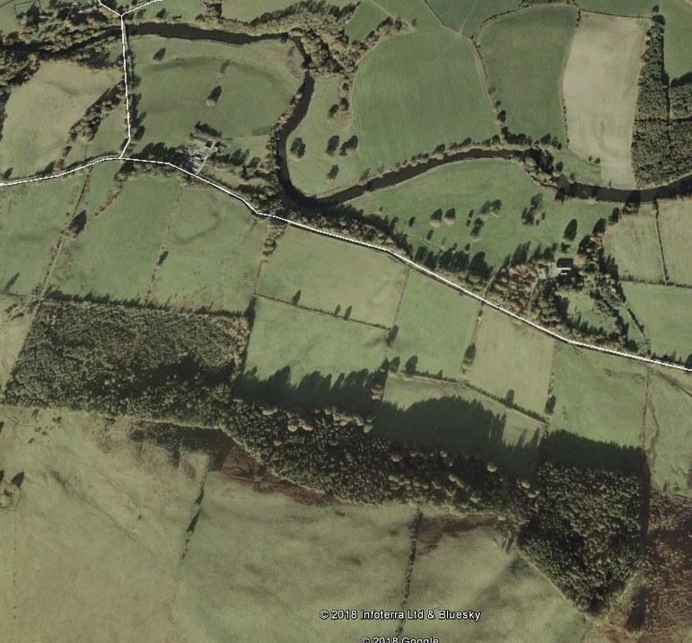
13c
13b
13a

Dunthwaite Woods. Cpts 13a, b & c form the single largest woodland area on the Dunthwaite estate. Overall condition of the woodland is good with abundant regeneration despite the presence of roe deer. Sheep trespass is only occasional. Post thinning some boundary repairs/ or replacement will be necessary.
Cpt 13a. 8.2ha. Sligo Wood A P 95 plantation of Japanese larch, sitka spruce and norway spruce. The edges of the woodland are planted with birch and oak and the entire compartment needs thinning. Extraction racks are needed, and the compartment needs to be brashed prior to marking. Felling of larch carried out in autumn 2020 due to Phytophthora.

Cpt 13b 6.1ha Hillside wood. A more complex compartment some of which is recorded by Natural England as ancient woodland. There are numerous areas with relatively young larch and oak, mature scots pines are present toward the upper reaches of the compartment these would benefit from some halo thinning. Other areas are overstocked with broadleaves and should be thinned as soon as
possible. The lower slopes support a number of fine oaks, large sycamores and a few large beeches, these will be retained.
Cpt 13c 4.4ha Hillside wood. A compartment of mixed P 80 broadleaves, mainly ash and oak with a few scattered elms. In the likely event that ash is lost to Chalara after thinning further planting maybe required, the cpt is also overstocked with oak and is in need of crown thinning. Larch in the compartment will be thinned at the same time.
Cpts 13h 1.0ha Small woodland to screen Dunthwaite House, mixed bl will be thinned during plan period.
13I 1.7ha Roadside and river woodland of mixed bl will be thinned during plan period.
All other compartments are included for reference to wooded areas on the estate however no works are planned for these small compartments.

4.2 Information
Use this section to identify features that are both present in your woodland(s) and where required, on land adjacent to your woodland. It may be useful to identify known features on an accompanying map. Woodland information for your property can be found on the Magic website or the Forestry Commission Land Information Search.
Feature | Within Woodland(s) | Cpts | Adjacent to Woodland(s) | Map No
Biodiversity- Designations
Site of Special Scientific Interest | Yes | 7e 7f | Yes River Derwent SAC | Buttermere Designation maps
Special Area of Conservation | No |  | Yes. River Derwent
Tree Preservation Order | No | N/A | No
Conservation Area | No | N/A | No
Special Protection Area | No | N/A | No
Ramsar Site | No | N/A | No
National Nature Reserve | No | N/A | No
Local Nature Reserve | No | N/A | No
Other (please Specify):
Notes

Feature |  |  | Within Woodland(s) |  |  | Cpts |  | Map No |  | Notes
Biodiversity - European Protected Species
Bat | Species (if known)  Pipistrelle, Brandt’s, whiskered,  Natterers, daubentons, noctule |  | Yes |  | All |  |  | All cpts |  | There are 7 species of bat recorded in Cumbria. It is likely that all 7 are present throughout the plan area.
Dormouse |  |  | No |  | N/A |  |  |  |  | Not recorded
Great Crested Newt |  |  | No |  | N/A |  |  |  |  | Not recorded
Otter |  |  | Yes |  |  |  |  |  |  | All main waterbodies
Sand Lizard |  |  | No |  | N/A |  |  |  |  | -
Smooth Snake |  |  | No |  | N/A |  |  |  |  | -
Natterjack Toad |  |  | No |  | N/A |  |  |  |  | -
Biodiversity – Priority Species
Schedule 1 Birds |  | Species  Peregrine falcon  Osprey  Barn owl | Yes |  |  |  |  |  |  | Resident within the plan area
red squirrel |  |  | Yes |  | All cpts
Reptiles (grass snake, adder, common lizard, slow worm etc) |  |  | Yes |  | All cpts? |  |  |  |  | No survey data available
Plants. Rannerdale bluebells, Some typical Atlantic oakwood communities in Holmewood, areas of Lanthwaite wood, and oak woodlands close to Buttermere. Unimproved acid grasslands adjacent to hillside wood at Dunthwaite. |  |  | Yes |  | 1e,1h,  1k,5f, 8a,13b |  |  |  |  | 1980’s NT bio surveys new surveys required
Fungi/Lichens |  |  | Yes |  | ALL |  |  |  |  | Wax caps at Dunthwaite, Further data/surveys needed
Invertebrates (butterflies, moths, saproxylic species) |  |  | Yes |  |  |  |  |  |  | Surveys needed
Amphibians (common frog, common toad, newts ) |  |  | Yes |  |  |  |  |  |  | Surveys needed
Other (please Specify): |  |  | Yes/No
Historic Environment
Scheduled Monuments |  |  | No |  | N/A |  |  |  | N/A
Unscheduled Monuments |  |  | Yes |  |  |  |  |  | Refer to NT HBMSR
Registered Parks and Gardens |  |  | No |  | N/A |  |  |  | N/A
Boundaries and Veteran Trees |  |  | Yes |  |  |  |  |  | See Buttermere & Dunthwaite Ancient Tree survey
Listed Buildings |  |  | Yes |  |  |  |  |  | None within woodlands
Other (please Specify):
Landscape
National Character Area The Cumbria High Fells covers the north and central Lake District and is largely within the Lake District National Park. It is a dramatic upland landscape, carved by past glaciations, with rugged peaks, ridges and open fells, separated by U-shaped valleys with a radiating pattern of lakes and rivers. The complex geology of the area has resulted in the smooth sided fells of the Skiddaw Group rocks, the rugged Borrowdale Volcanic Group fells and granite of the central area, with slates, mudstones and limestones forming the surrounding lower fells and foothills. The area is of national importance for its extensive mineralisation and the resultant mining heritage, dating back to the medieval period. Keswick and Ambleside are the main settlements with villages, hamlets and farmsteads along the valleys. Refer to: https://data.gov.uk/dataset/21104eeb-4a53-4e41-8ada-d2d442e416e0/national-character-areas-england
National Park |  |  |  | Yes
Area of Outstanding Natural Beauty |  |  |  | No
Other (please Specify): |  |  |  | Yes/No
People
CROW Access |  |  |  | Yes
Public Rights of Way (any) |  |  |  | Yes |  |  |  |  | See access Maps
Other Access Provision |  |  |  | Yes |  |  |  |  | As above
Public Involvement |  |  |  | Yes
Visitor Information |  |  |  | Yes
Public Recreation Facilities |  |  |  | Yes
Provision of Learning Opportunities |  |  |  | Yes
Anti-social Behaviour |  |  |  | Yes
Other (please Specify): |  |  |  | Yes/No
Water
Watercourses |  |  | Yes |  |  |  |  |  |  | See water course maps
Lakes |  |  | Yes
Ponds |  |  | No
Other (please Specify): |  |  | Yes/No

4.3 Habitat Types
This section is to consider the habitat types within your woodland(s) that might impact/inform your management decisions. Larger non-wooded areas within your woodland should be classified according to broad habitat type where relevant this information should also help inform your management decisions. Woodlands should be designed to achieve a diverse structure of habitat, species and ages of trees, appropriate to the scale and context of the woodland.
Feature | Within Woodland(s) | Cpts | Map No | Notes
Woodland Habitat Types
Ancient Semi-Natural Woodland | Yes | 1b,1c,1d 1h,1k, 4a,4b,5f  7d,7e,7f8a,11c,  13b. | ` | Lower cpts of Holmewood  Palace How & Back Hows, Lanthwaite wood, Long How & Nether how, Burtness wood.
Planted Ancient Woodland Site (PAWS) | Yes |  |  | Upper cpts of Lanthwaite wood, Holme wood and most of Burtness wood.
Semi-natural features in PAWS | Yes
Lowland beech and yew woodland | No
Lowland mixed deciduous woodland | No
Upland mixed ash woods | No
Upland Oakwood | Yes |  |  | Long How & Nether How
Wet woodland | NO
Wood-pasture and parkland | Yes |  |  | Dunthwaite House
Other (please Specify): | Yes/No
Non-Woodland Habitat Types
Blanket bog | Yes |  |  | Above Holmewood
Fenland | No
Lowland calcareous grassland | No
Lowland dry acid grassland | No
Lowland heath land | No
Lowland meadows | No
Lowland raised bog | No
Rush pasture | No
Reed bed | No
Wood pasture | Yes |  |  | Dunthwaite
Upland hay meadows | Yes |  |  | Loweswater High Nook Farm
Upland heath land | No
Unimproved grassland | Yes |  |  | Dunthwaite above Hillside wood
Peat lands | Yes |  |  | Above Holmewood
Wetland habitats | Yes |  |  | Dunthwaite
Other (please Specify): | Yes/No

4.4 Structure
This section should provide a snapshot of the current structure of your woodland as a whole. A full inventory for your woodland(s) can be included in the separate Plan of Operations spreadsheet. Ensuring woodland has a varied structure in terms of age, species, origin and open space will provide a range of benefits for the biodiversity of the woodland and its resilience. The diagrams below show an example of both uneven and even aged woodland.
Woodland Type (Broadleaf, Conifer, Coppice, Intimate Mix) | Percentage of Mgt Plan Area | Age Structure (even/uneven) | Notes (i.e. understory or natural regeneration present)
Native broadleaves | 15% | Uneven structure | NBL regen present
Native broadleaves | 5% | Even structure | Birch/oak/Mt ash
Intimate mix | 20% | Uneven structure | Birch/oak/hazel/regen
Conifers | 60% | Evan aged | Hemlock/silver fir/sitka regen
coppice | <1% | Uneven structure | Birch/oak regen

Section 5: Woodland Protection
Woodlands in England face a range of threats; this section allows you to consider the potential threats that could be facing your woodland(s). Use the simple Risk Assessment process below to consider any potential threats to their woodland(s) and whether there is a need to take action to protect their woodlands.
Note: To add more tables, Copy the table and Paste below.

5.1 Risk Matrix
The matrix below provides a system for scoring risk. The matrix also indicates the advised level of action to take to help manage the threat.

Impact | High | Plan for Action | Action | Action
 | Medium | Monitor | Plan for Action | Action
 | Low | Monitor | Monitor | Plan for Action
 |  | Low | Medium | High
 |  | Likelihood of Presence

5.2 Plant Health
Threat Ash Dieback  Hymenoscyphus fraxineus | Present throughout plan area
Likelihood of presence. | High. Rapid spread in 2019
Impact | High in certain cpts and wider landscape
Response (inc protection measures)  https://www.gov.uk/government/publications/chalara-management-plan | Develop planting/replacement strategy and continue monitoring. Refer to FC Guide Tree Species for ASNW

Threat Phytophthora ramorum | Remains high although not yet recorded within plan area.
Likelihood of presence | Remains high
Impact | Medium to high especially in Burtness and Holmewood and the wider environment.
Response. https://www.forestresearch.gov.uk/tools-and-resources/pest-and-disease-resources/ramorum-disease-phytophthora-ramorum/ | Remove as and when directed by FC and initiate species changes and replanting where necessary.

5.3 Deer
Species - Likelihood of presence | High Currently only roe deer are recorded from the plan area. Control measures are in place in Holmwood and Lanthwaite wood.
Impact | Impact throughout the plan area remains low. Some indications have been observed in Cpt 5a in Lanthwaite wood.
Response | Detailed in North Lakes Deer Management Plan.

5.4 Grey Squirrels
Likelihood of presence | Numbers have increased in recent years. Reports of greys throughout the Lorton Valley have also increased.
Impact | Impact on woodland remains low but impact on red squirrel densities is likely to be high. No bark stripping has been observed within the Plan area.
Response  http://www.redsquirrelsunited.org.uk/wp-content/uploads/2020/01/UKFSTN022-FINAL.pdf | West Cumbria squirrel group carries out control measures over most of the plan area. Numbers controlled and associated data are recorded monthly.

5.5 Livestock and Other Mammals
Threat Sheep. | All woodlands detailed in this plan are in-hand and should be free from grazing livestock.
Likelihood of presence | High in certain woods while low in others. Burtness wood (Cpts 11a to 11j very high risk of trespass. Visitor numbers are high, and gates are often left open.
Impact (high/medium/low) | Burtness woodland is held in check and thinning works are not advisable due to the total lack of natural regeneration.
Response (inc protection measures) | Major boundary reviews and explore realistic solutions with neighbouring farmers. Continue with annual boundary inspections and maintenance.

5.6 Water & Soil
Threat (Soil Erosion, Acidification of Water, Pollution incidents etc) | All woodlands detailed in this plan are either adjacent or close to major water bodies, all except Loweswater are designated. Poorly timed forest operations in periods of high rainfall are likely to lead to soil loss and sedimentation of water courses and increased acidification.
Likelihood of presence | Low
Impact | High
Response (inc protection measures) | Compartments with flushes, water courses and adjacent water bodies are not worked during the wetter months of the year. In the event of unseasonal weather extraction operations will cease. Prior to works starting measure will be put in place to protect water supplies & water courses in line with https://www.gov.uk/government/publications/the-uk-forestry-standard

Threat (Soil Erosion, Acidification of Water, Pollution incidents etc)
Likelihood of presence (high/medium/low)
Impact (high/medium/low)
Response (inc protection measures)

5.7 Environmental
Threat Invasive Species. | Species include, rhododendron, (cpt10a) Himalayan balsam (River cocker)
Likelihood of presence | There are no known areas of Himalayan balsam within the woodlands, but colonies do exist throughout the Lorton Valley.
Impact | Currently impacts are low

Threat (Pollution, Fire, Flood, Wind, Invasive Species, etc) | Incidents involving fires remain rare and are not regarded as a threat. Damage from climatic events occur in most years especially storms occurring when trees are still in leaf.
Likelihood of presence | medium
Impact (low) | Impacts are low although they may occur regularly. Holmewood is often affected by high winds.
Response (protection measures) | Regular thinning has reduced windthrow in many Cpts.

5.8 Social
Threat (Rights of Way, CROW, permissive access, events sporting rights, Anti-social Behaviour etc) | All woodlands in this plan have PROW and permissive access. There are no major events apart from orienteering and educational visits. Anti-social behaviour is rare and may involve wild camping and litter.
Likelihood of presence (high/medium/low) | Low
Impact (high/medium/low) | Low
Response (inc protection measures) | Regular visit by NT Rangers at relevant times of the year

5.9 Economic
Threat (Timber forecasting, markets, products, operational costs etc) | Wood fuel /saw log timber markets
Likelihood of presence (high/medium/low) | medium
Impact (high/medium/low) | low
Response (inc protection measures) | Regular thinning ensures crown integrity in conifers & broadleaves and aids crop stabilisation reducing potential for wind blow. Mensuration data available for most cpts gives good indication of thinning yields.

5.10 Climate Change Resilience
Threat (Uniform Structure, Provenance, Lack of Diversity etc) | Mono cultures with uniform structure/ trees of poor provenance e.g. beech
Likelihood of presence (high/medium/low) | Medium/Low
Impact (high/medium/low) | Low
Response (inc protection measures) | Ensure regular thinning especially of larch, increase halo thinning to maintain mature retained species. Enrichment planting where necessary. Widen provenance range. (2⁰ south within UK)

Threat (Uniform Structure, Provenance, Lack of Diversity etc)
Likelihood of presence (high/medium/low)
Impact (high/medium/low)
Response (inc protection measures)

Threat (Uniform Structure, Provenance, Lack of Diversity etc)
Likelihood of presence (high/medium/low)
Impact (high/medium/low)
Response (inc protection measures)

Section 6: Management Strategy
This section requires a statement of intent, setting out how you intend to achieve your management objectives and manage important features identified within the previous sections of the plan. A detailed work programme by sub-compartment can be added to the Plan of Operations.

Management Objective / Feature | Management Intention
1.Increase the overall area of woodlands by a minimum of 5% by the end of the plan period. | Identify areas of land suitable for woodland expansion with linkage being a priority.
2.All woodlands managed in accordance with the UK Forestry Standard and the UK Woodland Assurance Scheme. | Adhere to appropriate guidelines in all forestry operations. Refer to UK Forestry Standard.  Ensure management and monitoring records are up to date.  Completion of operational site assessments prior to the implementation of all woodland operations.
3.Protect and enhance the biodiversity of the woodlands  EPS species present especially bats, surveys required by year 3 latest. | a. Ensure long term retention of woodland cover.  b. All under thinned compartments are thinned by the end of the plan period and natural regeneration is present where appropriate.  c. Maintain or increase levels of deadwood in appropriate compartments.  d. Restore PAWS sites in Lanthwaite wood  e. Monitor deer and grey squirrels and manage accordingly.  f. Increase species diversity; Enrichment planting in single species stands. Consider wider provenance?
4.Protect soils and water | a. Undertake best practice during forestry operations.  b. Increase area of riverine/floodplain woodland when/ if opportunities arise.  Investigate opportunities within Riverlands programme.
5.Access and Public Enjoyment | a. Ensure that the WMP is used as a tool to engage visitors and illustrate the importance of our work and what our woodlands offer.  b. Continue to collaborate with schools/ colleges/ Universities/& local groups in order to demonstrate the conservation status of our woodlands.  c. Review woodland interpretation and agree areas of improvement.
6.Contribute to the Local Economy | When possible work with local contractors for thinning and timber extraction and infrastructure works.

Section 7: Stakeholder Engagement
There can be a requirement on both the FC and the owner to undertake consultation/engagement. Please refer to Operations Note 35 for further information. Use this section to identify people or organisations with an interest in your woodland and also to record any engagement that you have undertaken, relative to activities identified within the plan.

Work Proposal | Individual/ Organisation | Date Contacted | Date feedback received | Response | Action
Buttermere Woodland Management Plan | Buttermere Parish Council | 11/1120
Buttermere woodland Management Plan | Woodland Trust | 11/11/20
Management Plan | L.D.N. P | 11/1120
Management Plan | Cumbria Wildlife Trust | 11/11/20
Management Plan | Natural England | 11/11/20
Management Plan | National Trust consultants | 11/11/20
Management Plan | administrator@melbreakcommunities.org.uk | 11/11/20
Management Plan | Loweswater Parish Council | 11/11/20

Section 8: Monitoring
Indicators of progress/success should be defined for each management objective and then checked at regular intervals. Other management activities could also be considered within this monitoring section. The data collected will help to evaluate progress.
Management Objective/Activities | Indicator of Progress/Success | Method of Assessment | Frequency of Assessment | Responsibility | Assessment Results
1. Increase area of woodland cover by 5%. To be achieved by the end of the plan period. |  | Mapping | 5 years | Forest Ranger & Property staff
2.Control Invasive species | Areas treated/ | Photo/monitor | 5years | Forest Ranger/Property staff
Improve woodland structure &  Increase species diversity. | RN is present and enrichment planting undertaken > niches | Visual monitoring | Post thin 5 years | Forest Ranger
3. PAWS Restoration | Thin/final thin | Photo/monitor | 5 years | Forest Ranger
4.Improved Visitor experience | On site interpretation |  | 5 years | Countryside manager/VSM
5. Rare & BAP Species.  Red Squirrel, Otter & Bats | Habitat condition | SURVEY DATA | 5 years | Property staff
6.Ancient/veteran trees | Significant trees undergo haloing | Number of trees released | Post thinning/ Year 5 | Forest Ranger
7.Bryophytes & Lichen | Surveys/mapping | Reports | 5 years | Forest Ranger

UK Forestry Standard woodland plan assessment

For FC office use and approval only:
UKFS management plan criteria | Minimum approval requirements | Achieved | Review notes
Plan Objectives:  Forest management plans should state the objectives of management and set out how an appropriate balance between social, economic, environmental objectives will be achieved. | - Management plan objectives are stated.  - Consideration is given to environmental, economic and social objectives relevant to the vision for the woodland. | Yes/No
Forest context and important features in management strategy:  Forest management plans should address the forest context and the forest potential and demonstrate how the relevant interests and issues have been considered and addressed. | Management intentions communicated in Sect.6 of the management plan are in line with stated objective(s) in Sect. 2.  Management intentions should take account of:  - Relevant features and issues identified in the woodland survey (Sect. 4).  - Any potential threats to and opportunities for the woodland, as identified under woodland protection (Sect. 5).  - Relevant comments received from stakeholder engagement are documented in Sect. 7. | Yes/No
Identification of designations within and surrounding the woodland site:  For designated areas, e.g. National Parks or SSSI, particular account is taken of landscape and other sensitivities in the design of forests and forest infrastructure. | - Survey information (Sect. 4) identifies any designations that impact on woodland management.  - Management intentions (Sect. 6) have taken account of any designations. | Yes/No
Felling and restocking to improve forest structure and diversity:  When planning felling and restocking, the design of existing forests should be re-assessed and any necessary changes made to meet UKFS requirements.  Forests should be designed to achieve a diverse structure of habitat, species and age range of trees, appropriate to the scale and context.  Forests characterised by a lack of diversity, due to extensive areas of even-aged trees, should be progressively restructured to achieve age class range. | - Felling and restocking proposals are consistent with UKFS design principles (for example scale and adjacency).  - Current diversity (structure, species, age structure) of the woodland has been identified through the survey (Sect. 4).  - Management intentions aim to improve / maintain current diversity (structure, species, and ages of trees). | Yes/No
Consultation:  Consultation on forest management plans and proposals should be carried out according to forestry authority procedures and, where required, the Environmental Impact Assessment (Forestry) Regulations. | - Stakeholder consultation is in line with current FC guidance, and recorded in Sect. 7. The minimum requirement is for statutory consultation to take place, and this will be carried out by the Forestry Commission.  - Plan authors undertake stakeholder engagement (ref FC Ops Note 35) relevant to the context and setting of the woodland. | Yes/No
Plan update and review:  Management of the forest should conform to the plan, and the plan should be updated to ensure it is current and relevant. | - A 5 year review period is stated on the 1st page of the plan  - Sect. 8 is completed with 1 indicator of success identified per management objective | Yes/No

Approved in Principle  This means the FC is happy with your plan; it meets UKFS requirements.  - You can use it to support a CS-HT or other grant application.  - You do not yet have a licence to undertake any tree felling in the plan. | Name (WO or FM): | Date:
Approved  This means FC is happy with your plan; it meets UKFS requirements, and we have also approved a felling licence for any tree felling in the plan (where required). | Name (AO, WO or FM): | Date:

